Chapter 1 — Module Overview: Software, AI and Symbolic AI
Chapter lead: Gunawan Nicolas Benedictus 李庆成 · Module: Software and Symbolic AI · Version: V2.0 working draft (2 November 2026) — discussed by the team on 4 November 2026

Learning outcomes
After this chapter, learners should be able to:
- Describe software as instructions and supporting information that process inputs and produce outputs.
- Explain AI as a broad field and symbolic AI as one approach that represents knowledge explicitly.
- Identify facts and rule conditions, and explain how a rule-based program reaches a conclusion.
- Summarize selected milestones in software and symbolic AI history and state one strength and one limitation of explicit rules.

Module map: the twelve chapters
The module follows the professor's PPT 2024 outline: Part A — Software and Algorithms (chap3) and Part B — Symbolic AI (chap4). The umbrella decision and the library loan desk run through both parts.
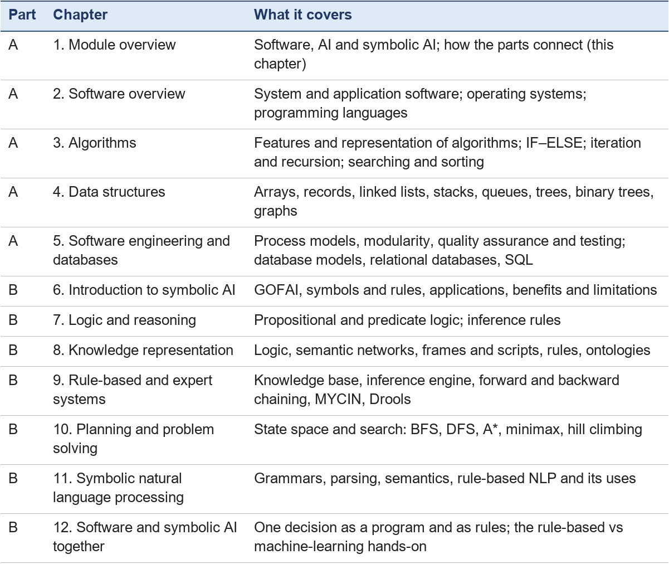
Sections 3 and 4 of this chapter preview symbolic AI; Chapters 6–9 develop it fully.

1. Start with a familiar decision
Imagine leaving home for class. It is raining and you are going outside, so you take an umbrella. The situation can be represented with two facts and one rule: IF it is raining AND you are going outside, THEN recommend an umbrella. The result is a recommendation based on stated information. A program can store the facts, check the conditions, and display the conclusion.
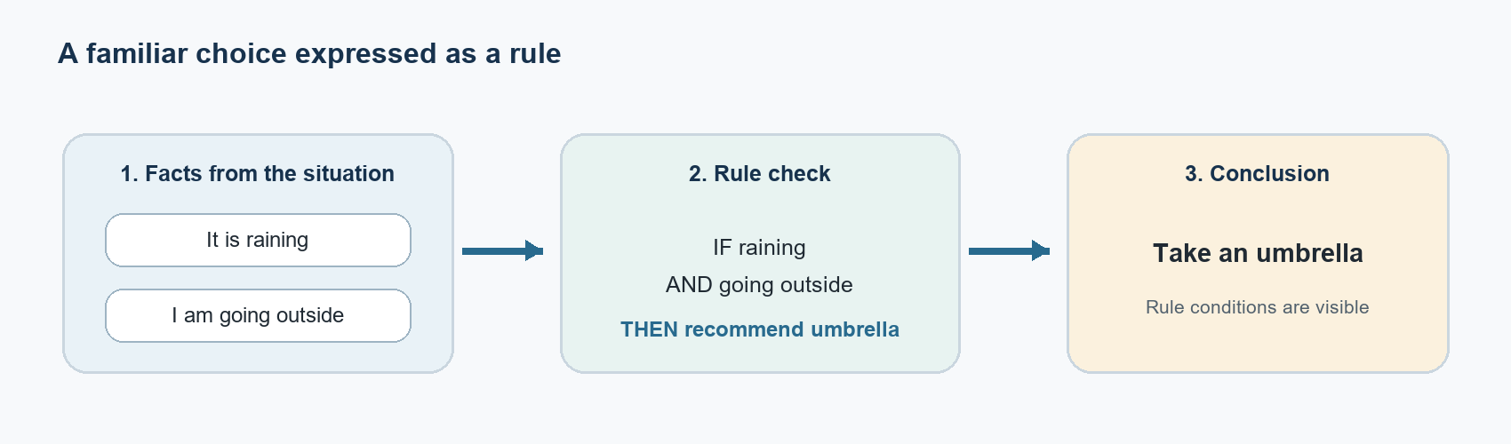
Figure 1. A familiar decision represented as facts, a rule, and a conclusion.

2. What software is and what AI means here
Software is the set of computer programs and procedures, with associated information such as data and documentation, that tells a computer system how to perform tasks [1, 15]. A simple model is input → processing → output: a person or sensor supplies information, the program processes it according to instructions, and the system returns a result or action. A calculator and a messaging app are software; their usefulness alone does not make them AI.
AI is a broad field. For this chapter, use the OECD's practical description of an AI system: a machine-based system that infers from inputs how to produce outputs such as predictions, content, recommendations, or decisions [2]. Different AI approaches perform that inference in different ways. Machine-learning systems commonly learn statistical patterns from data; symbolic AI works with explicit representations and rules [14].

3. How symbolic AI represents information
A symbol is a named representation of something in a problem, such as member_has_valid_card. A fact is an assertion about the current case, such as book_available = true. A rule is an IF-THEN statement that connects conditions to a conclusion or action. For example: IF raining AND going_outside THEN recommend_umbrella.
A rule-based system commonly has two parts. The knowledge base stores the facts and rules for the task. The inference engine checks whether current facts satisfy a rule's conditions and applies matching rules. The recommendation can then be shown to the user. Because the knowledge and rules are stated explicitly, a person can inspect what the system used to reach its result [14, 15].
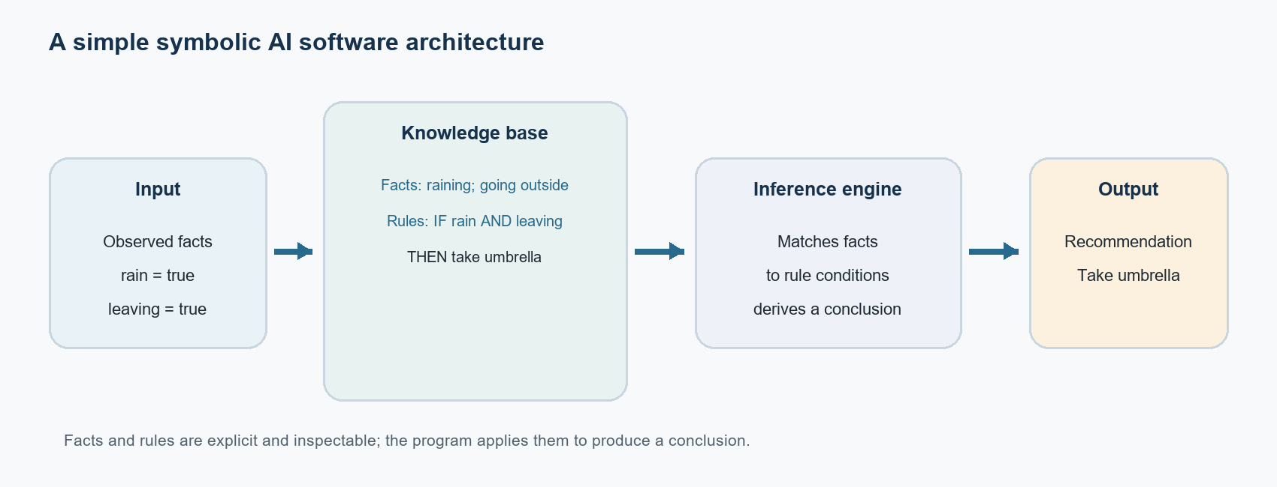
Figure 2. A simple architecture for symbolic AI software.

Check yourself 1 — Is it AI?
Use the working definition from Section 2: an AI system infers from its inputs how to produce an output. A system that only carries out fixed steps is ordinary software. Decide for each system, and give a one-sentence reason.
1. A calculator adds 2 and 3.
2. An email filter that has learned from thousands of labelled messages marks a new email as spam.
3. A library program stores facts and IF-THEN rules and uses an inference engine to decide whether a member may borrow a book.
4. A music app plays the songs of a playlist in the order the user saved them.
Expected answers
1. Not AI. It follows a fixed arithmetic procedure; it does not infer anything.
2. AI (machine learning). It infers whether a new email is spam from patterns it learned from data.
3. AI (symbolic AI). Its inference engine infers a conclusion from stated facts and rules.
4. Not AI. It follows the saved order exactly.
The useful test is not whether the software is clever or useful, but whether it infers its output (from learned patterns or from explicit knowledge) or only carries out fixed steps. Chapter 3 shows how fixed steps work; Chapter 9 shows how rules are applied.

4. How software and symbolic AI relate
Symbolic AI is one way to build software that reasons with explicit knowledge. The surrounding program still receives input, stores data, and displays an output; its symbolic component applies facts and rules to infer a conclusion. This separates domain knowledge from the general instructions that run the program. Ordinary software also includes many systems that follow fixed procedures without using an AI reasoning component.

Worked example: the library loan
The supplied project plan uses a library-loan scenario in its mini lecture [16]. Start with these facts: the member has a valid card, has no overdue books, and the requested book is available.
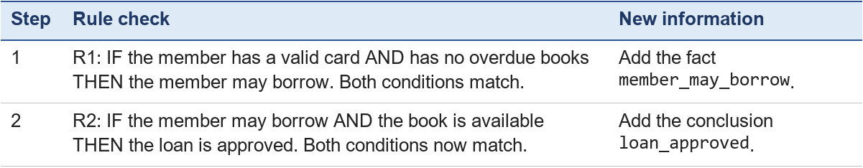
This is a small example of forward chaining: start with known facts, apply a rule whose conditions match, add its conclusion as a new fact, and check the rules again. The software produces the approval because the stated facts and rules support it. Chapter 9 explains forward chaining fully and traces this example one step at a time.

Strength and limitation
Explicit rules are easy to inspect and test one by one. This is useful when a task has clear conditions, such as an eligibility check. But a rule system depends on accurate facts and a complete, maintained rule set. If overdue status is unknown, the system cannot infer that the member has no overdue books. Missing information is not automatically proof of the opposite, and conflicting or outdated facts can make a conclusion unreliable.

5. Historical background and progression
The history of software follows the development of programmable machines, stored programs, more expressive languages, and disciplined software engineering. Symbolic AI developed alongside it as researchers explored whether computers could manipulate symbols, represent knowledge, and reason from it. The two histories meet because AI systems are software: they use computer hardware and must also be designed, tested, and maintained.
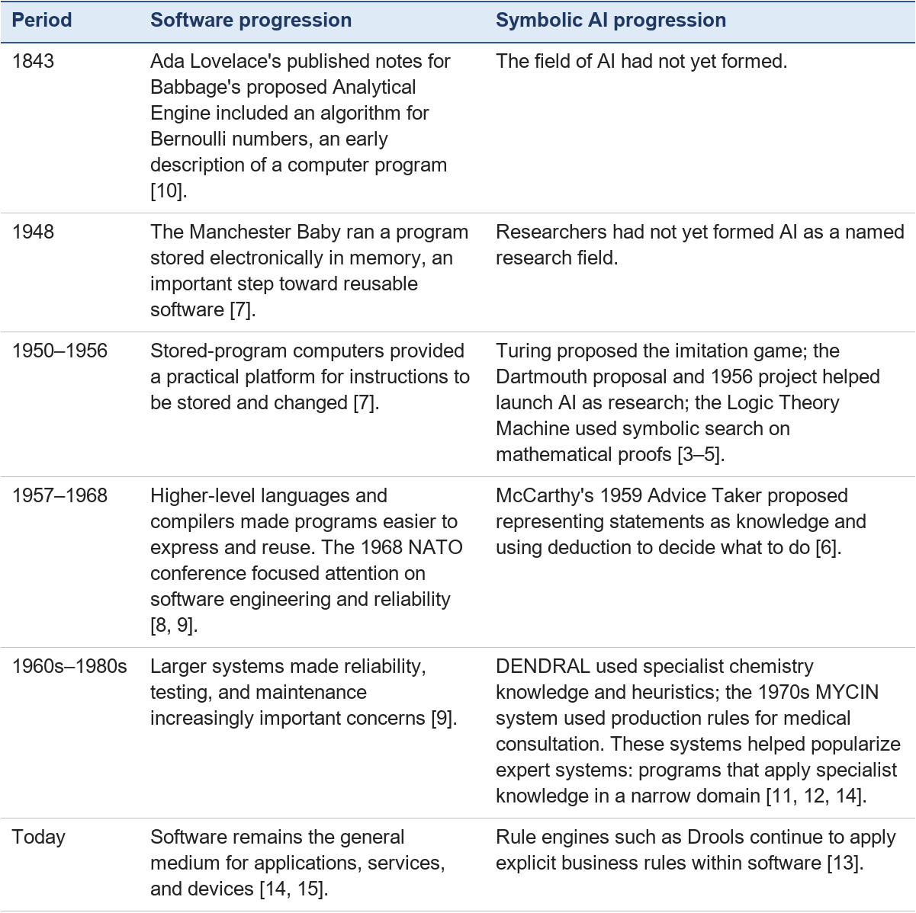
This timeline is selective. It shows how software moved from early programmable ideas to engineered systems, while symbolic AI moved from logic and deduction programs to expert systems and rule engines.

Check yourself 2 — Put the milestones in order
Without looking at the table, put these events in time order, then answer the question below.
- A. MYCIN gives medical advice using production rules.
- B. The Manchester Baby runs a program stored in its memory.
- C. Ada Lovelace publishes an algorithm for Babbage's Analytical Engine.
- D. The Dartmouth proposal launches AI as a research field.
Question: Why did symbolic AI programs appear only after stored-program computers existed?
Expected answer: C (1843) → B (1948) → D (1955–1956) → A (1970s). Symbolic AI programs are software: they need a machine that can store and change instructions and data, such as symbols, facts and rules. Stored-program computers provided that platform, so symbolic AI research could follow (Section 5: "AI systems are software").

6. Learner activity
Suppose a library member has a valid card and the requested book is available, but the member has an overdue book. Using R1 and R2 above, what can the system conclude? Does it automatically know that the loan must be rejected?
Expected answer: R1 does not match because the condition "has no overdue books" is not satisfied. Therefore member_may_borrow is not added, and R2 cannot match because it requires that fact. The system cannot approve the loan from these rules. It also cannot conclude that the loan must be rejected unless the knowledge base contains a separate rejection rule. If the overdue status were unknown rather than known to be true, the system should not treat the missing fact as proof that there are no overdue books.

Chapter takeaway
Software provides instructions for processing information. AI describes systems that infer useful outputs for a task, and symbolic AI is one approach that represents facts and rules explicitly. The central relationship is that symbolic AI is software organized to reason over explicit knowledge.

Chapter 2 — Software Overview
Chapter lead (proposed): Gunawan Nicolas Benedictus · Module: Software and Symbolic AI · Version: V2.0 working draft (3 November 2026) — AI-assisted draft; discussed by the team on 4 November 2026

Learning outcomes
After this chapter, you should be able to:
- Sort familiar programs into system software and application software.
- Say what an operating system does, and name two of its jobs: managing processes and managing memory.
- Describe how programming languages moved from machine code to languages such as Python.
- Name four kinds of programming language and the features that most languages share.
- Explain why UNIX matters and how an app such as Weixin depends on the operating system below it.

1. System software and application software
Think about your phone. When you send a message in Weixin, you only see Weixin. But many other programs are working underneath: one program controls the screen, another talks to the network, another decides which app may use the processor. Software comes in two groups:
- Application software is the software you use to get a task done: chatting, writing a report, borrowing a library book, browsing the web. Examples: Weixin, Microsoft Word, a web browser, the library management system of Chapter 5.
- System software is the software that runs the computer itself and gives applications a place to run. The most important piece is the operating system (OS), for example Windows, Android, iOS or Linux. System software also includes device drivers (small programs that let the OS use a printer or camera) and utilities (tools such as file managers and antivirus programs).
A building is a useful picture. The operating system is the building's foundations, electricity and water pipes. The applications are the shops inside. A shop does not lay its own water pipe; it uses the one the building provides. In the same way, Weixin does not control the network card directly; it asks the operating system to send the message.
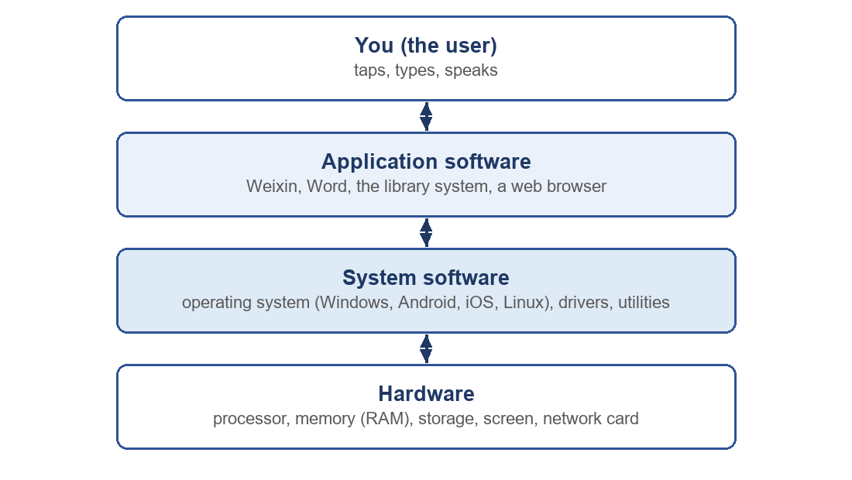
Figure 1. Layers of software. Each layer uses the services of the layer below it.
Check yourself 1. Is a calculator app system software or application software? Answer: application software, because it does a task for the user; it runs on top of the operating system.

2. Operating systems: evolution
Operating systems grew as computers became faster, cheaper and more widely used. A simple timeline (Forouzan, 2018, Ch. 7; Brookshear & Brylow, 2019, Ch. 3):
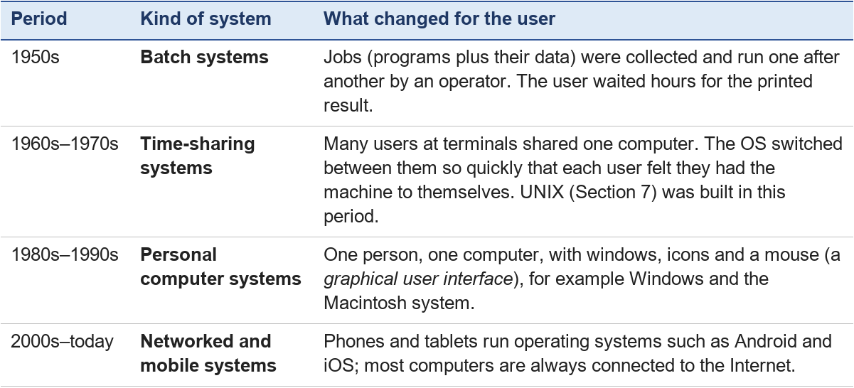
The main idea stays the same in every period: the operating system stands between the user's programs and the hardware, and shares the hardware fairly and safely.

3. Operating systems: process management
A program is a set of instructions stored in a file. When you start it, the operating system loads it and runs it; a running program is called a process. If you play music, keep a browser open and chat in Weixin, at least three processes exist at the same time.
A simple processor can carry out only one instruction stream at a time, so the operating system takes turns. It gives each process a very short time slice, perhaps a few milliseconds, then pauses it and lets the next one run. This is called scheduling. Because the switching is so fast, you see all three programs working together.
Each process is always in one of three main states:
- Running: the processor is carrying out its instructions now.
- Ready: it could run and is waiting for its turn.
- Waiting (blocked): it is waiting for something else, for example a file to load or a message to arrive.
Worked example: taking turns. Three processes need the processor: Music (needs 2 time slices), Browser (3 slices) and Weixin (1 slice). The OS gives one slice at a time, in a circle (this is called round-robin scheduling):
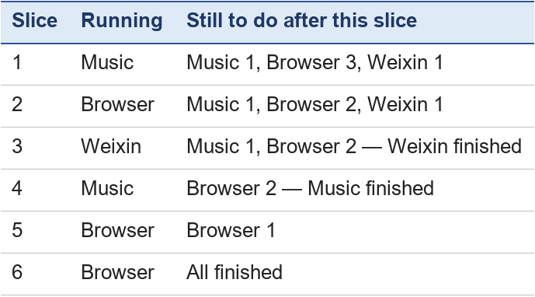
Nobody waits too long, and the short job (Weixin) finishes early.

4. Operating systems: memory management
A process can only run while its instructions and data are in the computer's main memory (RAM). RAM is fast but limited, and many processes want it at once. The operating system's memory manager has three jobs:
1. Give memory out: when a process starts, the OS finds free space for it.
2. Keep processes apart: the browser must not be able to read or overwrite Weixin's memory. The OS protects each process's area.
3. Take memory back: when a process ends, its space is freed for others.
When RAM is full, many operating systems use virtual memory: parts of a process that are not needed right now are moved to storage (the disk) and brought back when needed. This lets more programs run than RAM alone could hold, but moving data to and from the disk is slow, which is why a computer with too little RAM feels sluggish.
Going further (optional). Many systems divide memory into equal-sized blocks called pages. A process's pages do not have to sit next to each other in RAM, and only the pages in use need to be in RAM at all. This method is called paging.

5. Programming languages: evolution
A processor only understands machine language: instructions written as patterns of 0s and 1s. Programmers then made the work easier, step by step:
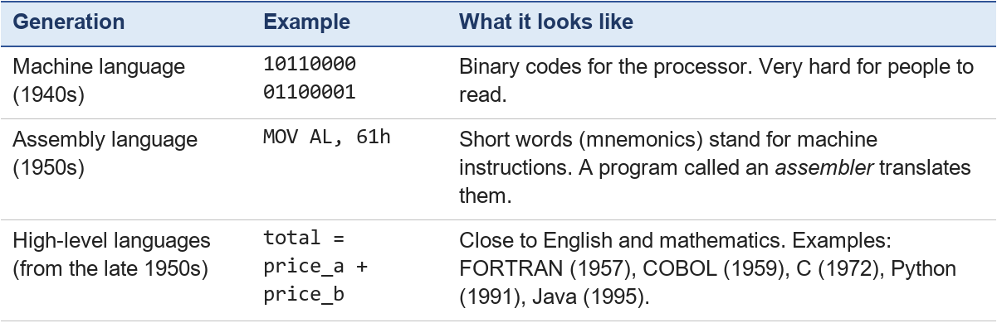
A high-level program must be translated before the processor can run it:
- A compiler translates the whole program into machine language first, then the result is run (for example C).
- An interpreter reads and carries out the program step by step instead of producing a separate machine-language file first. Python is usually run this way: the Python interpreter first makes a quick translation of the whole file into an in-between form called bytecode, then carries it out.

6. Programming languages: categories and features
Languages are grouped by the way a programmer describes the solution (Forouzan, 2018, Ch. 9):
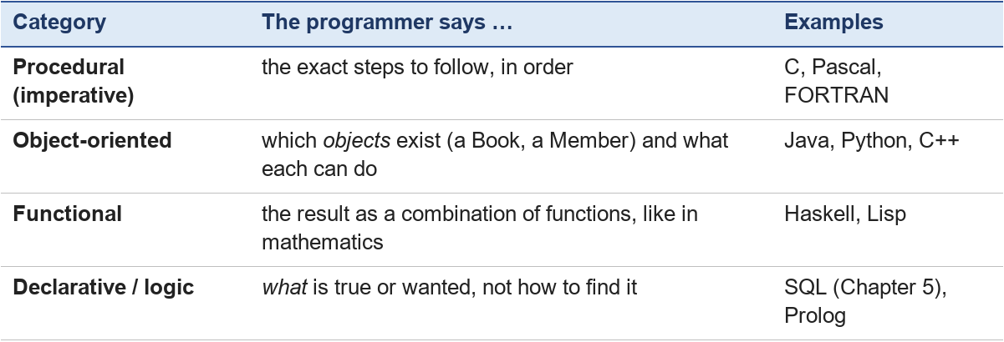
The last group links directly to Part B of this module: in Prolog and in rule-based systems, the programmer writes facts and rules, and the system works out the answer (Chapter 9).
Most languages share the same basic features:
- Variables and data types: named places that store values such as numbers, text or true/false (Chapter 3).
- Sequence: instructions run one after another.
- Selection: the program chooses a path, for example with IF–ELSE (Chapter 3).
- Iteration: the program repeats steps, for example with a loop (Chapter 3, Section C).
- Subprograms (functions): a named group of steps that can be reused.
Check yourself 2. The query SELECT title FROM Books WHERE available = true says what is wanted but not how to search. Which category is it? Answer: declarative.

7. Case studies: UNIX and Weixin
PPT 2024 suggests two pieces of software as learning examples: one system, one application.
UNIX (system software). UNIX is an operating system created in 1969 at Bell Labs by Ken Thompson and Dennis Ritchie. In 1973 it was rewritten in the C programming language, which made it much easier to move to new kinds of computers (Ritchie & Thompson, 1974). Three UNIX ideas are still everywhere:
- Many small tools that each do one job, which can be joined together. For example, one tool lists files and another counts them; a pipe (|) passes the output of one into the other.
- Many users at once, each with their own files and permissions — the time-sharing idea of Section 2.
- Everything is organised as files in folders (a hierarchical file system).
Linux, macOS and Android all follow these ideas: macOS is UNIX-based (it held the official UNIX certification for many years), and Android is built on the Linux kernel — the core part of an operating system that controls the hardware.
Weixin (application software). Weixin (WeChat) is a messaging application launched by Tencent in 2011. It is application software: it does tasks for the user — chatting, voice calls, sharing photos, paying, running mini programs. Every one of those tasks uses the operating system below it:
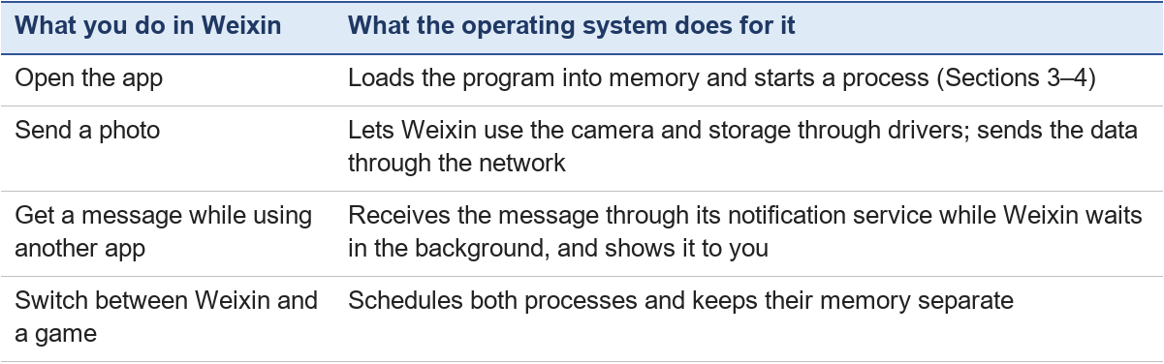
The same Weixin features exist on Android and on iOS because each version is written to use that operating system's services.

8. Activity: who does what?
Part A — sort the software. Write system or application for each: (1) Android; (2) the library loan-check program; (3) a printer driver; (4) a web browser; (5) a file manager that comes with the operating system.
Part B — process states. You are writing a report in Word, Weixin is downloading a large video, and the music player is playing. At one instant the processor is running Word. What state is each of the three processes in?
Part C — languages. Which category (procedural, object-oriented, functional, declarative) fits a program made of facts and IF-THEN rules?
Expected answers
- Part A: (1) system — it is an operating system; (2) application — it does a task for the librarian; (3) system — drivers let the OS use hardware; (4) application; (5) system (a utility), although it is used directly by the user. Some utilities sit on the border; what matters is the reason you give.
- Part B: Word is running. Weixin is waiting (blocked) for data from the network. The music player is ready, waiting for its next time slice (it runs very often, so the music does not stop).
- Part C: declarative (logic programming). Chapter 9 shows how such a program reaches a conclusion.

Key points
- Application software does tasks for users; system software, above all the operating system, runs the computer and serves the applications.
- The operating system shares the processor among processes by scheduling, and shares memory by giving it out, protecting it and taking it back.
- Programming languages moved from machine code to assembly to high-level languages, which compilers or interpreters translate.
- Languages can be procedural, object-oriented, functional or declarative; all use variables, sequence, selection, iteration and subprograms.

Chapter 3 — Algorithms: How Programs Process Information and Make Decisions
Chapter lead: Ritchard Alexander 林俊宇 · Module: Software and Symbolic AI · Version: V2.0 working draft (2 November 2026) — discussed by the team on 4 November 2026

Why this chapter matters
Software helps computers carry out tasks. A program receives or uses data, follows instructions written by a programmer, and may produce a result. Understanding this basic cycle makes it easier to see how ordinary programs make decisions. Later chapters will compare these programmed decisions with rule-based reasoning in symbolic AI.

Learning goals
After studying this chapter, you should be able to:
- Explain input, processing, and output in a simple program.
- Distinguish data from instructions.
- Describe an algorithm as an ordered, step-by-step procedure for solving a problem.
- Explain how an IF–ELSE condition gives a program two possible paths.
- Trace a short program and state its output for a given input.

1. Programs, data, and instructions
Software is a collection of programs and related files that help a computer perform tasks. A program is a set of instructions written in a programming language. The computer carries out those instructions using data. The physical parts of a computer — such as its keyboard, screen, and processor — are hardware. Software provides instructions that the hardware can carry out.
For example, a weather application can receive a location, process weather information, and display a forecast. A program does not decide what a person ought to do by itself. Its instructions describe what to do for the cases the programmer has provided.

Data and instructions are different
Data are values a program receives, stores, or works with. Data may be text, numbers, answers, dates, or measurements. Instructions tell the program what to do with the data. An instruction might ask the program to compare two values, calculate a total, save information, or display a message.
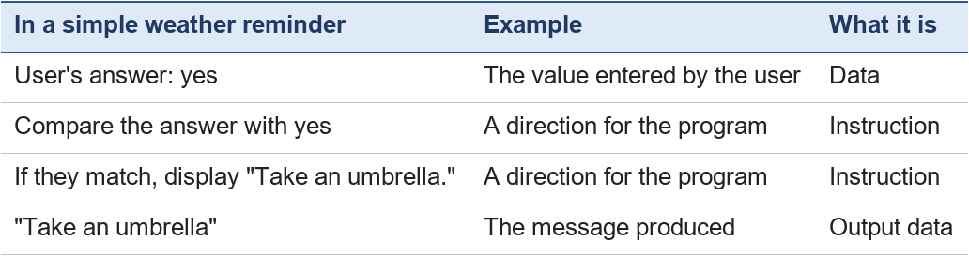
The computer does not treat the user's answer as a command in this example. The answer is data. The program's instructions decide how to use it.

2. Input, processing, and output
A useful way to understand many programs is to divide their work into three stages:
1. Input: The program receives data. A person might type it, or it might come from a file, sensor, or another program.
2. Processing: The program follows its instructions to check, organize, calculate, or change the data.
3. Output: The program presents or sends a result. It might show a message, save a file, or send information to another program.
A weather reminder can be represented like this:
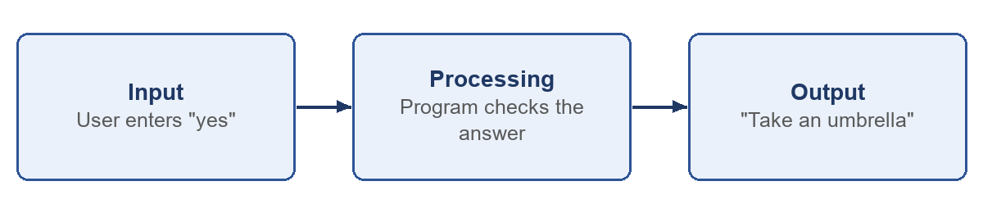
Input, processing, and output describe roles in a task. A program can have several inputs and outputs, and the output of one step can become the input for a later step.

Example: a shopping total
Suppose a program receives the prices of two items. The prices are input data. The instructions add the prices together during processing. The total is the output.
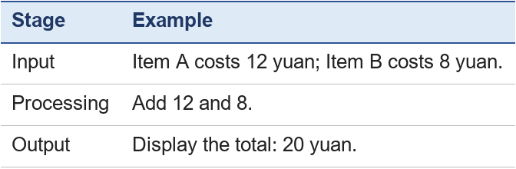
The numbers are data. "Add the two prices" is an instruction.

3. Algorithms: planning the steps
An algorithm is a clear, ordered, step-by-step procedure for solving a problem. It describes what needs to happen, without requiring a particular programming language. For the weather reminder, an algorithm could be:
1. Ask the user whether it is raining.
2. Receive and store the answer.
3. Check whether the answer is yes.
4. If it is yes, display "Take an umbrella."
5. Otherwise, display "No umbrella needed."
6. Stop.
A useful algorithm has steps that are clear enough to follow, in an order that solves the task. For this example, step 3 must happen after the program receives the answer, because there is nothing to check before then.
A program expresses an algorithm in a programming language. Python, Java, and C++ are examples of programming languages. The algorithm describes the planned steps; the program uses the syntax of a language to tell a computer how to carry them out.

4. How a program makes a decision with IF–ELSE
A program can choose between actions by checking a condition. A condition is a test whose result is either true or false. An IF–ELSE structure tells the program what to do for those two results:
- If the condition is true, run the instructions in the IF branch.
- If the condition is false, run the instructions in the ELSE branch.
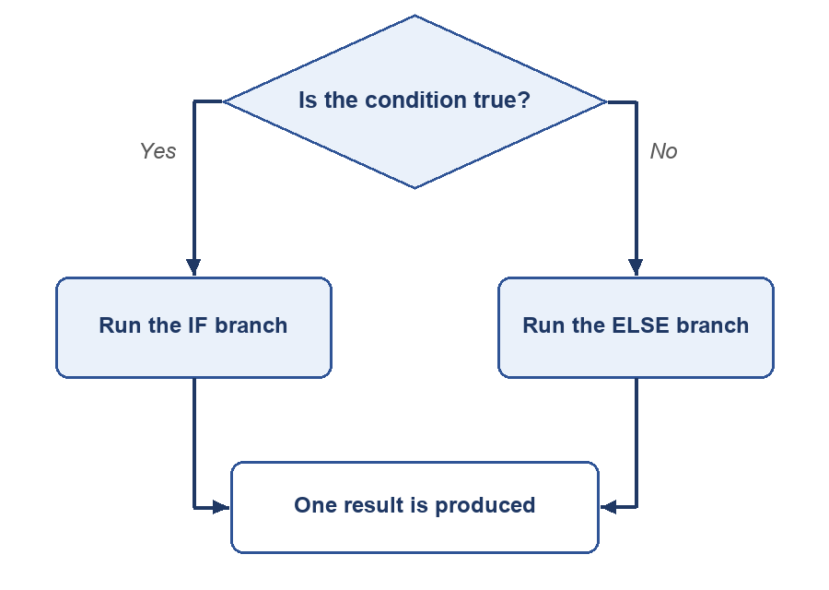
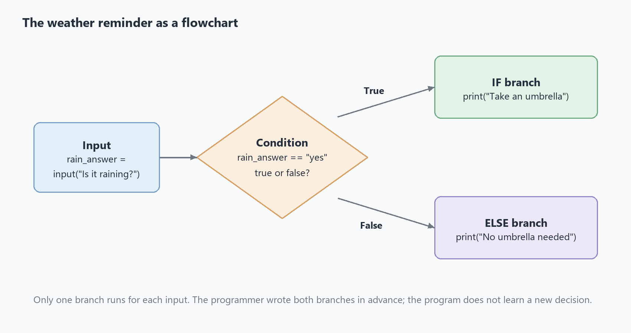
Figure 1. The weather reminder as a flowchart: the condition is checked once, and exactly one branch runs.
The programmer writes the condition and the instructions for each branch. The program checks the input against that condition and follows the matching path. The program does not learn a new decision from this IF–ELSE statement; it follows the instructions already written.

5. Worked example: a weather reminder
The following Python program asks whether it is raining and displays a message:
rain_answer = input("Is it raining? Enter yes or no: ")
if rain_answer == "yes":
print("Take an umbrella")
else:
print("No umbrella needed")

The Python Language Reference explains that an if statement selects exactly one of its branches to run, depending on whether its condition is true. In Python, the indented statements belong to their IF or ELSE branch. [2]

What each line does
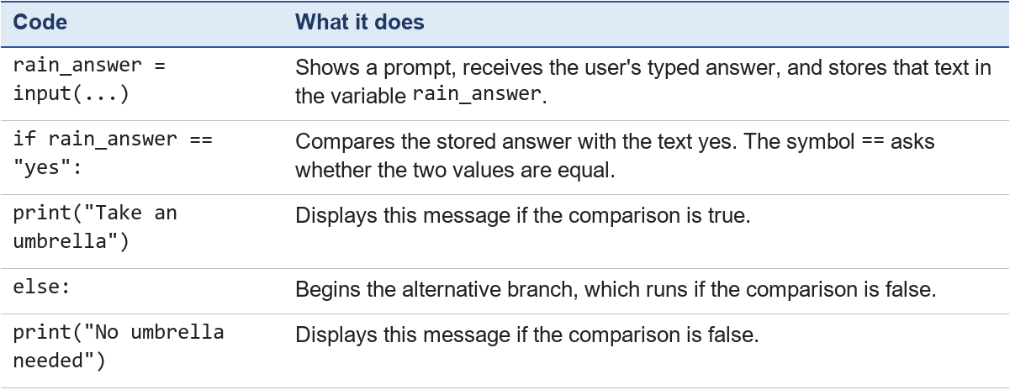
A variable is a named place in a program where a value can be stored. Here, rain_answer stores the input. In Python, = assigns a value to a variable, while == compares two values. Python's input() receives text, and print() displays output. [3]

Trace A: the user enters yes
To trace a program is to follow its instructions in order for a particular input. Record the data, evaluate each condition, and note which instructions run.
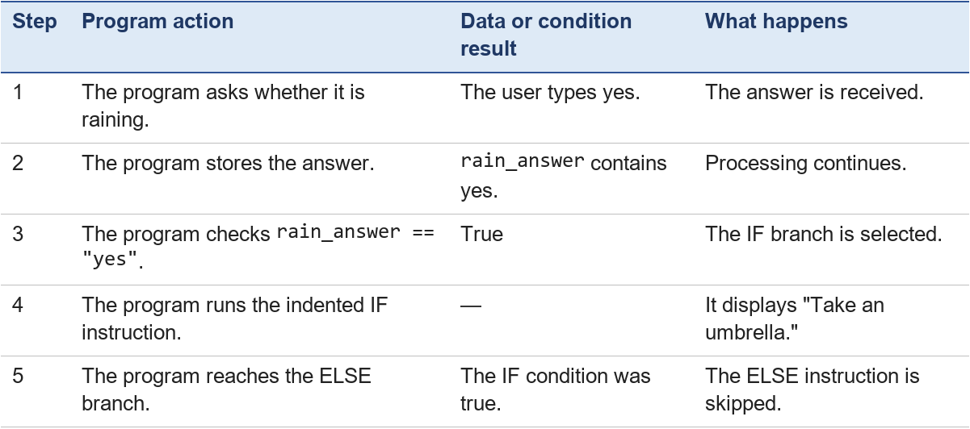
Output: Take an umbrella

Trace B: the user enters no
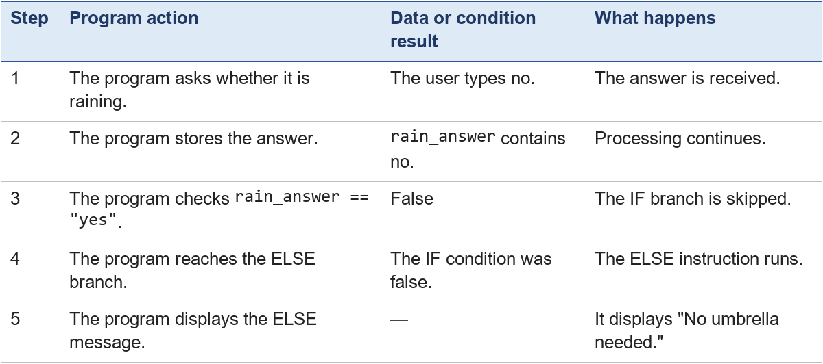
Output: No umbrella needed
Only one branch runs in each trace: the IF branch when the condition is true, or the ELSE branch when it is false.

Check the input carefully
This simple program compares the answer with the exact lowercase text yes. If the user types Yes with a capital letter, the comparison is false and the ELSE message appears. The program follows its written instructions; it does not automatically know that Yes and yes are intended to mean the same thing. A more complete program could check the input and ask again when it is not an accepted answer.

6. Practice: trace a short program
Trace the program for each input: yes and no.
store_open = input("Is the store open? Enter yes or no: ")
if store_open == "yes":
print("The store is open")
else:
print("The store is closed")

For each input, write:
1. What value is stored in store_open?
2. Is the condition true or false?
3. Which branch runs?
4. What output is displayed?
Expected answers
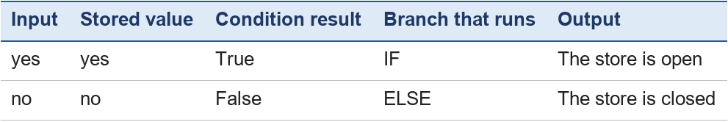

Practice 2: find the error
A student wants the program to remind people to take an umbrella when it rains. They type yes when it is raining, but the program says "No umbrella needed". Find the error and fix it.
rain_answer = input("Is it raining? Enter yes or no: ")
if rain_answer == "Yes":
print("Take an umbrella")
else:
print("No umbrella needed")

Expected answer: The condition compares the input with "Yes" (capital Y), but the user typed yes. The two texts are not equal, so the condition is false and the ELSE branch runs. Fix: compare with "yes", as in Section 5, or make the comparison ignore capital letters, for example if rain_answer.lower() == "yes":. The computer did exactly what was written — the mistake was in the instruction, not in the computer (see "Check the input carefully" in Section 5).

Identify the data and instructions
In the practice program:
- The user's answer (yes or no) is data.
- The comparison with yes is an instruction.
- The print instructions in the IF and ELSE branches are instructions.
- The message shown by the program is output.

7. More about algorithms (PPT 2024 chap3, slide 3)
Sections 1–6 showed one small algorithm, the weather reminder. This section answers four questions from the PPT 2024 outline: What makes a list of steps a good algorithm? How can we write it down? How does an algorithm repeat work? And what are the classic algorithms for searching and sorting?

A. Features of an algorithm
Not every list of steps is an algorithm. Knuth (1997, §1.1) describes five features; the course books give shorter definitions with the same ideas — an ordered set of unambiguous steps that produces a result and stops (Forouzan, 2018, pp. 223–224; Brookshear & Brylow, 2019, Ch. 5):
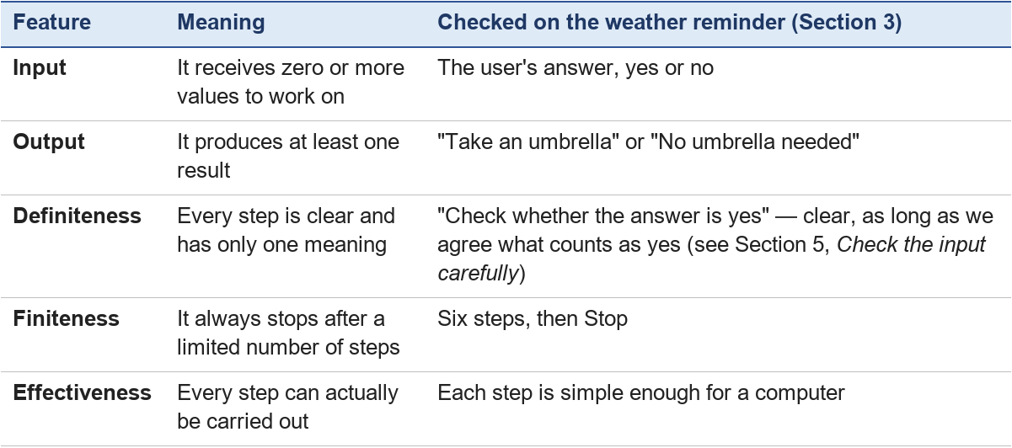
A recipe that says "add salt until it tastes right" fails definiteness: two cooks will do different things. A step that says "keep counting until you reach the last number" fails finiteness, because there is no last number.

B. Representing algorithms: words, pseudocode, flowcharts and code
The same algorithm can be written in several ways. Each way suits a different reader.
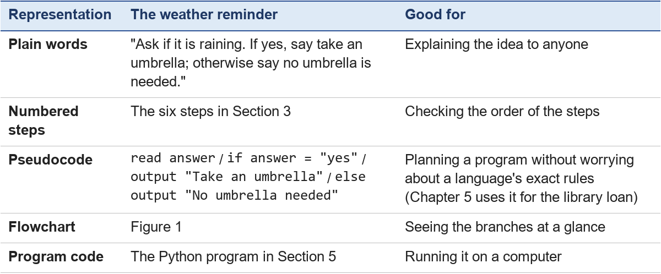
A flowchart uses standard shapes: an oval for Start and Stop, a parallelogram for input and output, a rectangle for a processing step, a diamond for a yes/no decision, and arrows for the order.

C. Iteration and recursion
Many problems need the same steps again and again. There are two ways to repeat.
Iteration means using a loop: a block of steps that runs repeatedly, either a set number of times or while a condition is true.
Worked example: total late fines. A member returns three books that are 2, 0 and 5 days late. The fine is 1 yuan per day.
days_late = [2, 0, 5]
total = 0
for days in days_late:
total = total + days * 1
print("Total fine:", total, "yuan")

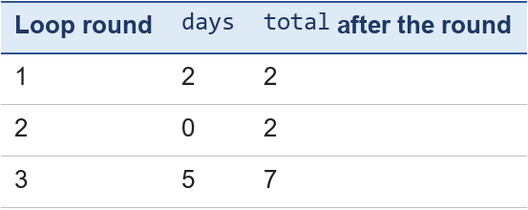
Output: Total fine: 7 yuan. The loop stops by itself after the last item, so the algorithm is finite.
Recursion means a function that solves a problem by calling itself on a smaller version of the same problem. It needs two parts:
- a base case: a version so small that the answer is known at once;
- a recursive case: break the problem into a smaller one and use the function's own answer to it.
Worked example: count down.
def countdown(n):
if n == 0: # base case
print("Lift off!")
else: # recursive case
print(n)
countdown(n - 1)

countdown(3)

The output is 3, 2, 1, Lift off!. Each call works on a smaller number until it reaches the base case, 0. Without the base case the function would never stop — it would break the finiteness feature of Section A.
The same problem can usually be solved either way. Loops are often easier for beginners to trace; recursion is natural for problems that contain smaller copies of themselves, such as folders inside folders, or the trees of Chapter 4.

D. Basic algorithms: searching and sorting
Linear search checks the items one by one, from the start, until it finds the target or reaches the end.
Example: find book B412 on the shelf B205, B518, B101, B412, B310. Check B205 (no), B518 (no), B101 (no), B412 — found after 4 checks. On a shelf of n books, linear search may need up to n checks.
Binary search only works on a sorted list, but it is much faster. It looks at the middle item; if that is not the target, it throws away the half that cannot contain the target and repeats on the other half.
Example: find 70 in the sorted list 10, 20, 30, 40, 50, 60, 70, 80, 90 (positions 1–9).
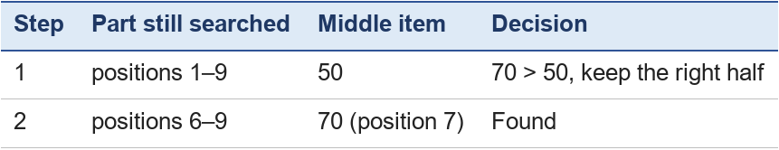
Two checks instead of seven. Each step halves the list, so even 1,000 sorted items need only about 10 checks. It is the same game as "guess my number from 1 to 100" when the answer is "higher" or "lower".
Sorting puts items into order. A simple method is bubble sort: go through the list comparing each pair of neighbours and swap them if they are in the wrong order; repeat the passes until a whole pass makes no swap.
Example: sort 5, 3, 8, 1.
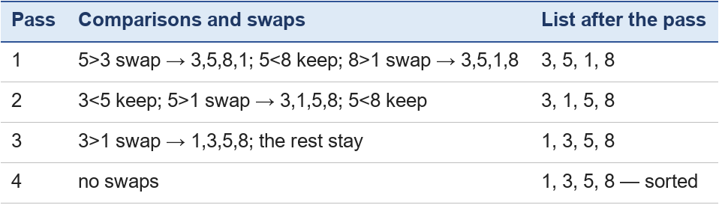
After each pass the largest remaining number has "bubbled" to its place at the end. Bubble sort is easy to understand but slow on long lists; real software uses faster methods such as merge sort and quicksort, which a "Going further" study can explore.
Practice 3 — your turn. (1) Which of the five features does this fail: "Step 1: pick a number. Step 2: go to step 1."? (2) How many checks does binary search need to find 20 in the sorted list above? (3) Write the list after the first pass of bubble sort on 4, 2, 6, 1.
Expected answers. (1) Finiteness — it never stops, and it produces no output. (2) Middle of 1–9 is 50 → go left (positions 1–4); middle is 20 (position 2, taking the left of the two middle items) → found in 2 checks. (3) 4>2 swap → 2,4,6,1; 4<6 keep; 6>1 swap → 2, 4, 1, 6.

Key points
- Programs process data by following instructions written by a programmer.
- Input is data received by a program; processing is the work performed on it; output is the result presented or sent.
- An algorithm is an ordered, step-by-step procedure for solving a problem.
- A program expresses an algorithm in a programming language.
- An IF–ELSE condition has two possible outcomes: true or false. The program follows the branch written for that outcome.
- Tracing a program means following its instructions in order for a specific input and recording the result.
- A good algorithm has input, output, definiteness, finiteness and effectiveness, and can be written as words, pseudocode, a flowchart or code.
- Loops repeat steps (iteration); a recursive function calls itself on a smaller problem and needs a base case.
- Linear search checks items one by one until it finds the target; binary search halves a sorted list at each step; bubble sort swaps neighbours until the list is in order.
- The IF–ELSE decisions in this chapter are directly written into the program. Later chapters will examine how rule-based systems represent and apply rules.

Chapter 4 — Data Structures
Chapter lead (proposed): Ritchard Alexander · Module: Software and Symbolic AI · Version: V2.0 working draft (3 November 2026) — AI-assisted draft; discussed by the team on 4 November 2026

Learning outcomes
After this chapter, you should be able to:
- Explain what a data structure is and why the choice of structure matters.
- Describe arrays, records, linked lists, stacks, queues, trees, binary trees and graphs, with one library example for each.
- Trace push and pop on a stack, and enqueue and dequeue on a queue.
- Search a binary search tree, and list the order in which breadth-first search visits the rooms of a map.

1. Why data structures matter
A library keeps thousands of books. If they were piled on the floor, finding one would take hours. Shelves, numbers and catalogues make the same books easy to find. Programs have the same problem with data.
A data structure is a way of organising related data in a computer so that a program can use it efficiently (see Forouzan, 2018, p. 291). The data is the same; the organisation decides which jobs are fast and which are slow. For example:
- To look up "the 3rd book on the shelf" quickly, use an array.
- To serve people "in the order they arrived", use a queue.
- To find a route between rooms, use a graph.
Algorithms (Chapter 3) and data structures work together: an algorithm is the list of steps, and the data structure is where the steps find and store their data.

2. Arrays and records
An array is a fixed number of boxes of the same kind, stored side by side. Each box has a number called its index. In most languages the first index is 0.
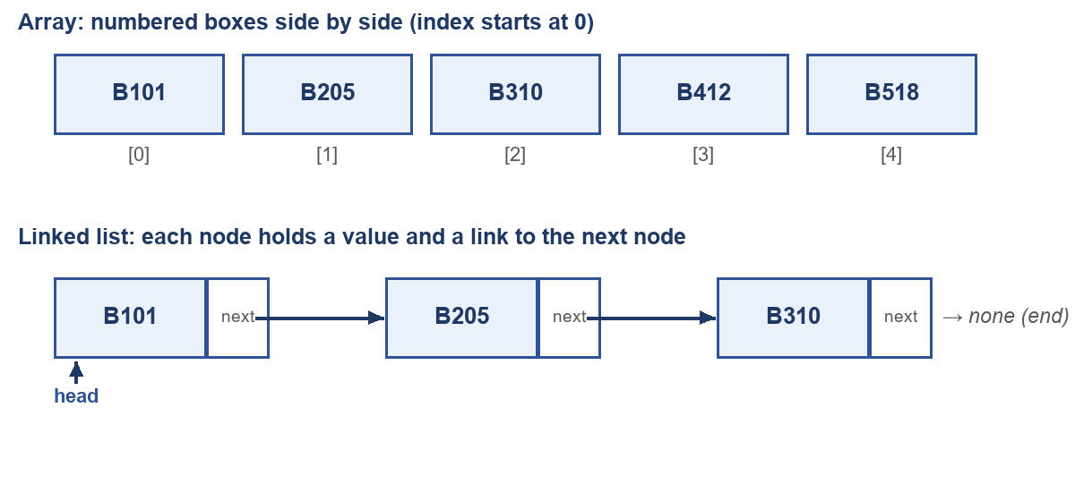
Figure 1. Top: an array. Bottom: a linked list (Section 3).
In Python, a list works like an array:
shelf = ["B101", "B205", "B310", "B412", "B518"]
print(shelf[2]) # displays B310 — the box with index 2
shelf[2] = "B399" # replaces the third book

Because the boxes sit side by side, the computer can jump straight to any index; this is why reading shelf[2] is fast. Inserting a new book in the middle is slow, though: every later book must move one box to the right.
A record groups several pieces of data about one thing, each with its own name (a field). A library member is a record:
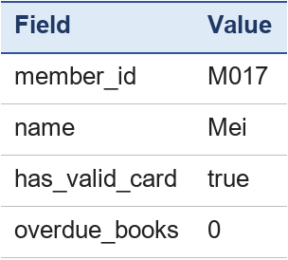
In Python a record can be written as a dictionary: member = {"member_id": "M017", "name": "Mei", "has_valid_card": True, "overdue_books": 0}. An array of records — one record per member — is much like a database table (Chapter 5, Section E), where each row is one record.

3. Linked lists
A linked list is a chain of nodes. Each node holds a value and a link (pointer) to the next node. The first node is called the head; the last node links to nothing (Figure 1, bottom).
Think of a treasure hunt: each clue tells you where the next clue is. To reach the third clue you must follow the first two — you cannot jump. That is the main trade-off:
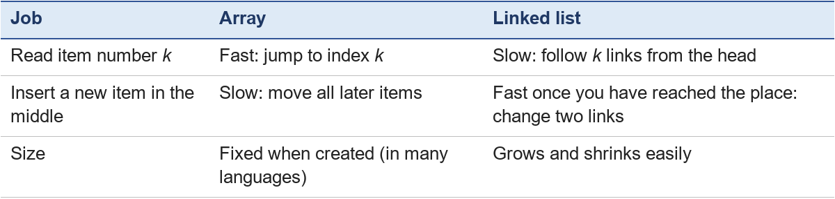
Example. To insert B250 between B205 and B310, make the new node point to B310, then make B205 point to the new node. Nothing else moves.

4. Stacks and queues
A stack is a list where you add and remove items only at one end, the top — like a pile of returned books on the desk. The last book put on the pile is the first one taken off: last in, first out (LIFO).
- push: put an item on top.
- pop: take the top item off.
A queue is a list where items join at the back and leave from the front — like members waiting at the loan desk: first in, first out (FIFO).
- enqueue: join at the back.
- dequeue: leave from the front.
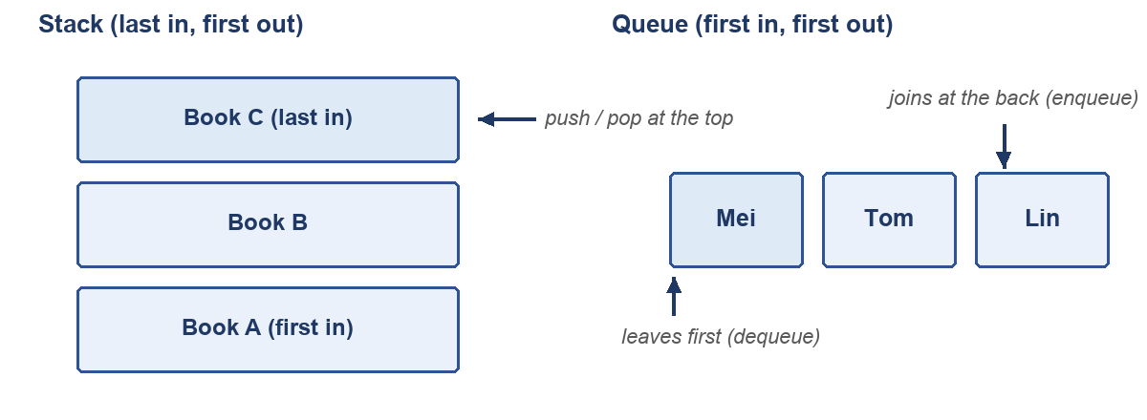
Figure 2. A stack (left) and a queue (right).
Worked example: trace a stack. Start with an empty stack.
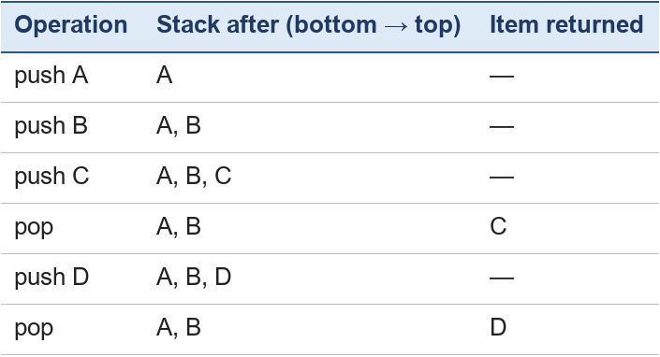
Where they are used: the Undo button keeps your last actions on a stack; a printer keeps jobs in a queue; the operating system keeps ready processes in a queue (Chapter 2, Section 3).

5. Trees and binary trees
A tree stores data in a hierarchy, like a family tree or the library's subject catalogue: Library → Science → Computing → Artificial intelligence. The top node is the root; each node can have children; a node with no children is a leaf.
A binary tree is a tree in which every node has at most two children, a left one and a right one. A very useful kind is the binary search tree: for every node, all numbers in its left part are smaller, and all numbers in its right part are larger.
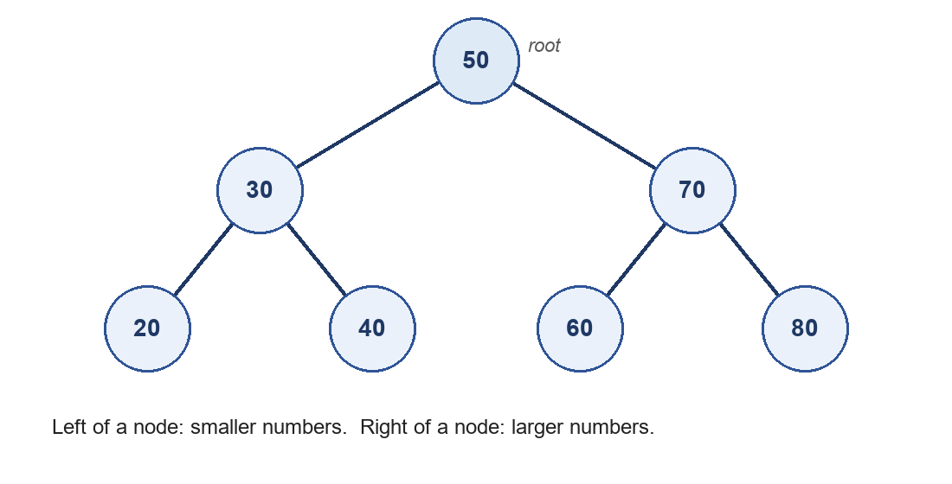
Figure 3. A binary search tree of shelf numbers.
Worked example: find 60. Start at the root, 50. 60 is larger, so go right to 70. 60 is smaller than 70, so go left to 60. Found, after looking at only three nodes. A plain list of seven numbers might need seven looks. This "halve the problem at every step" idea is the same as binary search (Chapter 3, Section D).
Find 45. 50 → left to 30 → right to 40 → right of 40 is empty. So 45 is not in the tree. The search stops as soon as there is nowhere left to go.

6. Graphs and breadth-first search
A graph is a set of nodes (also called vertices) joined by edges. Unlike a tree, a graph can have cycles (paths that lead back to where they started), and any node can connect to any other. Maps, social networks and the web are graphs.
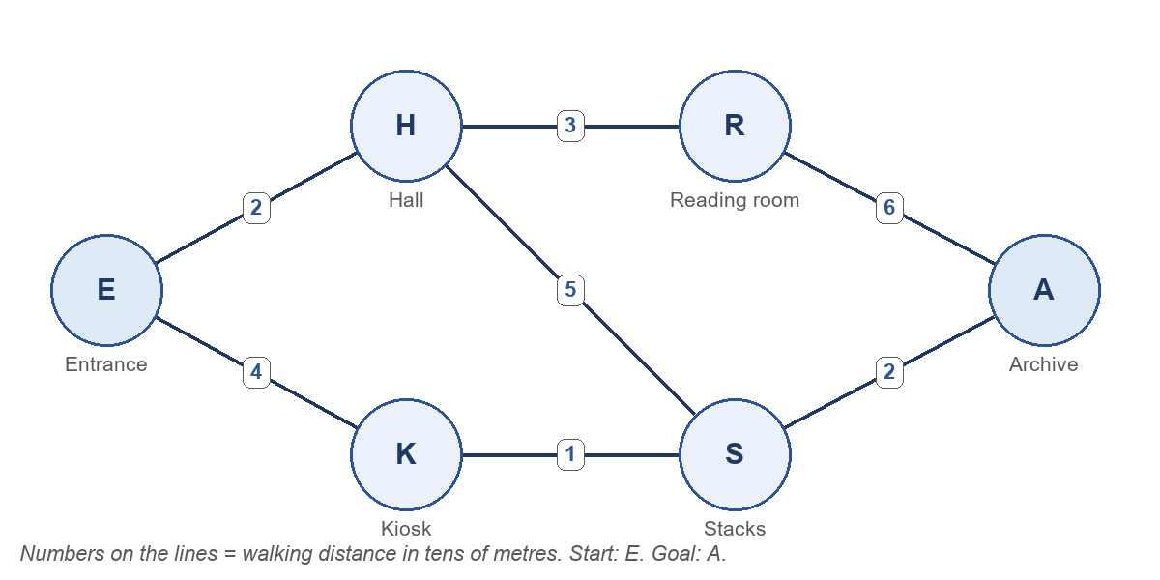
Figure 4. The library map as a graph. Chapter 10 uses the numbers on the edges; here we only need which rooms are connected.
Breadth-first search (BFS) visits a graph layer by layer: first the start node, then all its neighbours, then their neighbours, and so on. It uses a queue (Section 4) to remember which node to visit next. PPT 2024 (chap3, slide 4) names BFS as a sample algorithm.
Worked example: BFS from the Entrance (E). Neighbours are added in alphabetical order, and a node is never added twice.
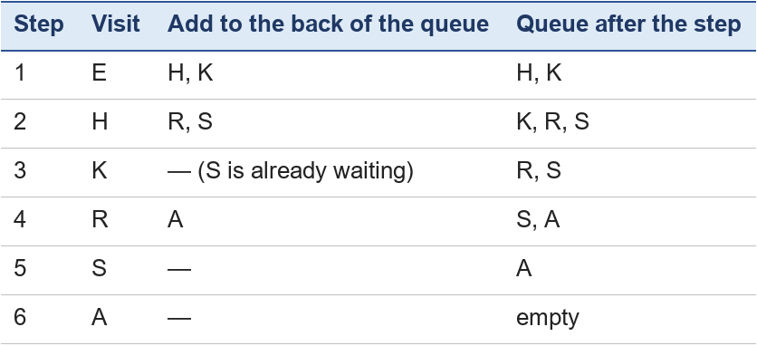
Visiting order: E, H, K, R, S, A. The rooms one step away (H, K) come before the rooms two steps away (R, S). Chapter 10 uses BFS and other search methods to plan a route to the Archive.

7. Activity: choose and trace
Part A — choose the structure. Which data structure fits best? (1) The order in which customers called a help line, to answer them fairly. (2) The browser's Back button. (3) The 30 seats in a classroom, numbered 0–29. (4) Which train stations are connected to which.
Part B — queue trace. Start with an empty queue. Do: enqueue Mei, enqueue Tom, dequeue, enqueue Lin, enqueue Ana, dequeue. Who is in the queue at the end, front first?
Part C — tree. Insert 65 into the tree of Figure 3. Where does it go?
Expected answers
- Part A: (1) queue — first come, first served; (2) stack — the last page you opened is the first one Back returns to; (3) array — fixed size, numbered positions; (4) graph — any station can link to several others.
- Part B: after enqueue Mei, Tom → [Mei, Tom]; dequeue removes Mei → [Tom]; enqueue Lin, Ana → [Tom, Lin, Ana]; dequeue removes Tom → [Lin, Ana].
- Part C: 65 > 50 → go right to 70; 65 < 70 → go left to 60; 65 > 60 → right of 60, which is empty. So 65 becomes the right child of 60.

Key points
- A data structure organises data so that the jobs a program needs are efficient.
- Arrays allow fast access by index; records group named fields about one thing; linked lists make insertion easy.
- Stacks are last in, first out; queues are first in, first out.
- Trees store hierarchies; binary search trees make searching fast by halving the choices.
- Graphs model connections; breadth-first search visits them layer by layer using a queue.

Chapter 5 — Software Engineering and Databases: From Problem to Program
Chapter lead: Eizel Mthana Conqueror 康哲 (Visual Design Lead) · Module: Software and Symbolic AI — "How Can Software Use Rules to Reach a Conclusion?" · Version: V2.0 working draft (2 November 2026) — discussed by the team on 4 November 2026

Abstract
Chapter 3 of this module showed how a short program makes a decision with IF–ELSE, and Chapter 9 will write the same library-loan decision as facts and IF–THEN rules. This chapter steps back and asks a more practical question: where does such a program come from, and where does it live? It follows a piece of software from the problem it is meant to solve to a working, tested and maintained program, using the five stages of the software life cycle — understand the problem, plan the steps, write the program, test it, and use and maintain it. A library management system is the running case study. The library-loan decision is written as an ordinary program, placed inside that system, tested with four cases, and then changed when the library adds a new policy. The chapter ends on the point that Chapter 12 picks up: when the decision logic is written inside the program, changing the policy means changing the code.

1. Introduction
Every day we use software that makes small decisions for us: a library catalogue tells us whether a book is available, a ticket app tells us whether a seat is free, a timetable app tells us which class is next. In Chapter 3 we looked inside one such decision — the umbrella reminder — and traced it line by line as a program with IF–ELSE. In Chapter 9 we will write a bigger decision — whether a library member may borrow a book — in a very different way, as facts and rules that a separate inference engine applies.
This chapter is about the ordinary-software side of that pair. It answers three questions that Chapter 3 left open: how is a program like these actually built, where does it sit inside a real system, and what happens when the library changes its rules? The answers prepare the comparison in Chapter 12, where the same decision written as code (this chapter) and written as rules (Chapter 9) are set side by side.

What you will be able to do
- C5.1 Describe the stages of building software — understand the problem, plan the steps, write the program, test it, maintain it — and say why maintenance is needed.
- C5.2 Give familiar examples of software that supports everyday decisions (module outcome ILO8).
- C5.3 Read the library-loan decision written as an ordinary program and point to where the decision logic lives.
- C5.4 Describe the steps of a small everyday program and write two test cases for it.

What you need before reading
Chapter 3: input, processing and output; the idea of an algorithm; reading a short IF–ELSE program. Nothing else is assumed.

2. Key terms
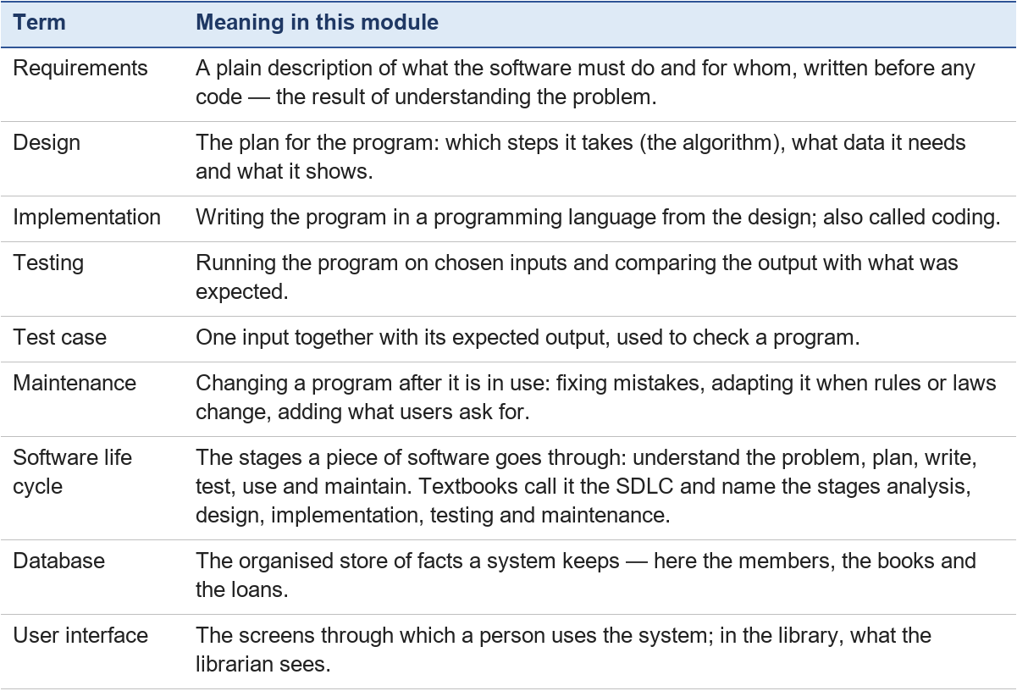

3. Software all around us
A piece of software exists because somebody had a problem and decided to solve it with a program. Three everyday examples make the point, and each one fits the input–processing–output pattern of Chapter 3:
- A library system. The problem: hundreds of members, thousands of books, and a loan desk that has to answer "can this member borrow this book?" many times a day without losing track of anything. The software keeps the catalogue, records loans and returns, and sends reminders for overdue books. Input: a member and a book; processing: the loan check; output: a decision on the screen and a new record in the database.
- A ticket-booking app. The problem: many people want the same seats at the same time. Input: a chosen seat and a payment; processing: is the seat still free, is the payment valid; output: a ticket or a refusal.
- A timetable app. The problem: a class schedule that changes every week. Input: today's date and the student's group; processing: look up the lessons; output: the list for today with rooms and times.
In each case the decision is small and clear, which is why ordinary program logic handles it well. The rest of this chapter follows the first example, the library system, from the problem to the program.

4. From problem to program: the software life cycle
Building software is not one step but a sequence of stages, and the sequence repeats for as long as the software is in use. Textbooks describe the sequence with slightly different lists: Forouzan (2018, Chapter 10) uses analysis, design, implementation and testing; Brookshear (2011, Sections 7.1–7.2) adds maintenance; the Atlassian and IBM web guides each list seven phases, with different names (planning, feasibility or analysis, design, implementation or coding, testing, deployment, maintenance). The lists differ in how finely they cut the work, not in what the work is. This module uses the five plain-language stages of the project plan and gives the textbook names in brackets (Figure 1).
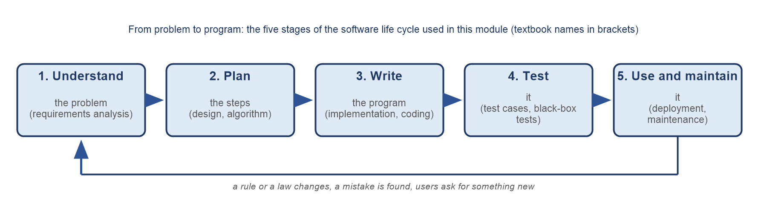
Figure 1. The five stages of the software life cycle used in this module, with the textbook names in brackets. The return arrow is the point of the diagram: software is never finished while it is in use.

4.1 Understand the problem (requirements analysis)
Before anything is written, somebody has to find out what the software must do and for whom. For the library this means talking to the librarians: What does the desk decide? On what information? What must be recorded? The result is a short list of requirements in plain words, for example: "The system must tell the librarian whether a member may borrow a chosen book, using the member's card, their overdue books and the book's availability, and must record the loan if it is approved." Getting this stage wrong is expensive, because every later stage builds on it.

4.2 Plan the steps (design, algorithm)
Next the requirements are turned into a plan: which data the program needs (card valid?, overdue books, book available?), which steps it takes, in which order, and what it shows at the end. The steps are the algorithm of Chapter 3 — an ordered list of unambiguous steps that produces a result and stops. For the loan check the plan is a chain of yes/no questions: the IF–ELSE of Chapter 3, extended with ELSE IF so that there can be more than two outcomes.

4.3 Write the program (implementation, coding)
The plan is written in a programming language so that a computer can execute it. In this chapter we write the steps in pseudocode — numbered lines close to plain English — because the language does not matter for the idea. Chapter 3 showed the same IF–ELSE idea in Python.

4.4 Test it (testing)
A program that runs is not yet a program that is right. Testing means choosing inputs, deciding in advance what the correct output is, running the program, and comparing. Each input with its expected output is a test case. Section 7 does this for the loan check.

4.5 Use and maintain it (deployment, maintenance)
Once the program is in daily use it still changes, for three reasons: a mistake is found that the tests missed; a rule or a law changes, so the program must change with it; or the users ask for something new. Sommerville (2016, Chapters 1–2) treats this as a normal part of a software process rather than an afterthought, and in long-lived systems maintenance takes more effort than the first version. The library gives an everyday example of the second reason: if the library decides that members may have at most five books on loan, the loan-check program is wrong until somebody changes it (Section 8).

5. Case study: a library management system
A library management system is a good first example of real software because every reader has stood at a loan desk. Three questions describe it.
- What it stores. Members (name, card number, whether the card is valid; how many books are overdue is worked out from the loans), books (title, copy number, whether the copy is available), and loans (which member has which book, and the due date). Together these are the system's database.
- What it does. Check out a book (the loan decision and a new loan record), return a book (close the loan and, if it is late, charge a fine), and remind members whose books are overdue.
- Who uses it. Librarians at the desk, members who search the catalogue, and an administrator who changes the rules — for example the loan period or the number of books a member may hold.
Figure 2 sketches the system as the librarian meets it: three screens on top, the loan-check program in the middle, and the database underneath. The check-out screen collects the member and the book, hands them to the program, and shows the decision; the program looks up the facts it needs in the database and records the loan if it is approved.
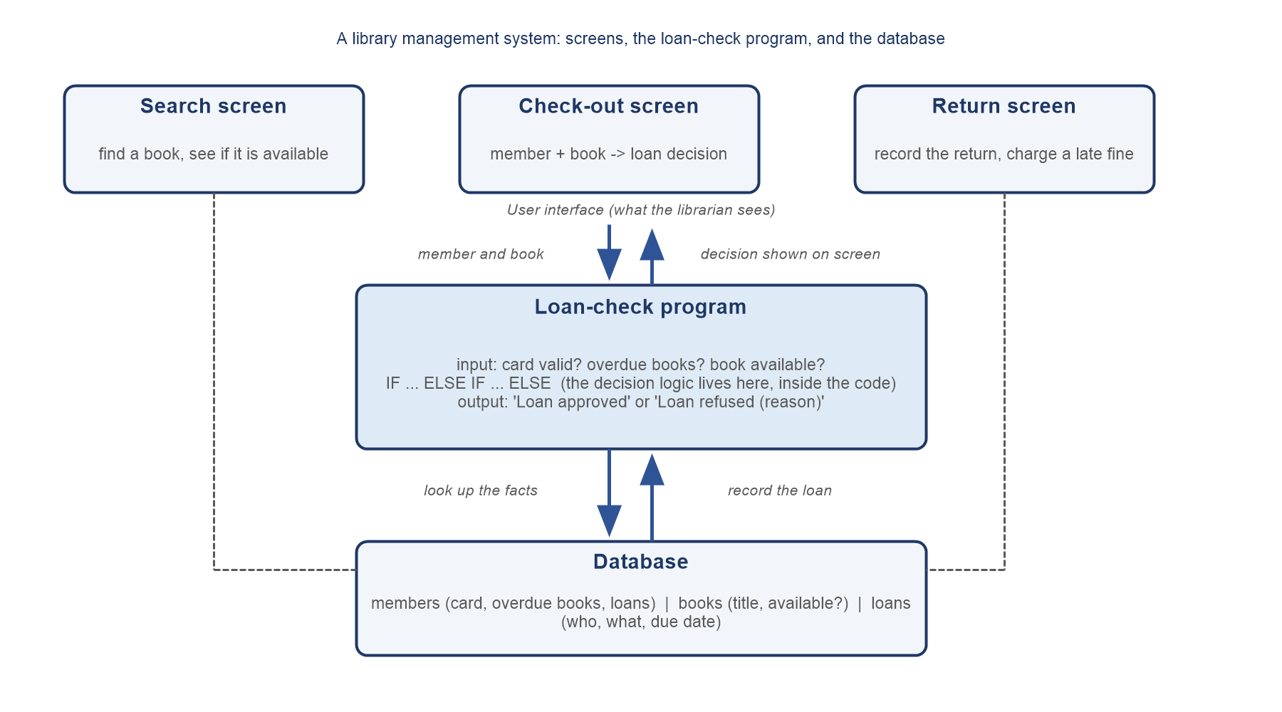
Figure 2. The library management system: screens (user interface), the loan-check program, and the database. The decision logic lives inside the program box. Chapter 12 adds a separate rules box to this same picture.

6. The loan decision as an ordinary program
Here is the library-loan decision written as an ordinary program, placed inside the check-out screen. The three inputs no longer come from a person typing; the screen reads them from the database when the librarian selects the member and the book. The output goes back to the screen. The listing is written in pseudocode (Forouzan style: if (condition) … else …, with indentation).
1 read member_has_card, overdue_books, book_available // from the database
2 if (member_has_card = false)
3 output "Loan refused (no valid card)"
4 else if (overdue_books > 0)
5 output "Loan refused (overdue books)"
6 else if (book_available = false)
7 output "Loan refused (book not available)"
8 else
9 output "Loan approved" // and record the loan

Where does the decision live? Entirely in lines 2 to 9. The library's policy — a member may borrow when the card is valid, no book is overdue and the copy is available — is not stored anywhere as a policy. It is spread across three conditions, in the order the programmer chose, inside the code. To find out what the policy is, you have to read the program; to change the policy, you have to change the program. Notice also that the program always produces an output: the final else covers every case the earlier conditions did not catch. That is a convenience of ordinary code which the rule-based version in Chapter 9 does not have — there, when no rule fires, the system simply has no conclusion.

7. Testing the program
Testing the loan check means choosing member cases, writing down the expected output before running, and comparing. We use three library members — Mei (valid card, nothing overdue), Tom (one overdue book) and Lin (no valid card) — and add one more case so that every branch of the program is exercised at least once (Table 2).
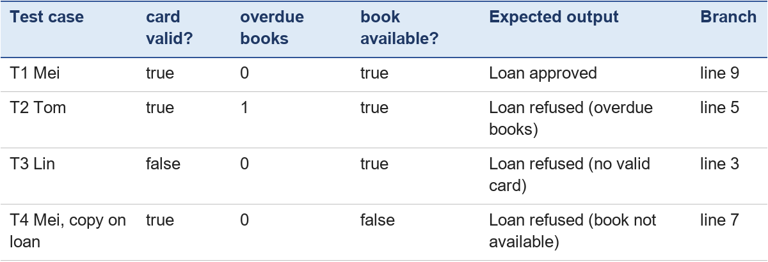
Table 2. Test table for the loan-check program: four cases that between them reach every output line.
The expected outputs come from the requirements, not from the code — this is the idea of black-box testing (Forouzan, 2018, Chapter 10): the tester judges only inputs and outputs, and the expected output is fixed before the program runs, so that the program cannot "tell" the tester what the right answer is. A test passes when the actual output equals the expected one. Two habits make a test table useful: every branch of the program should be reached by at least one case (choosing cases by looking at the branches is white-box testing, Section C), and the cases should be kept, because they will be run again after every change (Section 8).

8. Changing the policy: "at most five books on loan"
Suppose the library decides that a member may have at most five books on loan at the same time. The decision in Section 6 knows nothing about this, so the system will keep approving a sixth loan until a programmer changes it. The change runs through the whole life cycle in miniature:
- Understand: the new requirement is written down — "a loan is refused when the member already has five books on loan".
- Plan: the program needs one more input, the number of books the member currently has on loan, and one more condition in the chain.
- Write: the programmer edits the code — line 1 reads the new value and a new else-if is inserted (below).
- Test: all four old cases are run again to make sure nothing else broke, plus two new ones: a member with four books (approved) and a member with five (refused).
- Use: the new version replaces the old one at the loan desk.
1 read member_has_card, overdue_books, book_available, books_on_loan
2 if (member_has_card = false)
3 output "Loan refused (no valid card)"
4 else if (overdue_books > 0)
5 output "Loan refused (overdue books)"
6 else if (books_on_loan >= 5) // new condition
7 output "Loan refused (loan limit reached)"
8 else if (book_available = false)
9 output "Loan refused (book not available)"
10 else
11 output "Loan approved"

Three things are worth noticing. First, a one-sentence change of policy needed a programmer, an edit in two places, and a full re-test. Second, the order of the conditions is a design decision: putting the loan-limit check before the availability check changes which reason a member sees when two reasons apply at once. Third, nobody can see the policy without reading the code. This is the "change the policy, change the code" side of the story. Chapter 9 (Sections 5–6) shows the opposite picture — the loan policy written as rules R1 and R2 that a person can read, with the engine untouched when a rule is edited — and Chapter 12 compares the two directly, with their strengths and their limitations.

9. Activity 5.1 — Describe the steps of a small everyday program
The library needs a second small program for the return desk: when a book is returned, the system records the return and, if the book is late, charges a fine. Write the following, using only this chapter:
1. Requirements — two or three sentences saying what the program must do and with what information.
2. An algorithm of five to nine steps, each step a single action, in the order the program performs them. The late-fine decision should be an IF–ELSE.
3. Two test cases in the form of Table 2: one book returned on time and one returned late, each with its expected output written before you "run" the steps by hand.
Self-check before you look at the answer: Is every step one action? Is the fine decision written as IF … ELSE? Do you have one on-time case and one late case? Did you write each expected output before tracing?

10. Answers and expected outcomes
Any wording is acceptable if it has the same parts. A sample answer:
Requirements. When a librarian records a returned book, the program must close the member's loan for that book and mark the copy as available. If the return date is after the due date, the program must calculate a fine of one yuan for each day late and show it; otherwise it shows that no fine is due.
Algorithm.
1 read the book copy and today's date // return screen
2 look up the loan for this copy: member, due_date // database
3 days_late = today - due_date
4 if (days_late > 0)
5 fine = days_late * 1
6 output "Late by", days_late, "days. Fine:", fine, "yuan"
7 else
8 output "Returned on time. No fine."
9 mark the copy available and close the loan // write to database

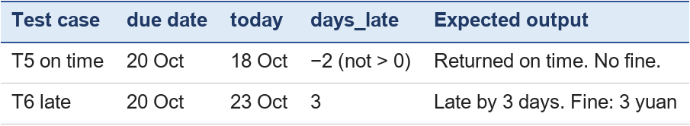
Table 3. Two test cases for the return program, with the expected output decided before tracing.
What to check in a learner's answer: the requirements name the inputs (copy, dates) and both outcomes (fine or no fine); the algorithm has one action per step and reads its facts before deciding; the fine decision is a single IF–ELSE on days_late; the two test cases cover both branches; and the expected outputs were written before the trace. A common mistake is to put the database update inside only one branch, so that a late return is never closed — a good example of why Section 7 insists on a case for every branch.

Software engineering and databases in more depth (PPT 2024 chap3, slide 2)
Sections 1–10 followed one small program from problem to tested code. Real software is built by teams and keeps its facts in databases. This part covers the six topics PPT 2024 lists for software engineering and databases, using the same library.

A. Software development process models
Section 4 described the five stages that all software goes through. A process model is a plan for how a team moves through those stages. Three common models (Sommerville, 2016, Ch. 2–3):
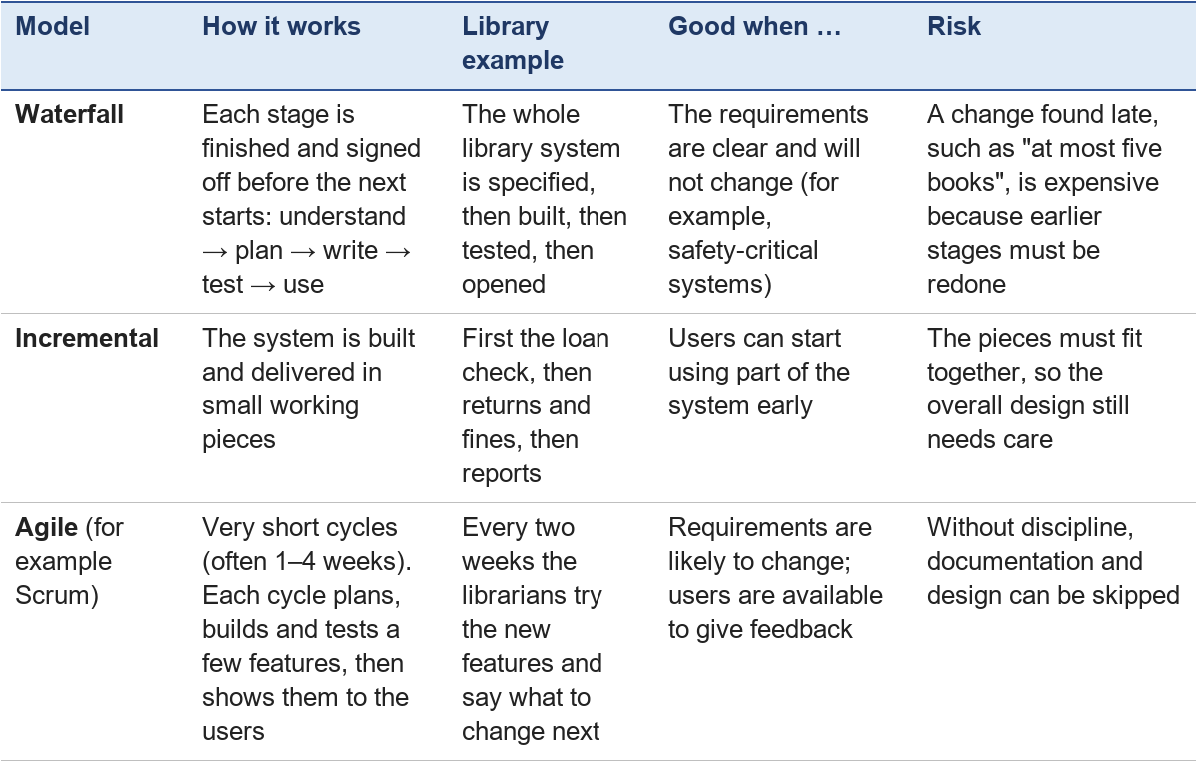
Section 8 ("at most five books on loan") is a small example of why many teams prefer incremental or agile models: the policy changed after the program was in use, and the team simply ran one more cycle.

B. Modularity
Modularity means dividing a large program into smaller parts called modules, each with one clear job and a clear way to talk to the others (its interface). The library system can be split like this:
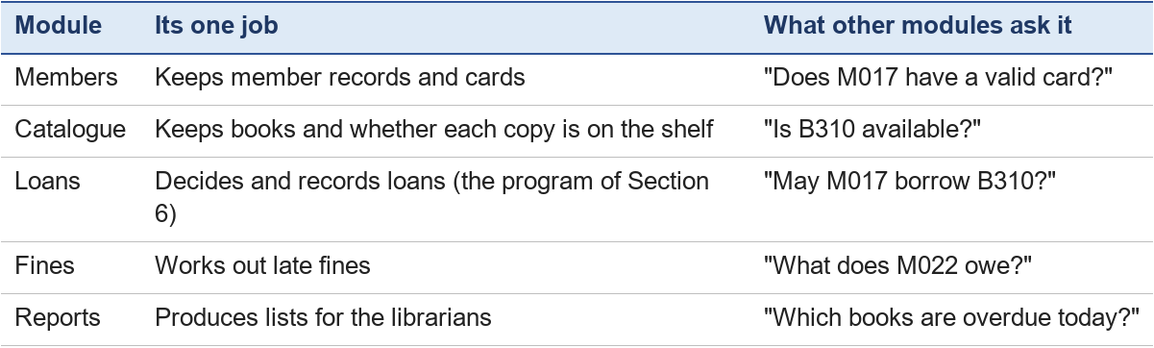
Why it helps:
- Easier to understand: a reader can study the Loans module without reading the whole system.
- Easier to test: each module can be tested on its own (Section C).
- Easier to change: if the fine becomes 2 yuan a day, only the Fines module changes.
- Easier to share work: different team members can build different modules at the same time.
Two words describe good modules. High cohesion: everything inside a module belongs to its one job. Low coupling: modules depend on each other only through their interfaces, so a change inside one does not break the others.

C. Quality assurance
Testing (Section 7) checks a program after it is written. Quality assurance (QA) is wider: it is every activity that helps make sure the software does what it should, to an agreed standard, from the first stage to the last.
QA activities include:
1. Standards: agreed rules for writing requirements and code (names, layout, comments), so that everyone's work looks the same.
2. Reviews and inspections: someone who did not write the work reads it and looks for mistakes. Our team's cross-review of chapters is the same idea.
3. Testing at several levels:
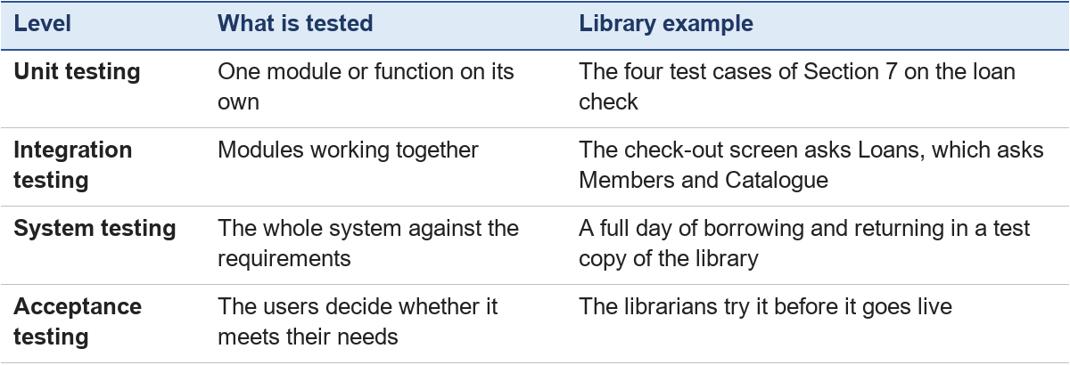
4. Regression testing: after every change, the old tests are run again to make sure nothing that used to work is now broken (Section 8 did this).
Two ways to choose tests: black-box testing looks only at inputs and expected outputs, without reading the code (Section 7); white-box testing uses the code to make sure every line and every branch is run at least once. The four test cases of Section 7 happen to satisfy both, because each reaches a different branch.
Quality has several sides, not only "no bugs": correctness (right answers), reliability (keeps working), usability (easy for librarians), efficiency (fast enough) and maintainability (easy to change later).

D. Database models
Early programs each kept their own data files. The same member could be stored in three files, and if her phone number changed in one file but not the others, the data disagreed. A database solves this: one organised store of data, shared by all the programs, managed by a database management system (DBMS) that controls who may read or change it (Forouzan, 2018, Ch. 14).
A database model is the way the data is organised inside the database:
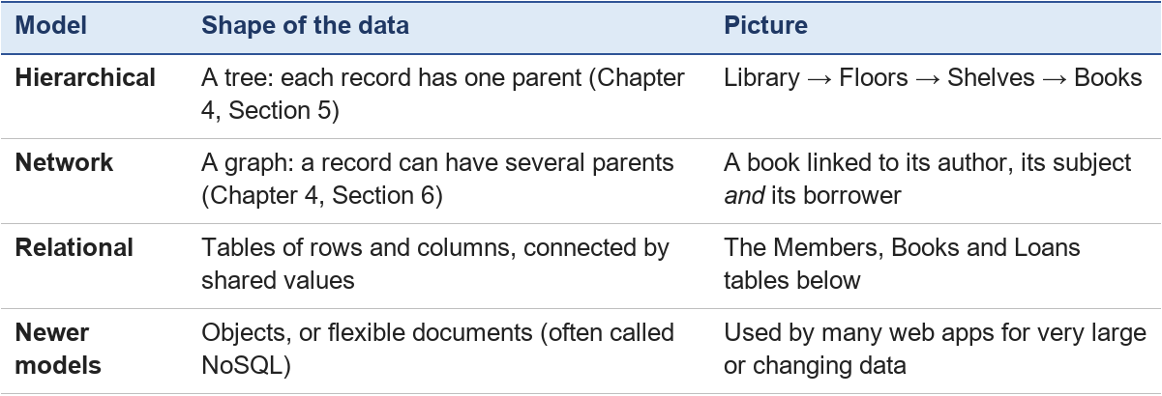
Today the relational model is the most widely used, and it is the one to learn first.

E. Relational databases
In a relational database, all data is stored in tables (also called relations). Each row is one record (Chapter 4, Section 2) and each column is one field. Here is a small library database:
Members
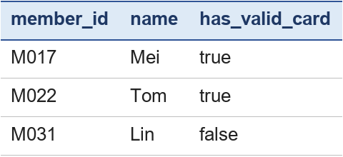
Books
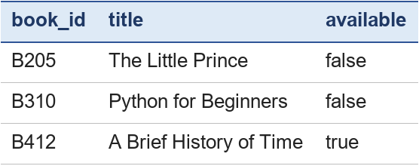
Loans
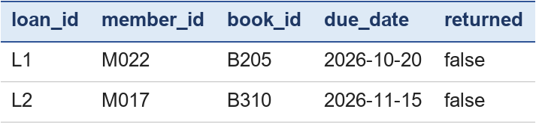
Two kinds of column connect the tables:
- A primary key identifies each row uniquely: member_id in Members, book_id in Books, loan_id in Loans.
- A foreign key is a column that refers to the primary key of another table: in Loans, member_id points to a member and book_id points to a book.
This is how the loan check of Section 6 gets its inputs. overdue_books for Tom is not stored anywhere as a number; the system counts his Loans rows that are not returned and whose due date has passed. On 3 November 2026, Tom has one (L1), so his loan is refused — exactly test case T2 in Section 7.

F. Querying the database with SQL
SQL (Structured Query Language) is the language used to ask relational databases questions and to change their data. SQL is a declarative language: you state what you want, and the database works out how to find it. It is based on the relational model, which rests on predicate logic (Codd, 1970; Forouzan, 2018, Ch. 14).
Find all books on the shelf:
SELECT title FROM Books WHERE available = TRUE;

Result: A Brief History of Time. You did not write a loop that checks every row — you stated a condition, and the database's query engine treats available = TRUE as a logical condition (a predicate, Chapter 7) and matches it against the stored facts.
Count Tom's overdue books on 3 November 2026:
SELECT COUNT(*) FROM Loans
WHERE member_id = 'M022' AND returned = FALSE AND due_date < '2026-11-03';

Result: 1. The AND works exactly like the AND in Chapter 3's conditions and Chapter 9's rules: all three parts must be true.
Join two tables — which members have an overdue book?
SELECT Members.name
FROM Members JOIN Loans ON Members.member_id = Loans.member_id
WHERE Loans.returned = FALSE AND Loans.due_date < '2026-11-03';

Result: Tom. The JOIN … ON uses the foreign key to match each loan with its member.
Record a new loan and mark the book as out:
INSERT INTO Loans VALUES ('L3', 'M017', 'B412', '2026-11-17', FALSE);
UPDATE Books SET available = FALSE WHERE book_id = 'B412';

The link to Part B of the module is direct: a WHERE clause is a condition over facts, much like the IF part of an IF-THEN rule. The difference is that SQL finds the facts that match, while a rule-based system adds new conclusions when its conditions match (Chapter 9).
Practice 5.2 — write the query. (1) List the titles of all books that are not available. (2) Write the query that finds the names of members whose card is not valid.
Expected answers (using the original tables, before the INSERT and UPDATE above). (1) SELECT title FROM Books WHERE available = FALSE; → The Little Prince, Python for Beginners. (2) SELECT name FROM Members WHERE has_valid_card = FALSE; → Lin.

11. Summary
- Software exists to solve a problem. Building it follows five stages — understand, plan, write, test, use and maintain — and the stages repeat for as long as the software is in use.
- Textbooks and web guides cut the same work into four, five or seven phases with different names; the work itself is the same.
- In a real system the program is one part among several: screens for the user, a database for the facts, and the program in between. The library-loan decision lives inside the check-out part of the library system.
- A test case is an input with its expected output, decided before running. A good test table reaches every branch and is kept for re-use after every change.
- Process models (waterfall, incremental, agile) organise how a team moves through the stages; modularity splits a system into modules with one job each; quality assurance covers standards, reviews and testing at every level.
- A relational database stores facts in tables linked by primary and foreign keys; SQL asks for the facts that match a condition, a declarative idea that leads into Part B.
- When the decision logic is written inside the code, the policy can only be read and changed by reading and changing the code. Chapter 12 compares this with the rules of Chapter 9.

Chapter 6 — Introduction to Symbolic AI
Chapter lead: Gunawan Nicolas Benedictus · Module: Software and Symbolic AI · Version: V2.0 working draft (2 November 2026) — restructured and AI-assisted draft (3 November 2026); discussed by the team on 4 November 2026

Learning outcomes
After this chapter, you should be able to:
- Explain what symbolic AI (GOFAI) is, using the words symbol, explicit rule and reasoning.
- Read an IF-THEN rule, say when it fires, and explain why "may have" and missing facts matter.
- Name the three benefits and four limitations of symbolic AI listed in PPT 2024, and explain each in one sentence.
- Describe how symbolic rules are used in assistants, medical diagnosis, autonomous cars and computer vision.

1. What symbolic AI is (GOFAI)
Imagine teaching a new library assistant. You could show them thousands of past loans and hope they spot the pattern. Or you could hand them the library's rule book: a member may borrow if the card is valid and nothing is overdue. Symbolic AI takes the second path.
Symbolic AI is the part of AI that represents knowledge with symbols — readable names such as valid_card or fever — and reasons with explicit rules and logic written by people (PPT 2024, chap4 slide 3). It is also called GOFAI, "Good Old-Fashioned AI" — a name coined by the philosopher John Haugeland (1985) — because it was the main approach to AI from the 1950s to the 1980s, before machine learning became popular.
Three ideas sit at its centre:
1. Symbols stand for things. Book(B412) stands for "B412 is a book"; available(B412) for "B412 is on the shelf".
2. Knowledge is written down explicitly as facts and rules, so a person can read it.
3. Reasoning is manipulating symbols with rules. The system combines facts and rules to reach new conclusions, step by step, the way you might solve a logic puzzle.
Newell and Simon, two founders of AI, proposed that a system which manipulates symbols in this way has what it needs for intelligent action — their physical symbol system hypothesis (Newell & Simon, 1976). Not everyone agrees, but the idea shaped decades of AI research.
Chapter 1, Sections 3–4, introduced facts, rules, the knowledge base and the inference engine. The rest of Part B develops each idea: logic (Chapter 7), ways of representing knowledge (Chapter 8), rule-based and expert systems (Chapter 9), planning and search (Chapter 10) and language (Chapter 11).

2. Rules in action: the medical example
PPT 2024 (chap4 slide 4) gives this rule:
IF the patient has a fever AND the patient has a cough AND the patient has difficulty breathing THEN the patient may have pneumonia.
Read it piece by piece:
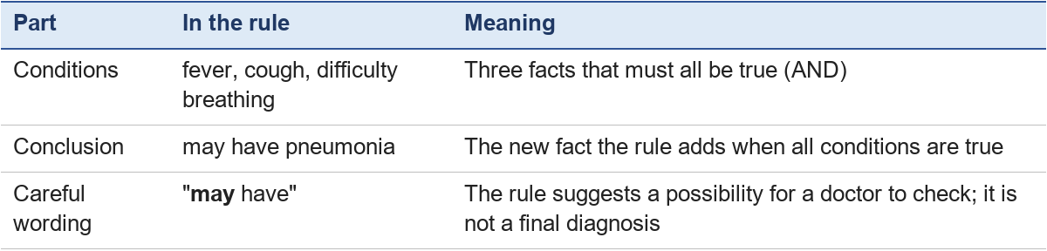
Worked example. Three patients arrive. The system knows these facts:
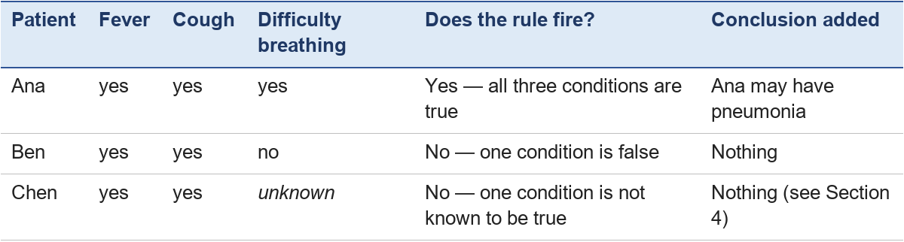
Two lessons for beginners:
- The system can explain itself. For Ana it can say exactly why: "the pneumonia rule fired because fever, cough and difficulty breathing are all true". This is the interpretability benefit in PPT 2024 (slide 6).
- No conclusion is not the same as "no pneumonia". For Chen, the rule simply could not fire. A safe system should ask for the missing fact rather than assume it is false — the trap explained in Section 4.

3. Strengths of Explicit Rules
PPT 2024 (slide 6) names three benefits of symbolic AI. All three come from one fact: the knowledge is written down as rules that people can read.
- Interpretability — you can see why. Every decision can be traced back to the exact facts and rules that produced it. Example: the system can say "Ana may have pneumonia because the pneumonia rule fired: fever, cough and difficulty breathing are all true" (Section 2). Many machine-learning models cannot give a reason like this; people call them "black boxes".
- Knowledge representation — knowledge is stored in a readable form. Facts and rules use symbols that people understand, such as valid_card and overdue_books, so an expert can check them. Example: a librarian can read rules R1 and R2 (Chapter 9) and confirm that they match the library's policy.
- Flexibility — easy to change. The rules are kept apart from the engine that applies them, so a rule can be added or changed without rewriting the program. Example: the library's new "at most five books" policy is one new rule (Chapter 9), instead of a change to the code (Chapter 5, Section 8).
A fourth advantage is often mentioned: predictability. Given the same facts and rules, the system always reaches the same conclusion.

4. Limitations: Handling Imperfect Real-World Information
Despite their clarity, explicit rules and symbolic systems possess significant limitations when confronted with messy, real-world data. They can become unreliable when information is missing, conflicting, or outdated. Expert systems proved hard to build and maintain, partly because their reasoning broke down in the face of uncertainty and partly because they could not learn from experience (Russell & Norvig, 2021, p. 42).
- Missing information: If a required fact is absent from the input data, a rule may fail to trigger entirely, leading to incomplete or stalled decision-making.
- Conflicting information: If two rules lead to contradictory conclusions from overlapping data, the system can produce conflicting results unless it has a way to resolve the conflict, for example by giving some rules priority.
- Outdated information: Rules that were accurate last year may become obsolete due to changing regulations or business policies, requiring manual updates by domain experts.

The trap of missing information ("Missing information does not prove the opposite")
In classical logic and rule-based systems, a critical pitfall arises when information is absent. If a database lacks a record of a customer's allergy, the system cannot logically conclude that the customer is safe from that allergen. In formal reasoning, lack of evidence is not evidence of absence. Some rule engines treat any fact they cannot find as false; this is called the closed-world assumption (Russell & Norvig, 2021, pp. 315, 356). It is safe only when the data is known to be complete — for example, a list of everyone who has paid. When the data may be incomplete, assuming that a missing fact is false can lead to serious mistakes, especially in safety-critical domains such as medicine.

5. Where symbolic AI is used
PPT 2024 (chap4 slide 5) lists four application areas. In most modern products, symbolic rules work together with machine learning rather than alone:
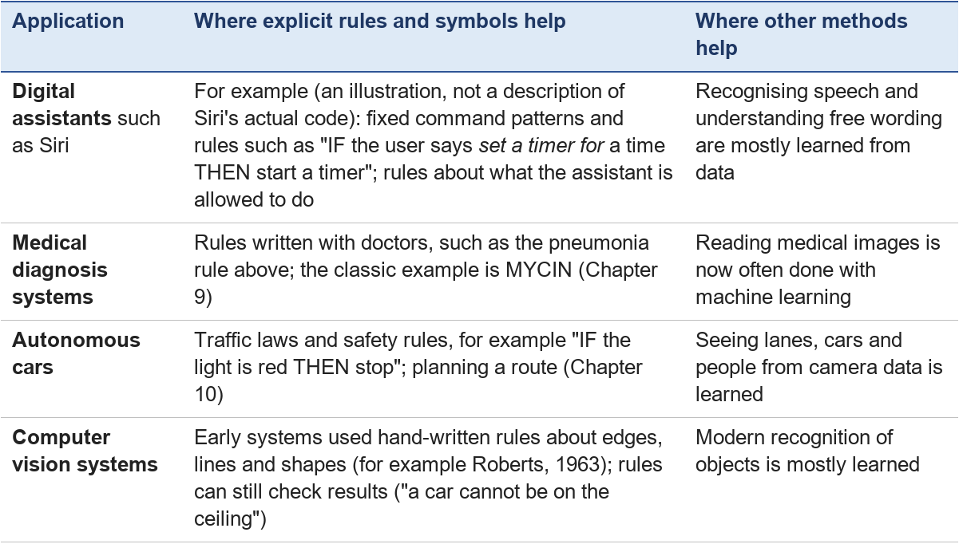
Other uses appear later in this module: business rule engines such as Drools (Chapter 9), route planning and games (Chapter 10), and grammar-based language processing (Chapter 11).
Benefits and limitations in one view. PPT 2024 lists three benefits — interpretability, knowledge representation and flexibility (rules can be added or changed without rewriting the whole program) — and four limitations — incomplete knowledge, scalability (thousands of rules become hard to manage), difficulty with uncertain or ambiguous information, and limited ability to learn and adapt (slides 6–7). Section 3 explains the three benefits with library examples; Section 4 explains incomplete and uncertain information; scalability and the limited ability to learn are discussed in Chapter 9, Section 10.

6. Activity: will the rule fire?
Use the pneumonia rule of Section 2.
1. Dina has a fever, a cough and difficulty breathing, and she also has a headache. Does the rule fire? What does the system add?
2. Eli has difficulty breathing and a cough, but his temperature has not been measured. What should a well-designed system do?
3. A hospital learns that the rule misses many patients who have no fever. Which benefit from PPT slide 6 makes this easy to fix, and how?
4. Is a spam filter that learned from thousands of example emails symbolic AI? Why or why not?
Expected answers
1. Yes. All three conditions are true; the extra fact (headache) does not matter to this rule. The system adds "Dina may have pneumonia".
2. It should not assume "no fever". It should ask for the missing fact (measure the temperature) before concluding, because missing information does not prove the opposite (Section 4).
3. Flexibility (and interpretability): experts can read the rule, see why it misses those patients, and change or add a rule — for example one without the fever condition — without rebuilding the system.
4. No, not in the sense of this chapter. It learned statistical patterns from data instead of following rules written explicitly by people. It is machine learning (Chapter 1, Section 2). Chapter 12 compares the two approaches with a hands-on activity.

Chapter 7 — Logic and Reasoning
Chapter lead (proposed): Frederic Chandra · Module: Software and Symbolic AI · Version: V2.0 working draft (3 November 2026) — AI-assisted draft; discussed by the team on 4 November 2026

Learning outcomes
After this chapter, you should be able to:
- Decide whether a sentence is a proposition, and work out AND, OR, NOT, implication and biconditional with a truth table.
- Use De Morgan's laws and double negation to rewrite a condition.
- Apply modus ponens and modus tollens to reach a conclusion.
- Read and write simple statements with predicates and the quantifiers ∀ ("for all") and ∃ ("there exists").
- Use universal modus ponens to draw a conclusion about one object from a general rule.

1. Propositions and Boolean operators
The umbrella program of Chapter 3 asked one question: is it raining? The answer was true or false. Logic is the study of sentences like that and of how to combine them correctly.
A proposition is a sentence that is either true or false, but not both (PPT 2024, slide 8). Examples from the slides:
- "The sky is blue."
- "It is raining."
- "2 + 2 = 4."
Not propositions: "Close the door!" (a command), "Is it raining?" (a question), "x > 3" (we cannot say true or false until we know x — Section 6 deals with this).
We give propositions short letters. Let p = "It is raining" and q = "I have an umbrella". Three Boolean operators combine them (slide 9):
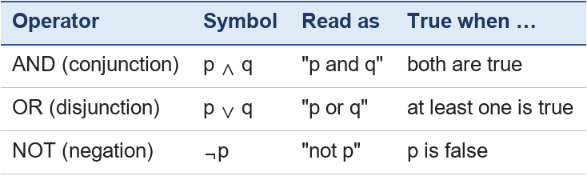
A truth table lists every possible combination:
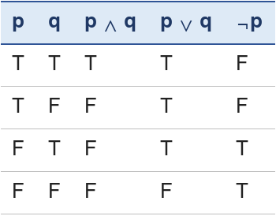
Note that logical OR is inclusive: "p ∨ q" is true when both are true. The library's loan rule from Chapter 5 is an AND of three propositions: valid card ∧ no overdue books ∧ book available.

2. Logical equivalences: De Morgan and double negation
Two expressions are logically equivalent (≡) when they have the same truth value in every row of the truth table (slide 10). Equivalences let us rewrite a condition into a simpler or clearer form.
De Morgan's laws:
- ¬(p ∧ q) ≡ ¬p ∨ ¬q — "not (p and q)" means "not p, or not q".
- ¬(p ∨ q) ≡ ¬p ∧ ¬q — "not (p or q)" means "not p, and not q".
Double negation: ¬(¬p) ≡ p — "it is not true that it is not raining" just means "it is raining".
Worked example: the library. A loan is approved when the card is valid (c) and there are no overdue books (n): c ∧ n. When is it refused? ¬(c ∧ n), which by De Morgan is ¬c ∨ ¬n: the card is not valid or there are overdue books. This is exactly how the refusal messages in Chapter 5 work — either reason alone is enough.
Check with a truth table (the two right-hand columns are equal in every row):
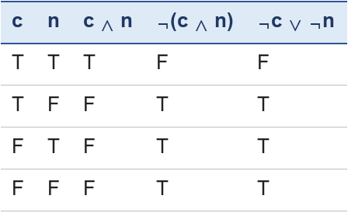

3. Implication and biconditional
Implication p → q is read "if p, then q" (slide 11). p is the antecedent (premise) and q is the consequent (conclusion). It is the logical form of an IF-THEN rule (Chapter 9).
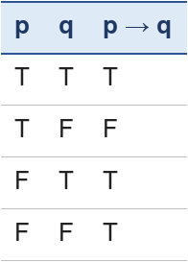
The only row that makes p → q false is the one where the promise is broken: p is true but q is false. Example: "If it rains (p), the match is cancelled (q)." If it does not rain, the rule has not been broken, whatever happens to the match — so the last two rows are true. Beginners often find this surprising; it helps to think of p → q as a promise that is only broken when p happens and q does not.
Biconditional p ↔ q is read "p if and only if q". It is true when p and q have the same truth value:
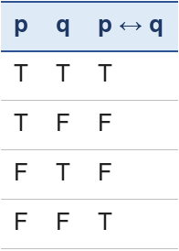
Example: "The light is on ↔ the switch is up" — when one is true, so is the other; when one is false, so is the other.

4. Inference rules: modus ponens and modus tollens
An inference rule lets us derive a new true proposition from ones we already accept (slide 12).
Modus ponens ("the way of affirming"):
- p → q If it is raining, the ground is wet.
- p It is raining.
- therefore q The ground is wet.
Modus tollens ("the way of denying"):
- p → q If it is raining, the ground is wet.
- ¬q The ground is not wet.
- therefore ¬p It is not raining.
Two common mistakes (they look similar but are not valid):
- From p → q and q, concluding p. The ground is wet, so it is raining? Not necessarily — a sprinkler may have been on.
- From p → q and ¬p, concluding ¬q. It is not raining, so the ground is not wet? Again, not necessarily.
Forward chaining in Chapter 9 is modus ponens used again and again: when a rule's IF part is known to be true, its THEN part is added as a new fact.

5. Propositional logic in AI
PPT 2024 (slide 13) names two roles for propositional logic in AI:
- Knowledge representation: facts and rules are written as propositions and implications, for example valid_card ∧ no_overdue → may_borrow. A computer can store and read these precisely, with no ambiguity.
- Logical inference: a program applies inference rules such as modus ponens automatically to reach new conclusions. This is what the inference engine of Chapter 9 does.
Propositional logic has a limit: each proposition is one fixed statement. To say "every member with a valid card may borrow", we would need a separate proposition for every member — Mei, Tom, Lin and thousands more. Predicate logic solves this.

6. Predicate logic: predicates and quantifiers
A predicate is a statement with a variable that becomes true or false once the variable is given a value (slide 14). Example from the slides: Even(x) — "x is even". Even(4) is true; Even(7) is false. A predicate can have more than one variable: Borrowed(m, b) — "member m borrowed book b".
Quantifiers say how many objects a statement is about:
- The universal quantifier ∀ ("for all") says the statement is true for every object in the domain. Slide example: ∀x (Cat(x) → Mammal(x)) — "for every x, if x is a cat then x is a mammal", or simply "all cats are mammals".
- The existential quantifier ∃ ("there exists") says it is true for at least one object. Slide example: ∃x (Prime(x) ∧ x < 10) — "there is at least one prime number smaller than 10" (true: 2, 3, 5 and 7).
A useful pattern: ∀ usually goes with → ("all cats are mammals"), and ∃ usually goes with ∧ ("some number is prime and smaller than 10").
Logical connectives work inside predicate logic just as in Section 1 (slide 16): Even(x) ∧ Prime(x); Positive(x) ∨ Negative(x); Adult(x) → CanVote(x); ¬Married(x).

7. Formalising natural-language sentences
To formalise a sentence is to write it precisely with predicates and quantifiers. PPT 2024 (slide 15) gives four steps. Here they are for "Some birds can fly":
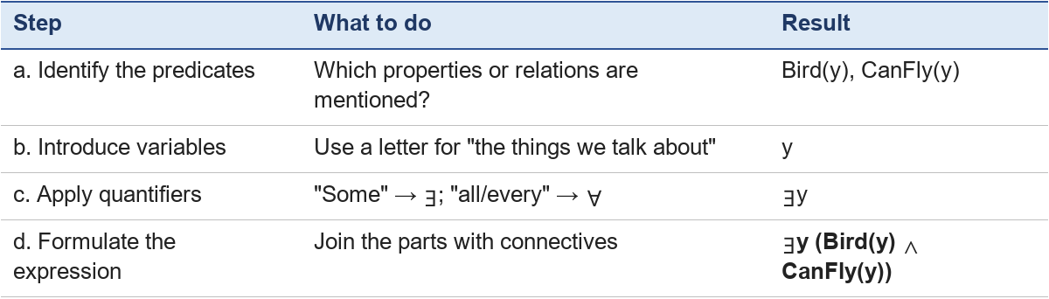
More examples (slide 19, plus library ones):
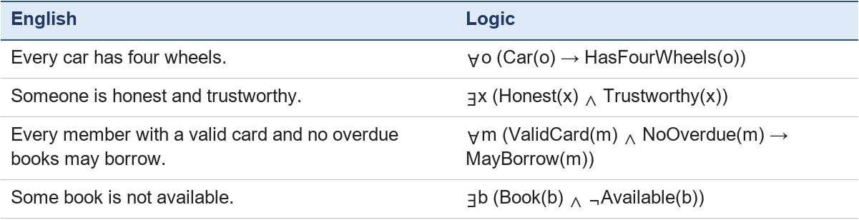

8. Rules of inference in predicate logic
The rules of Section 4 extend to statements with quantifiers (slides 17–18, 20).
Universal instantiation: from ∀x (P(x) → Q(x)) we may write P(a) → Q(a) for any particular object a. What is true for all is true for each one.
Universal modus ponens: from ∀x (P(x) → Q(x)) and P(a), infer Q(a).
Worked example — the library.
1. ∀m (ValidCard(m) ∧ NoOverdue(m) → MayBorrow(m)) — the library's rule.
2. ValidCard(Mei) ∧ NoOverdue(Mei) — facts about Mei.
3. By universal instantiation, ValidCard(Mei) ∧ NoOverdue(Mei) → MayBorrow(Mei).
4. By modus ponens on 2 and 3: MayBorrow(Mei).
Universal modus tollens: from ∀x (P(x) → Q(x)) and ¬Q(a), infer ¬P(a). All cats are mammals; Tweety is not a mammal; so Tweety is not a cat.
Existential instantiation: from ∃x P(x), we may give the object a name, P(c), where c is a new name not used anywhere else. There is a book that is not available; call it c.
Existential generalisation: from P(c) for a particular c, infer ∃x P(x). B205 is a book and is not available — Book(B205) ∧ ¬Available(B205) — so some book is not available: ∃b (Book(b) ∧ ¬Available(b)).
Universal generalisation: from P(a), infer ∀x P(x) — but only if a was an arbitrary object, one about which we assumed nothing special.
Slide 18 asks: "Do you see anything strange?" Two rules look dangerous at first sight. Universal generalisation seems to say "Mei may borrow, so everyone may borrow" — that would be wrong. It is valid only when a stands for any object at all, not a particular one we know facts about. Existential instantiation seems to say "some book is unavailable, so this book is" — it is valid only because c is a brand-new name that we do not identify with any known book.

9. Activity: reason it out
1. Which are propositions? (a) "Beijing is in China." (b) "Please sit down." (c) "y + 1 = 5."
2. Complete: if p is true and q is false, what are p ∧ q, p ∨ q, p → q and p ↔ q?
3. Use De Morgan to rewrite "It is not true that the shop is open and has bread."
4. "If a book is overdue, the member pays a fine. Tom paid no fine." What can you conclude, and which rule did you use?
5. Formalise: "All students in the module read Chapter 1." Use Student(x) and ReadCh1(x).
6. From ∀x (Bird(x) → HasFeathers(x)) and Bird(Tweety), what follows, and by which rule?
Expected answers
1. (a) yes — it is true; (b) no — a command; (c) no — it depends on y (it becomes a proposition once y has a value).
2. p ∧ q = F; p ∨ q = T; p → q = F; p ↔ q = F.
3. "The shop is not open or it has no bread" (¬o ∨ ¬b).
4. Tom's book was not overdue (assuming the rule is always applied). Modus tollens: p → q, ¬q, therefore ¬p.
5. ∀x (Student(x) → ReadCh1(x)).
6. HasFeathers(Tweety), by universal modus ponens (universal instantiation followed by modus ponens).

Key points
- A proposition is true or false; AND, OR and NOT combine propositions, and truth tables show every case.
- De Morgan's laws and double negation rewrite conditions without changing their meaning.
- p → q is false only when p is true and q is false; p ↔ q is true when both sides agree.
- Modus ponens and modus tollens are valid; "affirming the consequent" and "denying the antecedent" are not.
- Predicate logic adds predicates and the quantifiers ∀ and ∃, so one rule can cover every object; universal modus ponens applies such a rule to one case — the basis of rule-based reasoning in Chapter 9.

Chapter 8 — Knowledge Representation
Chapter lead (proposed): Louis Alexander Dalim · Module: Software and Symbolic AI · Version: V2.0 working draft (3 November 2026) — AI-assisted draft; discussed by the team on 4 November 2026

Learning outcomes
After this chapter, you should be able to:
- Explain what knowledge representation is and why an AI system needs it.
- Represent the same library knowledge with logic, a semantic network, a frame and a rule.
- Use inheritance in a semantic network to answer a question that is not stored directly.
- Describe a script and an ontology, and name four application areas.

1. What knowledge representation is
A new library assistant knows many things without being told each time: a book is something you can borrow, a DVD is too, a borrowed book is not on the shelf, and borrowing follows the same steps every time. A computer knows none of this unless we write it down in a form it can use.
Knowledge representation (KR) is the process of structuring information so that a computer program can use it to solve problems, reason or make decisions (PPT 2024, slide 21). It answers the question: in what form should we store what the system knows?
A good representation lets the system:
- store facts and relationships clearly;
- reason — work out new facts that were not stored directly;
- explain its answers in terms people understand;
- grow — accept new knowledge without being rebuilt.
There is no single best form. This chapter shows five forms from PPT 2024, all describing the same small library world, so you can compare them.

2. Logic-based representation
The logic of Chapter 7 is itself a representation language (slide 22).
Propositional logic stores whole statements: let P = "It is raining"; then "It is not raining" is ¬P.
First-order (predicate) logic adds objects, predicates and quantifiers, so it can say much more. The slide's example: "All humans are mortal" is ∀x (Human(x) → Mortal(x)).
For the library:
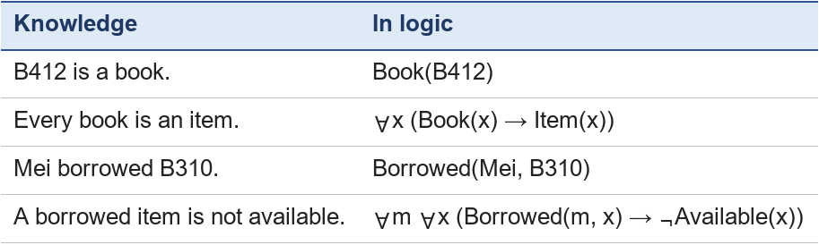
From the last two lines, universal modus ponens (Chapter 7, Section 8) gives ¬Available(B310). Strength: precise, and automatic inference is well understood. Weakness: hard for non-experts to read and write.

3. Semantic networks
A semantic network is a graph (Chapter 4, Section 6). Nodes stand for things or concepts, and labelled links stand for the relationships between them (slide 23).
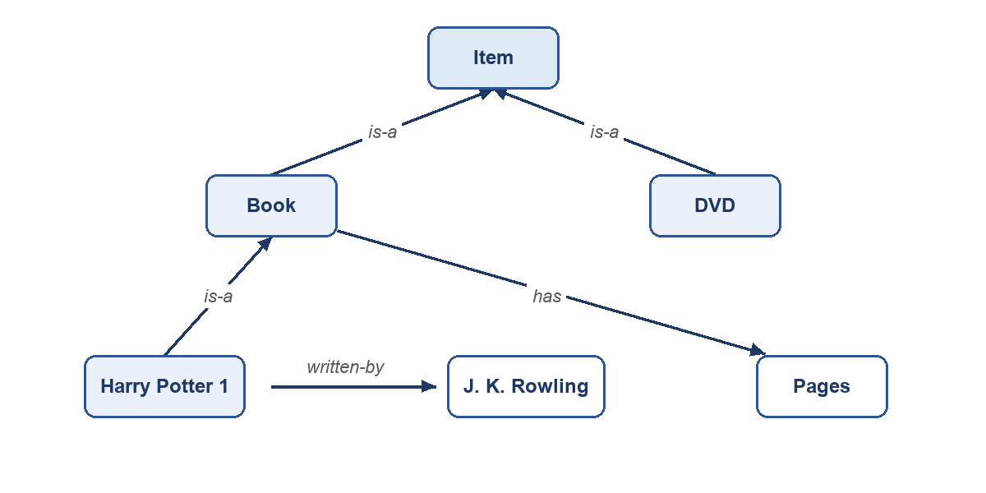
Figure 1. A semantic network for part of the library.
The most important kind of link is is-a, which builds a hierarchy. It allows inheritance: a node automatically has the properties of the nodes above it.
Worked example. Does Harry Potter 1 have pages? The network does not say so directly. But Harry Potter 1 is-a Book, and Book has Pages. By inheritance, yes. Can it be borrowed? If we add "Item — can-be — borrowed", then by following is-a twice (Harry Potter 1 → Book → Item), yes again.
Strength: easy to draw and read; questions become "follow the links". Weakness: link names must be used consistently, and exceptions (a reference book that cannot be borrowed) need extra care.

4. Frames and scripts
A frame is a structure that describes a typical object or situation, with slots for its properties and values (slide 24). It is like a form to fill in; slots can have default values that are used unless something else is known.
Frame: Book
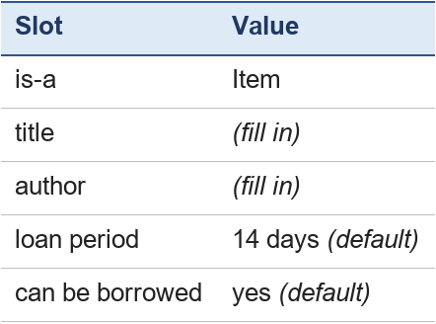
Frame: Reference book
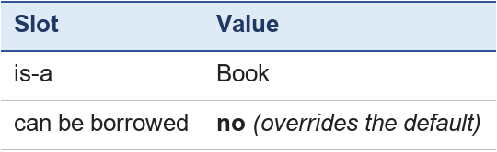
A dictionary in the reference section fills in the Reference-book frame; it inherits the loan period slot from Book, but its own "can be borrowed: no" overrides the default. Frames, like semantic networks with default values, handle exceptions by letting a more specific frame override an inherited value (Russell & Norvig, 2021, pp. 347–355).
A script is a sequence of frames that describes a typical series of events (slide 24; Schank & Abelson, 1977). Script: borrowing a book
1. Entry: the member brings a book and a card to the desk.
2. Check: the librarian scans the card and the book.
3. Decision: the system applies the loan rules (Chapter 9).
4. Loan: the loan is recorded with a due date.
5. Exit: the member leaves with the book.
Scripts let a system fill gaps in a story. If someone says "Mei went to the desk and left with the book", a system with this script can infer that her card was checked and a loan was recorded, even though nobody said so.

5. Rule-based representation
Knowledge can also be stored as production rules: IF-THEN statements that capture conditions and the actions or conclusions that follow (slide 25). The slide's medical example: "IF the patient has fever and cough, THEN consider the possibility of a respiratory infection."
For the library:
- R1: IF the member has a valid card AND has no overdue books THEN the member may borrow.
- R2: IF the member may borrow AND the book is available THEN approve the loan.
Rules are used to infer new knowledge from existing knowledge. Chapter 9 explains how a rule-based system stores them in a knowledge base and how its inference engine applies them by forward and backward chaining.

6. Ontologies
When two systems — or two people — use the same word, do they mean the same thing? For one library "item" includes e-books; for another it does not. An ontology fixes this. It is a formal description of the concepts in a domain and the relationships between them, giving a shared vocabulary and a hierarchy (slides 26–27). Gruber (1993) described an ontology as an explicit specification of a conceptualisation — a written-down, agreed way of seeing a domain.
A small library ontology:
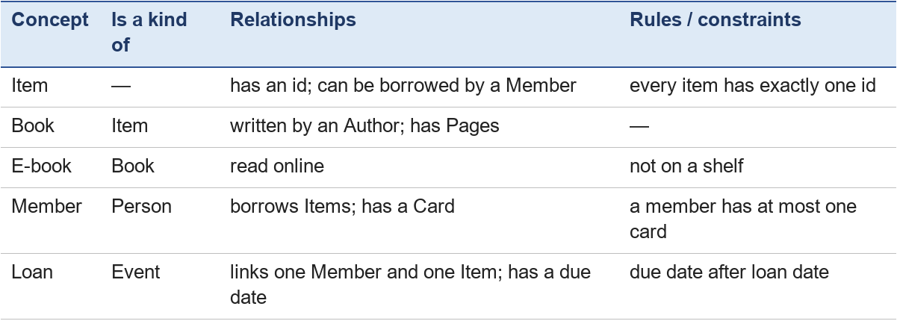
An ontology is like a semantic network with agreed definitions and rules, written carefully enough that different programs can share it. Large real examples include SNOMED CT for medical terms and the Gene Ontology for biology. Ontologies for the web are often written in OWL, the Web Ontology Language standardised by the World Wide Web Consortium (W3C, 2012).
How the five forms compare
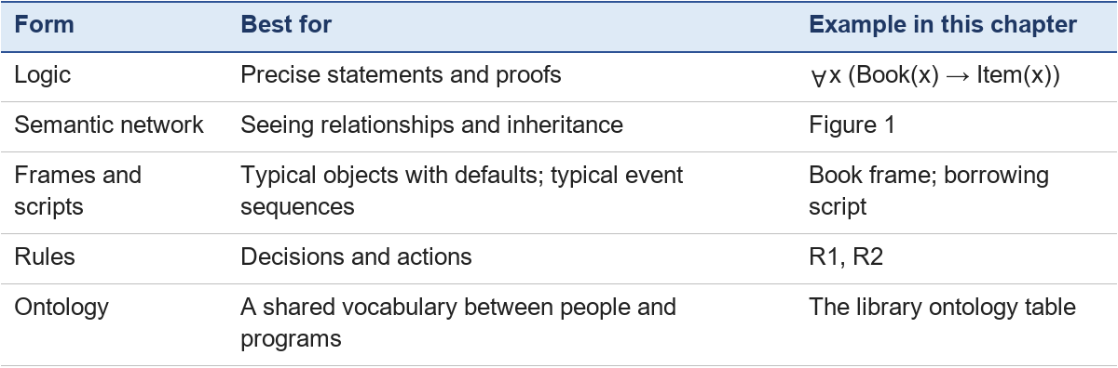

7. Applications
PPT 2024 (slide 28) lists four areas where knowledge representation is essential:
1. Medical diagnosis: symptoms, diseases and medical expertise are represented so the system can suggest diagnoses (the pneumonia rule of Chapter 6; MYCIN in Chapter 9).
2. Natural language understanding: knowledge about words and meaning lets a system understand and produce language — for example, knowing that a cat is an animal (Chapter 11).
3. Robotics: a robot needs to represent space, objects and tasks — where the shelves are, what a book is, how to plan a route (Chapter 10).
4. Expert systems: domain knowledge is represented so the system can give expert-level advice (Chapter 9).

8. Activity: represent it
1. Add to Figure 1: "A DVD has a running time" and "Spirited Away is a DVD". Write the new links.
2. Using your network, does Spirited Away have a running time? Which property of semantic networks did you use?
3. Write a frame for "Member" with at least four slots, including one default value.
4. Write "Every DVD is an item" in predicate logic.
5. Which representation would you choose to explain the steps of returning a book, and why?
Expected answers
1. DVD —has→ Running time; Spirited Away —is-a→ DVD.
2. Yes, by inheritance: Spirited Away is-a DVD, and DVD has a running time.
3. For example — is-a: Person; name: (fill in); card valid: (fill in); maximum loans: 5 (default); overdue books: 0 (default).
4. ∀x (DVD(x) → Item(x)).
5. A script, because returning a book is a typical sequence of events (bring the book → scan → check the due date → fine if late → mark as available). Rules would suit the fine decision inside it.

Key points
- Knowledge representation decides the form in which a system stores what it knows, so that it can reason and explain.
- Logic is precise; semantic networks show relationships and allow inheritance; frames hold typical properties with defaults; scripts hold typical sequences of events; rules capture decisions; ontologies give a shared, formal vocabulary.
- The same knowledge can be written in several forms; the best choice depends on the task.

Chapter 9 — Rule-Based and Expert Systems: Facts, IF-THEN Rules and Reasoning
Chapter lead: Louis Alexander Dalim 苏路成 (GitHub: LewiZHalimton) · Module: Software and Symbolic AI · Version: V2.0 working draft (2 November 2026) — discussed by the team on 4 November 2026

Learning outcomes
After this chapter, learners should be able to:
- Define symbol, fact, condition, IF-THEN rule, and AND condition, and spot them in a simple situation.
- Describe what the knowledge base, working memory, inference engine and user interface each do.
- Follow a forward-chaining example and say which rule applies at each step and what new fact it adds.
- Follow a backward-chaining example from a goal to the facts it needs.
- Explain how MYCIN worked and state two strengths and two limits of rule-based AI.
- Apply the same steps to a new case and state what can, and cannot, be concluded.

1. From IF-ELSE to IF-THEN
In Chapter 3, a programmer wrote the umbrella decision directly into the program: IF the answer is yes, display "Take an umbrella", ELSE display "No umbrella needed". Chapter 5 does the same for the library loan. The program always follows the steps in the order the programmer wrote them.
Symbolic AI takes a different approach. Instead of writing every decision into the steps of one program, we write down what we know (facts) and what follows from it (rules). A separate part of the system then works out the conclusion. The rest of this chapter shows how that works.

2. Key terms
Each term is defined when it first appears, using the library-loan situation.
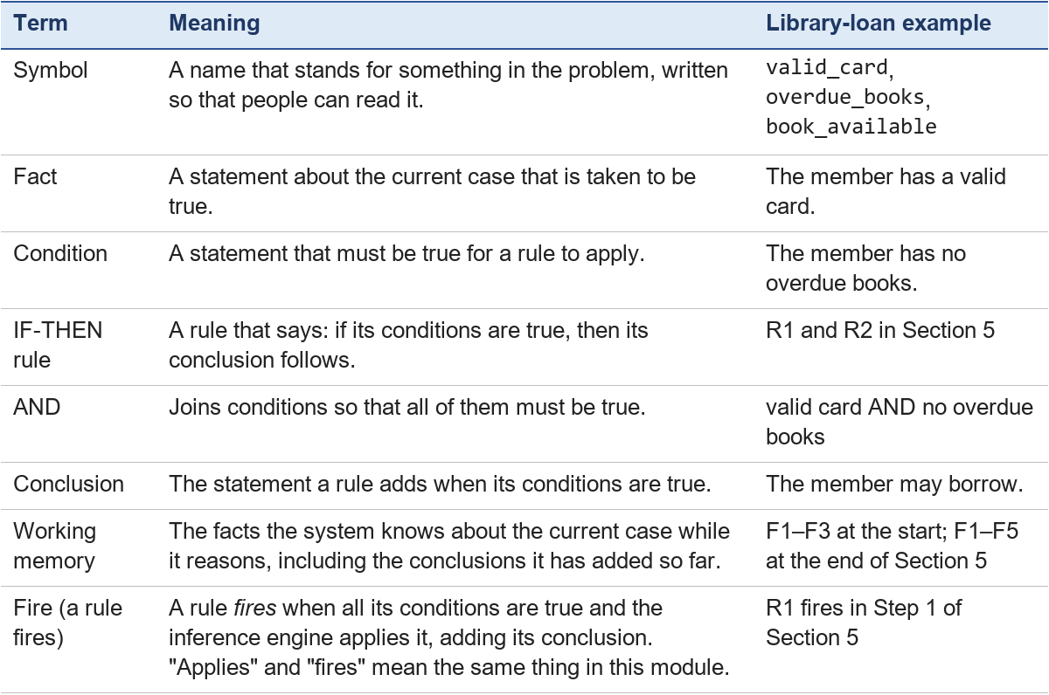
Remember. A conclusion that a rule adds becomes a new fact. This is how one rule can help the next rule to apply.

3. The parts of a rule-based system
Rule-based systems are also called production systems, because their rules "produce" new facts (PPT 2024, chap4 slide 29). Think of a chef in a busy kitchen. A kitchen needs a cookbook, a counter to work on, and someone to do the cooking. A rule-based system has the same three parts:
- The knowledge base (the cookbook) stores the system's rules and any lasting facts about its subject [1, 3]. Example: IF the member has a valid card AND the member has no overdue books, THEN the member may borrow.
- Working memory (the kitchen counter) holds the facts of the current case while the system reasons, including each new conclusion. Example: "this member has a valid card".
- The inference engine (the chef) checks the facts against the rules and applies the rules whose conditions are met. Russell and Norvig call this kind of step inference: deriving new sentences from the ones already known [1].
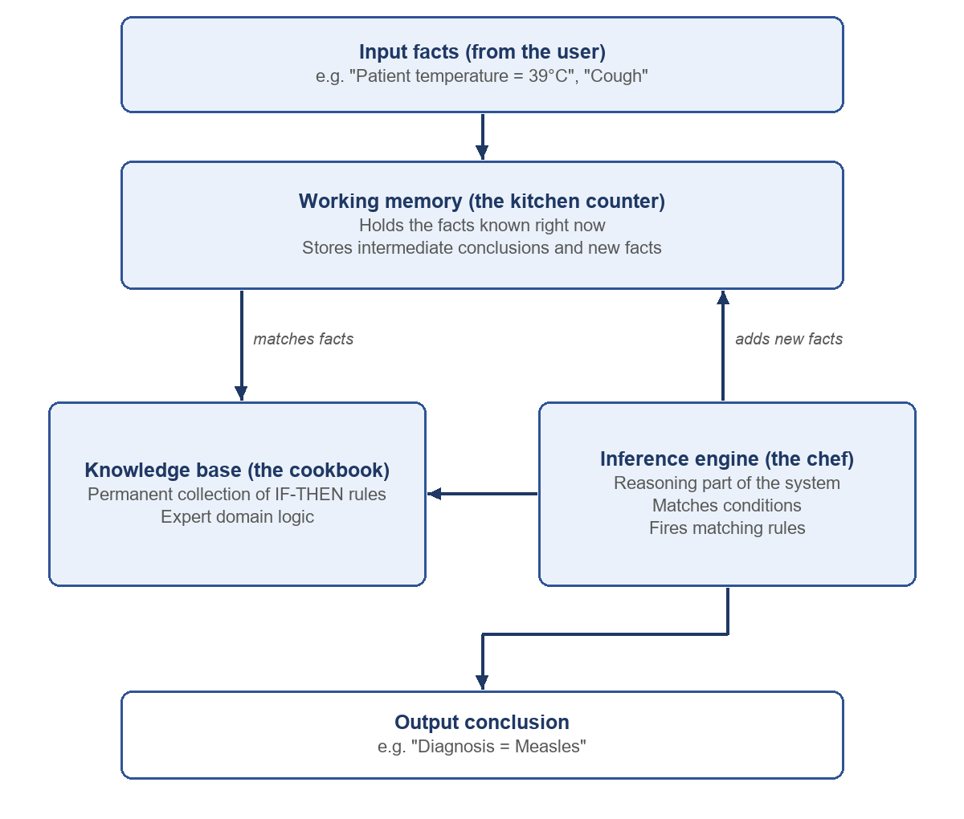
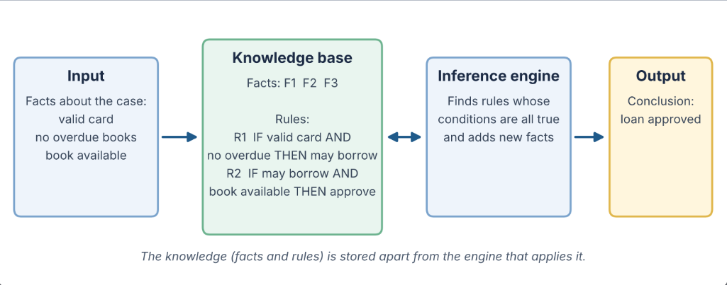
Figure 1. A rule-based system for the library loan. In a small system like this one, the facts of the case can be stored with the rules, so the figure draws them inside the knowledge base. Larger systems keep them apart in working memory, as in the kitchen picture above. The idea is the same: knowledge is kept separate from the engine.
To change what the system knows, we edit the facts and rules. We do not rewrite the engine.
An expert system is a rule-based system built to give the kind of advice a human expert gives in one narrow area, such as medicine (PPT 2024, chap4 slide 31). It adds a fourth part, the user interface, through which a person enters the facts of a case, asks questions and reads the advice (slide 32).

4. Forward and backward chaining
The inference engine can reason in two directions.
Forward chaining starts from the facts we already have and works forward to new conclusions [1]. It is like a detective who starts with clues and sees where they lead. The steps are:
1. Look through the rules and find one whose conditions are all true.
2. Apply it: add its conclusion to the facts as a new fact.
3. Go back to step 1, because the new fact may make another rule apply.
4. Stop when no rule can add anything new.
Backward chaining starts from a possible conclusion, called the goal, and works backward to check whether the facts support it [1, 2]. It is like a doctor who asks "could this be pneumonia?" and then checks only the symptoms that matter. The steps are:
1. Find a rule that could conclude the goal.
2. Make each condition of that rule a new, smaller goal.
3. If a goal is already a known fact, it is met. If a rule can conclude it, go back to step 1. If neither, ask the user.
4. The first goal is proved when all its conditions are met.
Section 5 works through both methods on the same library loan.
Going further (optional). In the course textbook, an IF-THEN rule is written as an implication. Its IF part is called the body and its THEN part the head, and simple rules of this kind are called definite clauses [1]. You do not need these names for this module; the plain words above are enough.

5. Worked examples: the library loan
The library-loan scenario comes from the team's project plan [5].
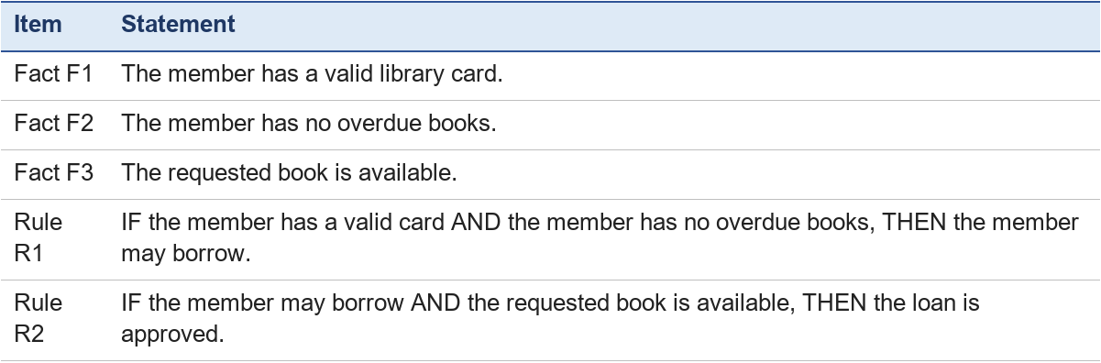
Trace. Follow each step in the table, and look at Figure 2.
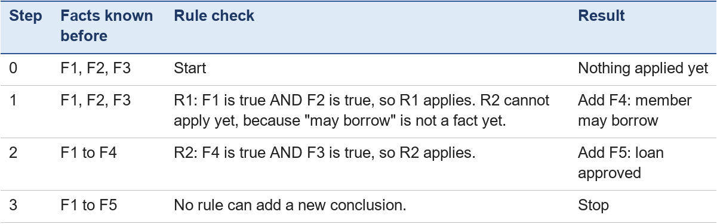
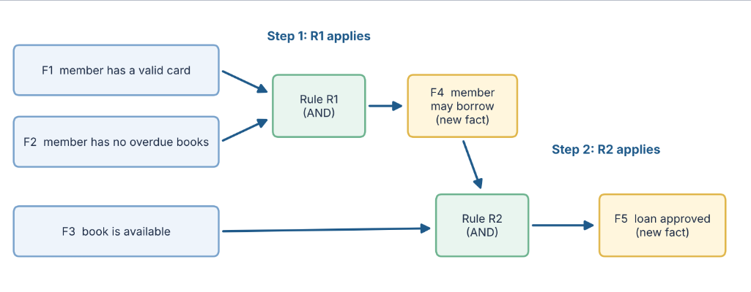
Figure 2. Forward chaining for the library loan: R1 adds F4, then R2 uses F4 to add F5.
Conclusion of the example. The loan is approved. The system reached it only because the stated facts and rules support it. R2 could apply only after R1 had added F4. This chain of rules is why the method is called chaining.
Does the order of the rules matter? Suppose the engine checks R2 before R1. In the first cycle R2 fails, because F4 ("member may borrow") is not yet known; R1 then fires and adds F4. In the second cycle R2 fires and adds F5. The order of checking can change how many rule checks are needed (here both orders need two firing cycles), but not the conclusion — as long as the rules only add facts and never remove them.

Backward chaining: the same loan
Now start from the question instead of the facts. Goal: is the loan approved? Use the same rules, R1 and R2.
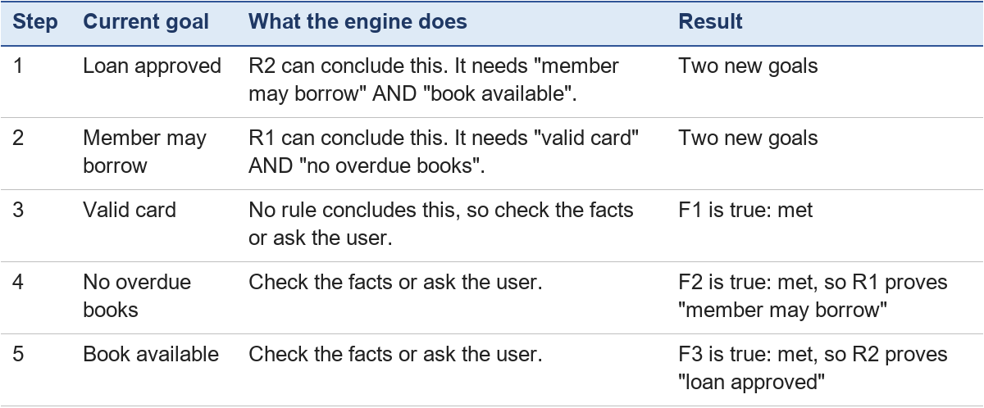
Both methods reach the same conclusion. The difference is the route. Forward chaining starts with whatever facts it has and may work out things nobody asked about. Backward chaining looks only for what the goal needs. If the member's card were not valid, step 3 would fail, and the engine would never need to ask about overdue books. This is why backward chaining suits a system that must ask a person questions, such as MYCIN (Section 8).

6. Rules versus ordinary program logic
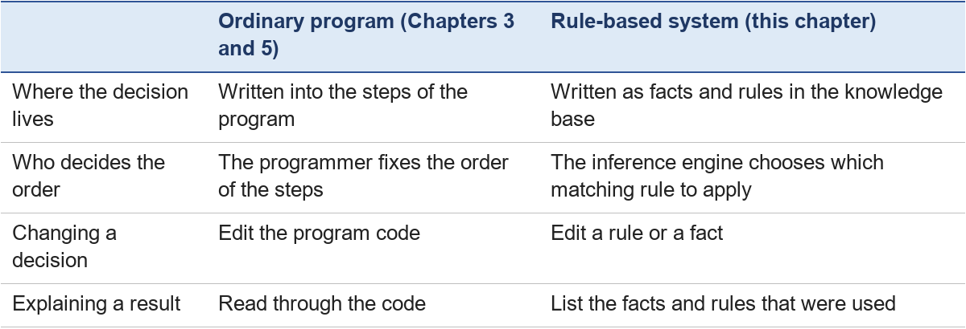
This table is a simplification to help beginners. Real systems often combine both: ordinary program logic for input and display, and a rule-based part for the reasoning. Chapter 12 compares their strengths and limits.

7. Learner activities

Activity 1: the book is on loan
Try it yourself. Case: A different member has a valid card (F1) and no overdue books (F2), but the requested book is not available (it is on loan).
Questions:
1. Using R1 and R2, which rules apply? What facts does the system end with?
2. Can the system approve the loan? Can it say the loan is refused?
3. Extension: write a new IF-THEN rule with an AND condition that lets the system offer a reservation to this member.
Expected answer
1. R1 applies, because F1 and F2 are true. It adds the new fact "member may borrow". R2 does not apply, because it also needs "the book is available", and that is false. The system ends with F1, F2 and "member may borrow".
2. The system cannot approve the loan, because R2 never applied. It also cannot say "refused", because no rule says that. A rule-based system only concludes what its rules and facts support.
3. One possible rule: R3: IF the member may borrow AND the requested book is not available, THEN offer a reservation. R3 applies after R1 adds "member may borrow". Any rule with two conditions joined by AND that gives this outcome is acceptable.

Activity 2: the overdue book, in both rule orders
Case: A member has a valid card (F1) and the requested book is available (F3), but the member has an overdue book.
1. Trace the case with the engine checking R1 first, then R2. Which rules fire? What facts does the system end with?
2. Trace it again with the engine checking R2 first, then R1. Does anything change?
3. The librarian wants the system to say that the loan is refused. Write a rule that does this.
Expected answer
1. R1 does not fire, because its condition "the member has no overdue books" is false. R2 does not fire either, because it needs "member may borrow", which was never added. No rule fires, so the system ends with only its starting facts and gives no conclusion.
2. Nothing changes: R2 fails (no "member may borrow"), then R1 fails (overdue book). The order changes the number of checks, not the result.
3. One possible rule: R4: IF the member has overdue books, THEN the loan is refused (reason: overdue books). Without a rule like R4, the system cannot say "refused" — it only concludes what its rules support (Activity 1, question 2).

8. Expert systems in practice: MYCIN
MYCIN is one of the best-known expert systems in the history of AI.

8.1 Why MYCIN was built
In the early 1970s at Stanford University, Edward Shortliffe and his colleagues worked on a hospital problem [4]. Patients with serious blood infections needed antibiotics quickly, but identifying the exact bacteria in the laboratory could take a day or more. Doctors needed expert advice before the laboratory results were ready.

8.2 How MYCIN made decisions
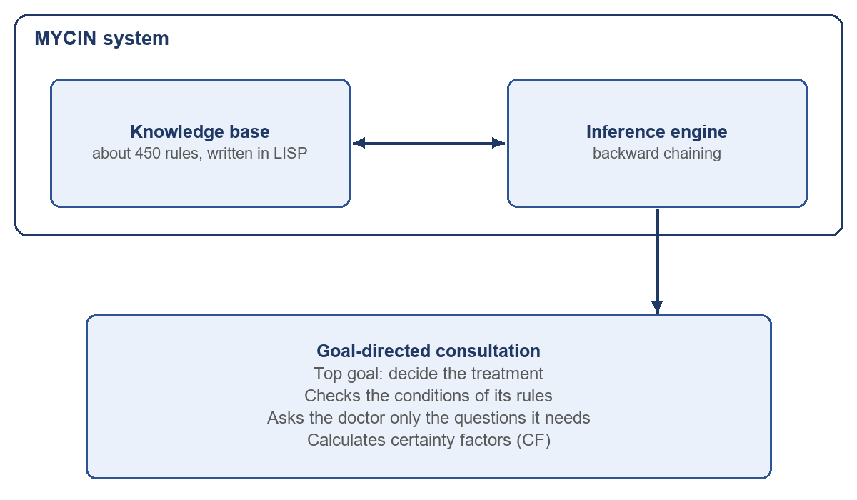
- Readable rules. MYCIN stored medical knowledge in about 450 IF-THEN rules [1, p. 41], written in a programming language called LISP. In English, a typical rule said: IF the stain of the organism is gram-negative AND its shape is rod AND it grows in air (aerobic), THEN there is strongly suggestive evidence (0.8) that the organism belongs to the group Enterobacteriaceae [2]. You do not need the medical words; notice the IF-THEN form and the number.
- Backward chaining. MYCIN started from its goal, recommending a treatment, and worked backward through its rules. It asked the doctor only for the facts it needed, such as where a culture was taken or whether the patient had allergies [2].
- Certainty factors. Medicine is rarely 100% certain, so each rule carried a certainty factor (CF), a number from −1.0 (definitely false) to +1.0 (definitely true) [4]. A CF of +0.8 meant strong belief, and 0 meant no evidence either way. MYCIN combined these numbers across rules.
- Explanation. A doctor could type WHY to see the rule MYCIN was trying to use, and HOW to see which rules and facts led to a conclusion [8]. This explanation facility is a major strength of many expert systems: their reasoning can be shown step by step.

8.3 What happened next
MYCIN performed as well as some experts and better than junior doctors [1, p. 41], but it was a research system, and its authors report that it was never used routinely in patient care [4, Chapter 32]. Practical reasons included the time needed to type in a consultation and the lack of connection to hospital record systems, together with questions about who is responsible for a computer's advice.
Systems like MYCIN also share a general problem, the knowledge acquisition bottleneck [9]. MYCIN's rules had to be collected through extensive interviews with experts [1, p. 41]. A classic rule-based system cannot learn by itself, so each new medical discovery meant that people had to update and re-check the rules.

9. Rule engines today: Drools
The core idea of expert systems lives on in business rule engines: software that keeps an organisation's rules outside its program code. Drools is one example [6].
The problem. Imagine a bank whose program contains thousands of nested IF-ELSE decisions. Programmers call this kind of tangled program "spaghetti code". Each time a credit-score limit changes, programmers must edit the code, rebuild the application and install it again.
The solution. A rule engine moves those decisions into separate, readable rule files, such as .drl files or decision tables. The rules can then be changed without rewriting the application's code, although the new rules must still be tested and deployed.
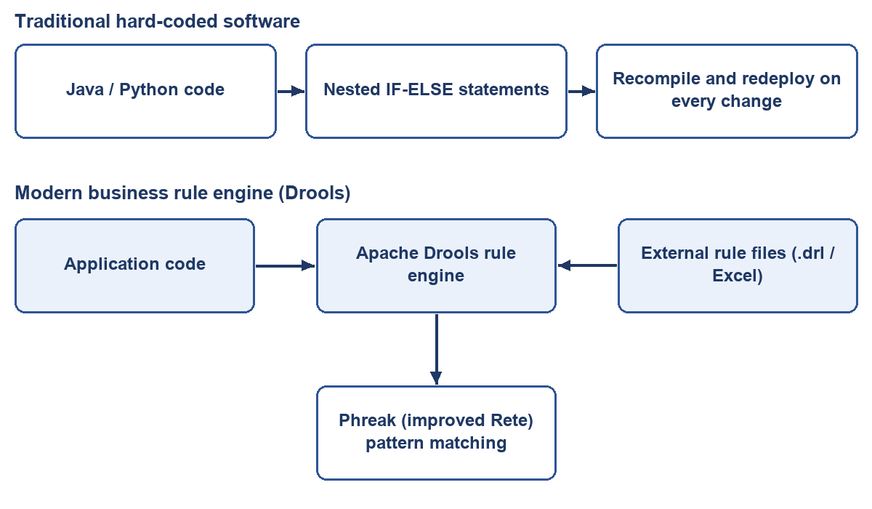
Where rules like these can be used (illustrations, not descriptions of particular companies):
- Credit decisions: IF salary > $3,000 AND credit_score > 700 THEN approve_credit_card.
- Online shops: rules for discounts, shipping fees and flagging suspicious orders.
- Hospitals: rules for sorting patients on arrival and for who may open a medical record (Section 11).
Going further (optional, not examined): how a rule engine stays fast. With 10,000 rules and millions of facts, checking every rule against every fact would be far too slow. Think of a post office: it does not carry each letter around the whole city, but sorts letters through a network of bins. The classic Rete algorithm does the same with facts [7]. It passes them through a network of tests and remembers partial matches, so that when one fact changes, only the affected rules are re-checked. Drools now uses Phreak, an improved version of this idea [6].
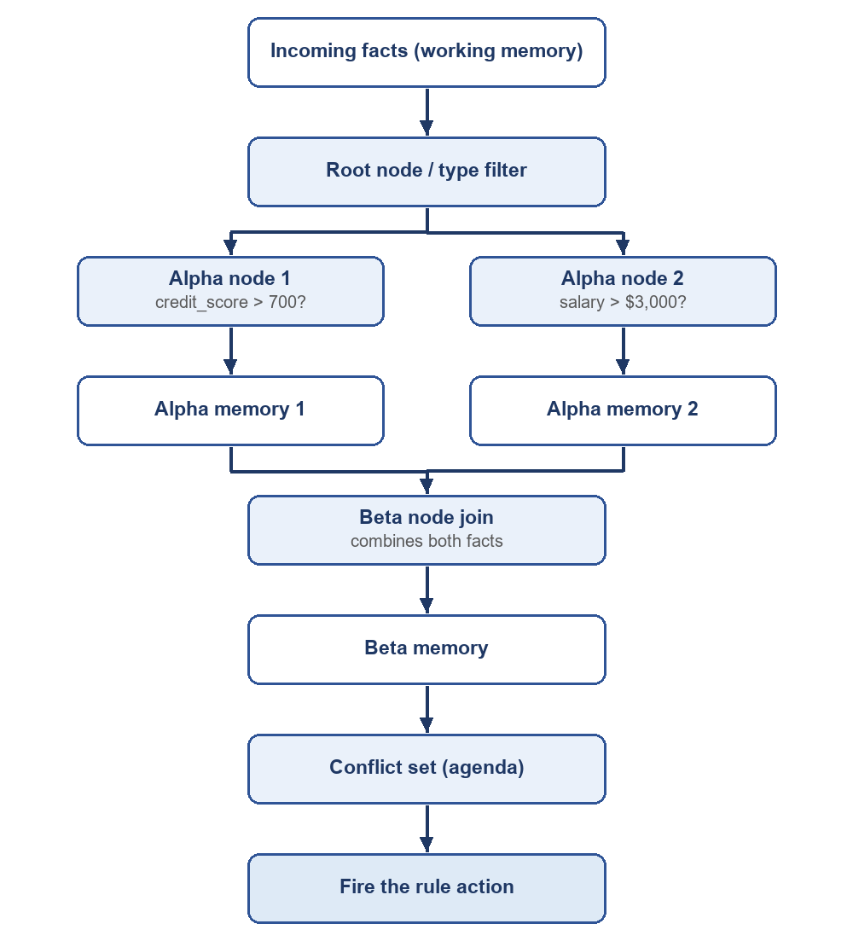

10. Strengths and limits of rule-based AI
Why rule-based AI is still used
- It can explain itself. Many neural networks are called "black boxes", because their decisions are spread across millions of numbers. A rule-based system can list the facts and rules it used at every step.
- It does not invent facts. A statistical language model can produce statements that sound right but are false; these are called "hallucinations". A rule-based system concludes only what its facts and rules support. That does not make it always right: if a rule is wrong or out of date, or a fact is missing, the conclusion will be wrong or missing too (Chapter 12).
- It needs no training data. A deep neural network usually needs large amounts of labelled data. A rule-based system needs none, but people must write, test and maintain the rules, and that is its main cost.
Where rules struggle
Expert systems proved hard to build and maintain for complex subjects, partly because their reasoning broke down in the face of uncertainty and partly because they could not learn from experience [1, p. 42].
- Brittleness: if an input has a typing mistake, or a situation is slightly outside the rules, the system may break or give no answer.
- No self-learning: a classic rule-based system cannot learn new rules by itself; people must write and update every rule. (Other methods, such as decision-tree learning, can learn rules from data, but they are not part of a classic rule engine.)
This is why many researchers argue that hybrid systems, which combine learning and rules, are a way forward [10, 11]. Chapter 12, Section 7 (optional) looks at this idea.
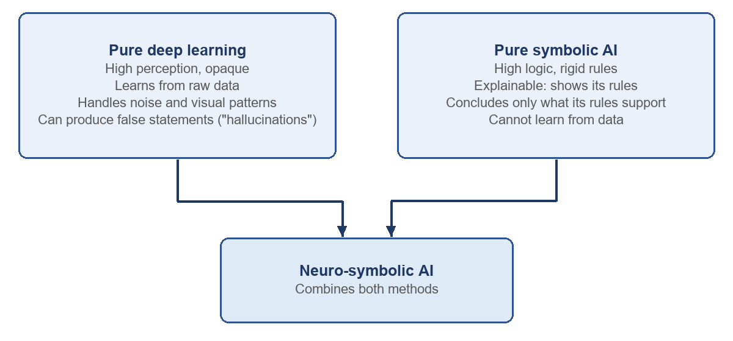

11. Learner Activity 3: the hospital access rules
The Scenario. A hospital uses an automated rule engine to enforce security permissions for Electronic Health Records (EHR).
Knowledge Base Rules:
- Rule H1: IF user_role = doctor AND patient_assigned = true THEN grant_access(EHR_record)
- Rule H2 (Emergency Break-the-Glass): IF patient_status = critical AND user_role = doctor THEN grant_emergency_access(EHR_record)
- Rule H3 (Audit Logging): IF grant_emergency_access = true THEN generate_compliance_audit_flag
Working Memory Initial Facts (Case Input):
- Fact F1: user_role = doctor
- Fact F2: patient_assigned = false (The doctor is not the primary attending physician)
- Fact F3: patient_status = critical
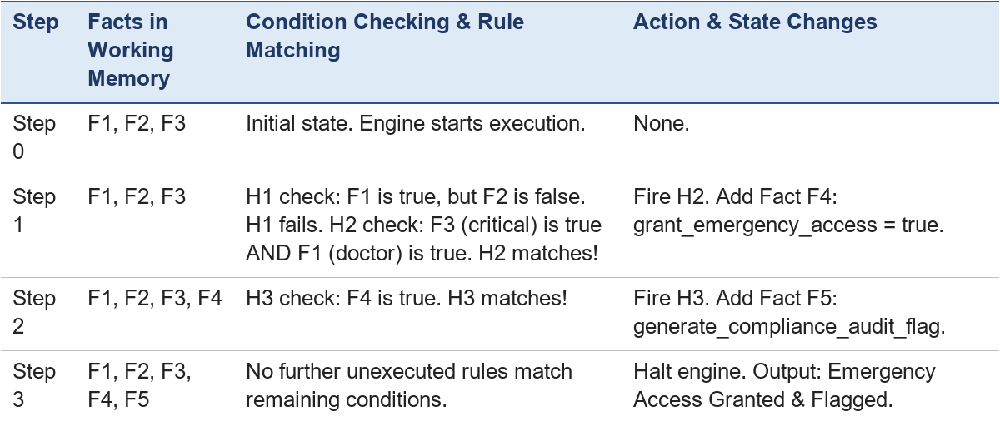
Critical questions and expected answers
- Trace question: Which rules fire, in what order, and what final facts are added to Working Memory? Answer: Rule H1 fails because patient_assigned = false. Rule H2 fires first, adding Fact F4 (grant_emergency_access = true). Rule H3 fires second, adding Fact F5 (generate_compliance_audit_flag).
- Safety question: Can the doctor access the patient's record? If patient_status were changed to normal, could the doctor access the record? Can the system infer "Access Permanently Banned"? Answer: Yes, emergency access is granted because Rule H2 fired. If patient_status were normal, Rule H2 would fail, Rule H1 would fail, and no access would be granted. The system cannot infer "Access Permanently Banned" because symbolic AI only asserts what explicit rules support — it never assumes unstated conclusions.
- System extension: Write a new rule, Rule H4, that automatically alerts the chief medical officer if emergency access is granted to an unassigned patient. Answer: Rule H4: IF grant_emergency_access = true AND patient_assigned = false THEN send_alert(Chief_Medical_Officer).

12. Chapter takeaway
A rule-based system keeps what it knows as facts and IF-THEN rules in a knowledge base. An inference engine applies the rules that match. In forward chaining, each new conclusion becomes a fact that may let another rule apply, until nothing new can be added. In backward chaining, the engine starts from a goal and looks only for the facts that goal needs. Expert systems such as MYCIN show the strengths of this approach, and its limits: rules must be written and kept up to date by people.

13. Use in the learning resources and review record
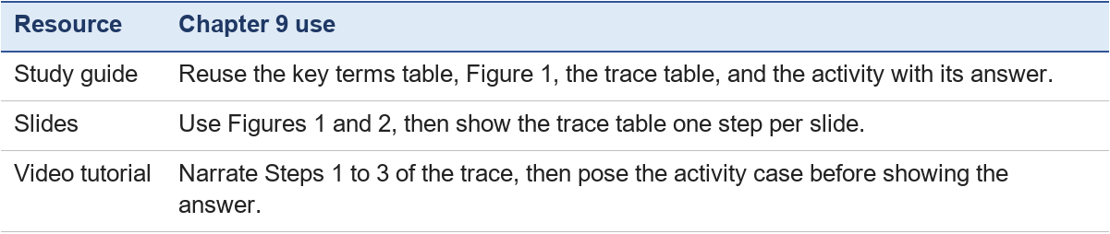
Review record. A planning-stage check of this chapter (review record R-01, 24 October 2026) is recorded in logs/Quality-Review/review-record-R01.md; its corrections are now included in this file. The Stage 2 peer review by a non-author (task 3.9) is recorded in the Stage 2 project log.

Chapter 10 — Planning and Problem Solving
Chapter lead (proposed): Eizel Mthana Conqueror · Module: Software and Symbolic AI · Version: V2.0 working draft (3 November 2026) — AI-assisted draft; discussed by the team on 4 November 2026

Learning outcomes
After this chapter, you should be able to:
- Describe a problem as a state space with an initial state, actions and a goal state.
- Trace breadth-first, depth-first and uniform-cost search on a small map, and say which finds the cheapest route.
- Explain what a heuristic is, and trace greedy best-first search and A*.
- Work out a minimax value in a small game tree and show which branch alpha-beta pruning skips.
- Explain how hill climbing can get stuck, and how simulated annealing tries to escape.

1. Planning and problem solving
A library robot must take a returned book from the desk to the Archive. Nobody tells it each step; it has to work out a sequence of actions that gets the job done. That is planning.
- Planning is finding a sequence of actions that turns a given initial state into a desired goal state. It means reasoning about actions, what they change, and the state of the world (PPT 2024, slide 33).
- Problem solving is finding solutions to problems by computational methods: searching for solutions, reasoning about possible actions and judging the possible outcomes.
Worked example: a small plan. The robot is at the desk; the book is on the desk. The goal: the book is in the Archive.
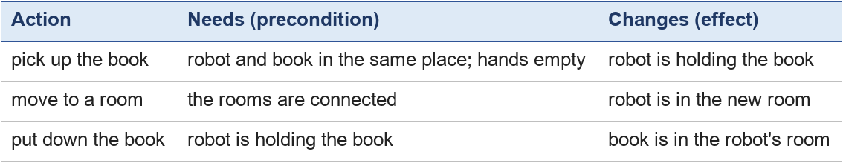
Plan: pick up the book → move along a route to the Archive → put down the book. The middle step hides a smaller problem — which route? That is a search problem, and it is the subject of the rest of the chapter.

2. State space, actions, goal state and search
Every search problem has four parts (slide 35):
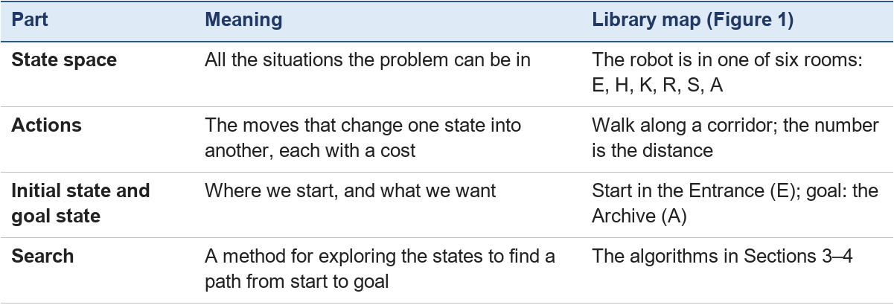
Figure 1. The library map (the same graph as Chapter 4, Figure 4). Start: E. Goal: A.
There are three routes from E to A that take three steps (a longer route, E → K → S → H → R → A, also exists, with a distance of 19):
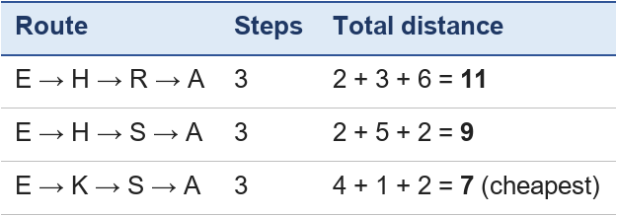
On a map with six rooms we can list every route. On a city map with thousands of streets we cannot, so we need a search method that explores cleverly. In every trace below, the frontier is the list of rooms found but not yet explored, neighbours are added in alphabetical order, ties are broken alphabetically, and the goal is recognised when it is taken from the frontier.

3. Uninformed search: BFS, DFS and uniform-cost search
Uninformed (blind) search uses no knowledge about where the goal is; it simply explores the state space in a fixed order until it finds the goal (slide 36).

Breadth-first search (BFS)
BFS explores layer by layer, using a queue — first in, first out (Chapter 4, Section 6).
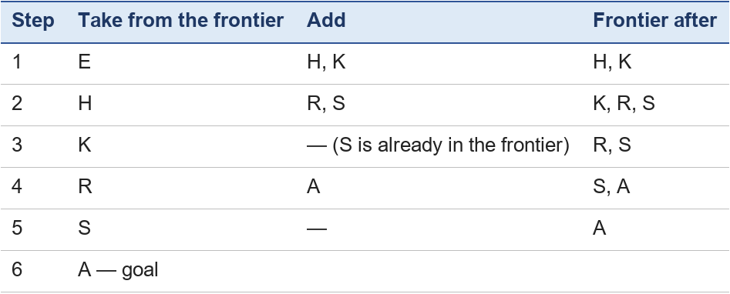
Route found: E → H → R → A (A was reached from R, R from H). BFS always finds a route with the fewest steps (here 3), but it ignores the distances, so this route costs 11, not 7.

Depth-first search (DFS)
DFS goes as deep as possible along one route before trying another, using a stack — last in, first out. (We push neighbours in reverse alphabetical order so that the alphabetically first one is on top.)
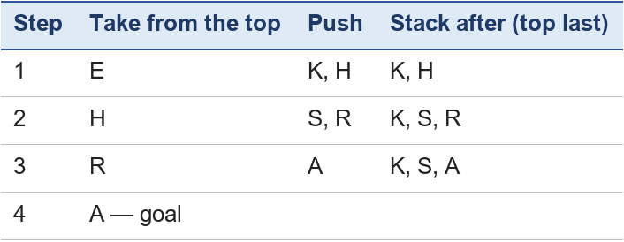
Route found: E → H → R → A, cost 11. DFS needs little memory and can be fast, but it gives no guarantee of finding the shortest or cheapest route, and on very large maps it may wander down a long dead end.

Uniform-cost search (UCS)
UCS always explores the frontier room with the lowest total cost so far, written g. If it finds a cheaper way to a room already in the frontier, it keeps the cheaper one.
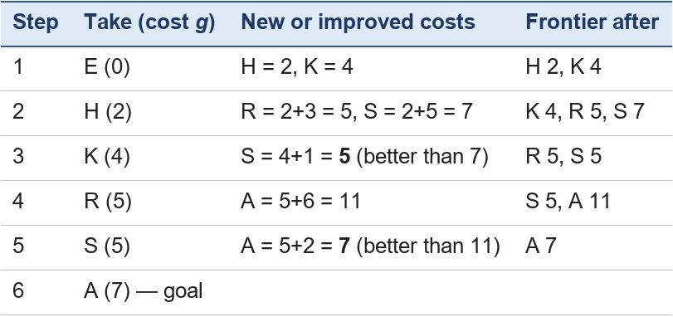
Route found: E → K → S → A, cost 7 — the cheapest. UCS is guaranteed to find the cheapest route when all costs are positive, but it explores in every direction, including away from the goal.
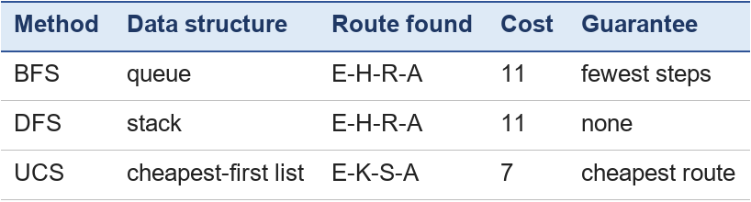

4. Informed search: greedy best-first search and A*
Informed search uses extra knowledge about the problem — a heuristic — to explore the most promising rooms first (slide 38). A heuristic h is an estimate of the remaining cost from a room to the goal, for example the straight-line distance on a floor plan.
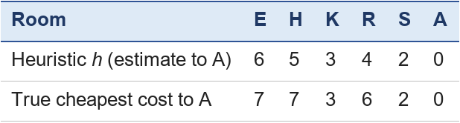
These estimates never exceed the true cost. A heuristic like this is called admissible, and it matters for A* below.

Greedy best-first search
Greedy search always explores the room that looks closest to the goal: the lowest h, ignoring the distance already walked.
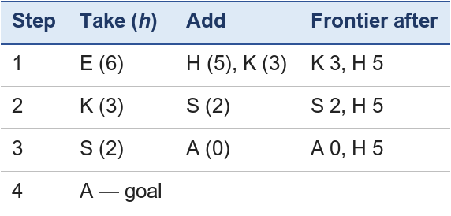
Route: E → K → S → A, cost 7, after exploring only four rooms. Greedy search is fast, but it is not guaranteed to find the cheapest route: a misleading estimate can lead it down a costly path.

A* search
A* combines both ideas. For each room it adds the cost already walked and the estimate still to go: f = g + h. It explores the room with the lowest f.
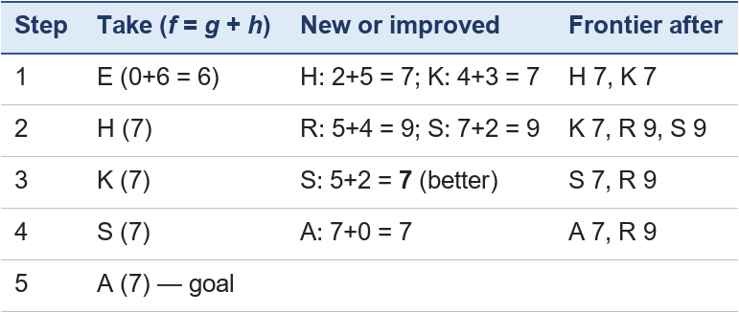
Route: E → K → S → A, cost 7. With an admissible heuristic, A* is guaranteed to find the cheapest route, and it usually explores fewer states than UCS because the heuristic pulls it towards the goal. Route-planning apps and computer games use A* and its relatives.

5. Adversarial search: minimax and alpha-beta pruning
In a game, an opponent works against you, so you cannot simply choose your favourite route: you must expect the best reply (slide 39). Adversarial search looks ahead through your moves and the opponent's replies.
Minimax. Call the two players MAX (you, who want a high score) and MIN (the opponent, who wants a low score). At the end of the game each position has a score for MAX. Working upwards from the end:
- at a MIN level, take the lowest value of the children (the opponent's best reply);
- at a MAX level, take the highest value.
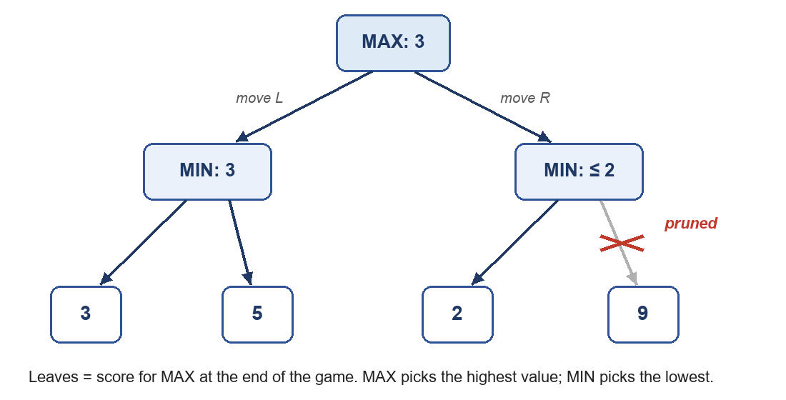
Figure 2. A two-move game tree with minimax values. The crossed branch is skipped by alpha-beta pruning.
Worked example. After move L, MIN can choose 3 or 5, and picks 3. After move R, MIN can choose 2 or 9, and picks 2. MAX compares 3 and 2 and plays L, guaranteeing a score of at least 3. (Choosing R in the hope of 9 would be a mistake: a sensible opponent would answer with 2.)
Alpha-beta pruning gives the same answer as minimax while skipping branches that cannot change it. After exploring L, MAX knows it can get 3. Exploring R, the first leaf is 2, so MIN can force R down to 2 or less. Whatever the second leaf is, R is already worse than 3 — so the leaf 9 does not need to be looked at at all. In large games such as chess, pruning skips huge parts of the tree and lets the program look several moves further ahead in the same time.

6. Local search: hill climbing and simulated annealing
Sometimes we do not need a route; we need a good final arrangement — for example, the best layout of shelves, or a timetable without clashes. Local search starts with one solution and keeps moving to a neighbouring solution, hoping to reach the best one (slide 40).
Picture the possible solutions as a landscape, where the height is how good each solution is:

Hill climbing always moves to the best (highest) neighbour, and stops when no neighbour is better. Starting at position 1: 1 (2) → 2 (4) → 3 (6). Both neighbours of 3 are worse (4 and 5), so it stops at quality 6. It is stuck on a local maximum: a hill that is not the highest one. The best solution, 9 at position 7, is never found. Hill climbing is simple and fast, but it can get stuck like this.
Simulated annealing sometimes accepts a worse move on purpose, to escape small hills. The chance of accepting a worse move is controlled by a "temperature": high at the start (many bad moves allowed), lowered step by step (fewer and fewer allowed). The name comes from annealing metal, which is heated and cooled slowly so that it settles into a strong structure. In the landscape above, it might go 3 (6) → 4 (5) → 5 (3) while the temperature is high, then climb 6 (7) → 7 (9), and as it cools it stays on the higher hill. It is not guaranteed to find the very best solution, but it usually does much better than plain hill climbing.

7. Activity: plan the route
Use Figure 1 and the heuristic table of Section 4.
1. The corridor between K and S is closed. Which of the three routes in Section 2 are still possible, and which is now cheapest?
2. With the K–S corridor closed, trace uniform-cost search from E. Which route does it find?
3. Without K–S, what is the true cheapest cost from K to A? Is the heuristic value h(K) = 3 still admissible?
4. In Figure 2, change the leaf 9 to 1. Does MAX's choice change? Is any leaf still pruned?
5. In the landscape of Section 6, where does hill climbing stop if it starts at position 5?
Expected answers
1. Without K–S, K is only connected to E, so two routes are left: E-H-R-A = 11 and E-H-S-A = 9 (E-K-S-A no longer exists). The cheapest is E-H-S-A, cost 9.
2. E(0) → frontier H 2, K 4. Take H(2) → R 5, S 7. Take K(4) → no new rooms. Take R(5) → A 11. Take S(7) → A = 9, better than 11. Take A(9) → goal. Route E → H → S → A, cost 9.
3. From K the only way is back to E and then on: K-E-H-S-A = 4+2+5+2 = 13. h(K) = 3 ≤ 13, so it is still admissible — it underestimates, which is allowed.
4. No. The MIN value of R becomes 1 instead of 2, which is still less than 3, so MAX still plays L. And the leaf is still pruned: after seeing 2, MIN can already force R to 2 or less, so the second leaf is skipped whatever its value.
5. From 5 (3), both neighbours are better; the best is 6 (7), then 7 (9). Both neighbours of 7 are lower (7 and 8), so it stops at position 7, quality 9 — the global maximum. Where you start matters for hill climbing.

Key points
- Planning finds a sequence of actions from an initial state to a goal state; many planning steps are search problems.
- A search problem has a state space, actions with costs, an initial state, a goal state and a search method.
- BFS (queue) finds the fewest steps; DFS (stack) uses little memory but guarantees nothing; uniform-cost search finds the cheapest route.
- A heuristic estimates the remaining cost. Greedy search follows the estimate only; A* uses f = g + h and, with an admissible heuristic, finds the cheapest route.
- Minimax chooses the best move against a sensible opponent; alpha-beta pruning gives the same answer while skipping hopeless branches.
- Hill climbing can stop on a local maximum; simulated annealing accepts some worse moves early on to escape.

Chapter 11 — Symbolic Natural Language Processing
Chapter lead: Frederick Bryan The · Module: Software and Symbolic AI · Version: V2.0 working draft (2 November 2026) — restructured and AI-assisted draft (3 November 2026); discussed by the team on 4 November 2026

Learning outcomes
After this chapter, you should be able to:
- Explain what NLP is and what makes an approach to it symbolic.
- Use a small context-free grammar to parse a sentence and draw its parse tree.
- Represent the meaning of a simple sentence with a predicate, and tag the parts of speech of a sentence with rules.
- Use rules about family relations to answer a question by inference.
- Describe how rules support sentiment analysis, question answering and information retrieval, and name one limit of each.

1. What NLP is, and the symbolic approach
You type "Which books by Rowling are available?" into the library catalogue. To answer, the computer must split the sentence into words, work out how they fit together, understand what is being asked, and find the facts. That is natural language processing.
Natural language processing (NLP) is the part of AI that deals with the interaction between computers and human language. It develops methods that let computers understand, interpret and produce human language in a meaningful way (PPT 2024, slide 41).
There are two broad approaches:
- Symbolic NLP uses formal rules, logic and symbolic representations written by people: grammars, dictionaries, rules and knowledge bases.
- Statistical and neural NLP learns patterns from very large amounts of text. Modern chatbots are mainly of this kind.
This chapter is about the symbolic approach. Its strengths are the same as in Chapter 6: every step can be inspected and explained, and it needs no training data. Its weakness is that human language is huge and full of exceptions, so the rules are never complete.

2. Grammars and parsing: a rule-based pipeline (moved from the former Chapter 5, §4.1)
Until statistical methods took over in the late 1980s and 1990s (and deep learning in the 2010s), most computer programs processed human text using Symbolic Natural Language Processing (NLP) (Jurafsky & Martin; Russell & Norvig, 2021, Ch. 24).
- Words as Symbols & Grammar Rules: Symbolic NLP treats words as discrete symbols governed by explicit grammar rules. Instead of guessing word probabilities, it builds syntax trees using formal rules such as Context-Free Grammar (CFG) to analyze sentence structure.
- The Step-by-Step Language Pipeline:
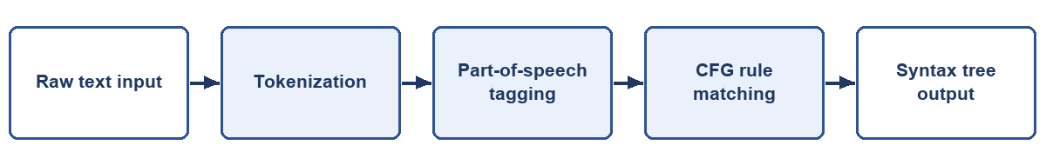
1. Text Input: Receiving raw text from the user (e.g., "The expert doctor examines the patient").
2. Tokenization: Splitting the text into individual word tokens ["The", "expert", "doctor", "examines", "the", "patient"].
3. Part-of-Speech Tagging: Labelling each token with its word class — "The" determiner, "doctor" noun, "examines" verb (Section 4).
4. *(For searching documents only — Section 6.3 — two further steps are common: stop-word removal, which drops filler words such as "the" and "a", and reducing words to a base form. Stemming chops endings by rule, so "studies" becomes "studi"; lemmatization gives the dictionary form, so "was" becomes "be". A parser must not use these steps, because it needs every word.)*
5. Rule Matching & Parsing: Matching the tagged tokens against formal grammar rules (NounPhrase + VerbPhrase) to construct a structured syntax tree.

2.1 Worked example: a grammar for "The cat chased the mouse"
PPT 2024 (slide 42) explains that formal grammars, such as context-free grammars (CFGs), define the rules for building correct sentences and capture their hierarchical structure. A CFG is a set of rewrite rules. Each rule says what a part of a sentence can be made of:
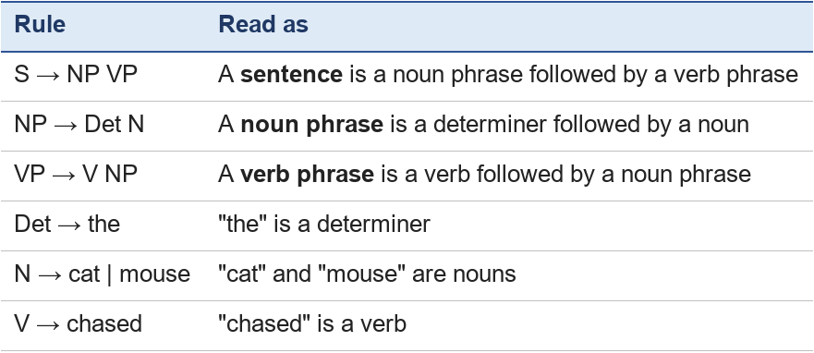
Parsing means finding how a sentence can be built from these rules. For "The cat chased the mouse":
1. "The" is a Det and "cat" is an N, so The cat is an NP (rule NP → Det N).
2. "chased" is a V; "the mouse" is another NP.
3. V + NP makes a VP: chased the mouse (rule VP → V NP).
4. NP + VP makes an S (rule S → NP VP). The whole sentence is grammatical.
The result is a parse tree:
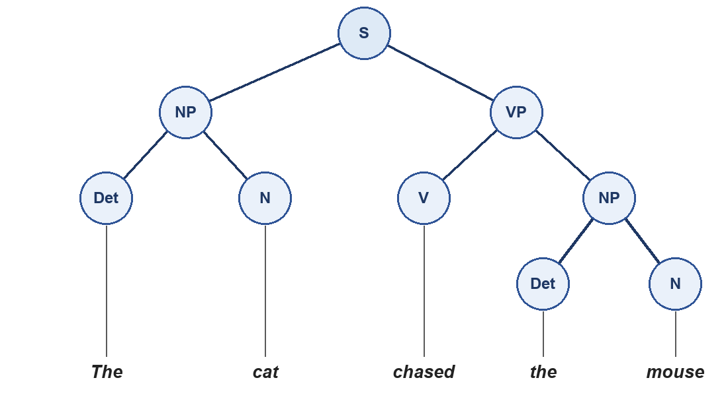
Figure 1. The parse tree shows the sentence's structure: who did what to whom.
"Mouse the chased cat the" cannot be parsed with these rules, so the grammar rejects it. Note that a parser needs all the words: if "the" were removed as a stop word (step 3 of the pipeline above), the rule NP → Det N could not match. Stop-word removal is useful for searching documents (Section 6), not for parsing.

3. Semantics and knowledge representation for language
Syntax is about structure; semantics is about meaning (slide 43). Two sentences with different structure can mean the same thing: "The cat chased the mouse" and "The mouse was chased by the cat". A symbolic system represents the meaning in a form that does not depend on the wording.
Using predicate logic (Chapter 7), the meaning of both sentences is:
Chased(cat, mouse)
As a semantic network (Chapter 8): cat —chased→ mouse. With an ontology, the system can also know that a cat is-a animal and a mouse is-a animal, and therefore answer "Did an animal chase another animal?" with yes.
PPT 2024 (slide 44) names the three knowledge representations most used for language:
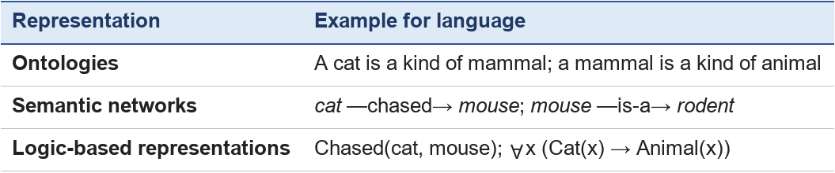

4. Rule-based NLP: part-of-speech tagging and parsing
Rule-based NLP systems use explicitly written rules and patterns to analyse language, for tasks such as part-of-speech tagging, syntactic parsing and information extraction (slide 45).
Part-of-speech (POS) tagging labels each word with its word class. A simple rule-based tagger uses two things: a lexicon (a dictionary of words and their classes) and rules for words that are not in the lexicon or have more than one class.
Example from the slide: "The quick brown fox jumps over the lazy dog."
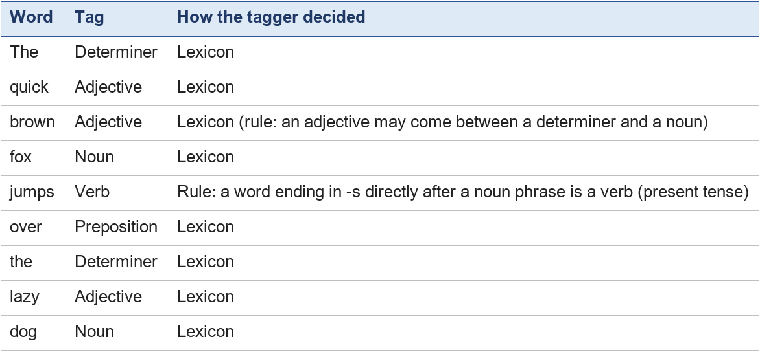
Rules like "a word ending in -ly is probably an adverb" or "after the, the next noun ends the noun phrase" handle words the lexicon does not know. Once the words are tagged, a grammar (Section 2.1, with extra rules for adjectives and prepositions) finds the structure: subject "the quick brown fox", verb "jumps", and the phrase "over the lazy dog" saying where.
The tagger can be wrong. In "Time flies like an arrow", flies could be a verb or a plural noun; rules must use the context to decide, and some sentences remain ambiguous even for people.

5. Logic and inference in NLP
Logic lets a symbolic NLP system reason about what a sentence says and derive new knowledge (slide 46). PPT 2024's example: relationships between people, written as predicates and rules.
Facts (from sentences such as "Ana is Ben's mother"):
- Parent(Ana, Ben)
- Parent(Ana, Cai)
- Parent(Ben, Dan)
Rules:
- Grandparent: ∀x ∀y ∀z (Parent(x, y) ∧ Parent(y, z) → Grandparent(x, z))
- Sibling: ∀x ∀y ∀p (Parent(p, x) ∧ Parent(p, y) ∧ x ≠ y → Sibling(x, y))
Question: "Who is Dan's grandparent?" The system looks for an x with Parent(x, y) and Parent(y, Dan). Parent(Ben, Dan) gives y = Ben; Parent(Ana, Ben) gives x = Ana. Answer: Ana. Nobody told the system "Ana is Dan's grandparent"; it inferred it, and it can show the two facts and the rule it used.
Question: "Is Cai Ben's sibling?" Parent(Ana, Ben), Parent(Ana, Cai) and Ben ≠ Cai → Sibling(Ben, Cai): yes.
This is universal modus ponens from Chapter 7, applied to knowledge taken from language.

6. Uses: sentiment analysis, question answering and information retrieval

6.1 Sentiment analysis
Sentiment analysis finds the emotional tone of a text — positive, negative or neutral — in reviews, posts or feedback (slide 47). A rule-based system uses word lists and patterns:
- positive words: good, excellent, happy, helpful;
- negative words: bad, poor, disappointed, slow;
- a negation rule: "not" or "never" directly before a sentiment word reverses it;
- a simple decision: count positive minus negative; above 0 → positive, below 0 → negative, 0 → neutral.
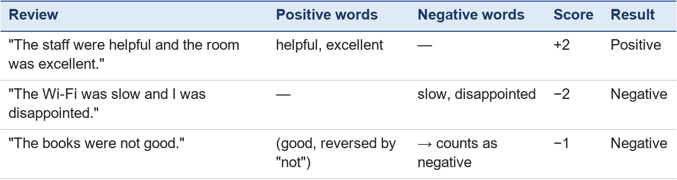
Limit: sarcasm ("Great, the printer is broken again") fools simple rules, because the words are positive but the meaning is negative.

6.2 Question answering
A question-answering system interprets a question in natural language and answers it from a knowledge base, often a knowledge graph of entities and relationships (slide 48). In the slide's medical example, diseases, symptoms and treatments are stored as entities linked by relations; when a user asks about the symptoms of a disease, the system follows the links to find the answer.
For the library: the question "Which books by Rowling are available?" becomes a query — find every x with Book(x) ∧ WrittenBy(x, Rowling) ∧ Available(x) — which the system answers from its facts (as SQL does in Chapter 5, Section F). Limit: it can only answer questions about knowledge it has been given.

6.3 Information retrieval
Information retrieval finds the documents that match what a user is looking for in a large collection (slide 49). Symbolic techniques help by representing the concepts in the documents and in the query. In the slide's legal example, legal concepts, case law and statutes are encoded in a formal structure, and the system matches a legal question with relevant documents.
A small library example: a search for "car repair" also returns a book indexed under "automobile maintenance", because an ontology records that car and automobile mean the same thing and repair is a kind of maintenance. Here stop-word removal and stemming (Section 2) are useful: "repairing the cars" and "car repairs" both reduce to car and repair. Limit: the ontology must be built and kept up to date by people.

7. Activity: process the language
1. Using the grammar of Section 2.1, add the rules needed to parse "The dog chased the cat". Then draw its parse tree.
2. Write the meaning of "The mouse was chased by the cat" as a predicate.
3. Tag each word: "The happy student reads quickly."
4. Using the family facts of Section 5, add Parent(Cai, Eve). Who are Eve's grandparents? Is Dan Eve's sibling?
5. Score this review with the rules of Section 6.1: "The library is good but the chairs are bad and not comfortable." (Treat comfortable as a positive word.)
Expected answers
1. Add N → dog. The tree is the same shape as Figure 1, with dog in place of cat and cat in place of mouse.
2. Chased(cat, mouse) — the same as the active sentence; meaning does not depend on the wording.
3. The — determiner; happy — adjective; student — noun; reads — verb; quickly — adverb (rule: ends in -ly).
4. Parent(Ana, Cai) and Parent(Cai, Eve) → Ana is Eve's grandparent. The system cannot conclude that Dan and Eve are siblings: the rule needs a parent they have in common, and no such fact is known (Dan's parent is Ben; Eve's is Cai). They are cousins — a rule for "cousin" could be added.
5. good (+1), bad (−1), not comfortable (−1) → score −1: negative. A person might call it mixed; this shows how simple counting can miss nuance.

Chapter 12 — Software and Symbolic AI Together
Chapter lead: Frederic Chandra 张国立 · Module: Software and Symbolic AI · Version: V2.0 working draft (2 November 2026) — discussed by the team on 4 November 2026

Learning goals
After studying this chapter, you should be able to:
- Explain how traditional program logic and symbolic rule-based components relate and combine in a hybrid system.
- Describe the division of labor where program logic handles input, storage, and display, while a rule-based component handles reasoning.
- Compare fixed program logic with explicit rules regarding inspectability and modifiability.
- Identify the limitations of explicit rules when dealing with missing, conflicting, or outdated information.
- Explain the concept that "missing information does not prove the opposite" in rule-based reasoning.
- Compare the same decision written as an ordinary program and as rules, and say which is easier to inspect and to change.

1. Bridging Software and Symbolic AI: The Hybrid Architecture
In many advanced applications, software and symbolic AI do not compete — they cooperate. A robust system often divides its work into two distinct layers:
1. Program Logic (The Procedural Shell): Written in traditional programming languages (such as Python or Java), this layer handles the operational "plumbing." It captures user input from interfaces, stores data in databases or variables, and renders the UI or output.
2. Rule-Based Component (The Declarative Core): This acts as the reasoning engine. Instead of burying business logic inside hundreds of hardcoded if-else statements, the program passes structured facts into a separate knowledge base of explicit rules.
By combining these two approaches, the program logic manages the user experience and data flow, while the rule-based component evaluates logical conditions to derive conclusions.
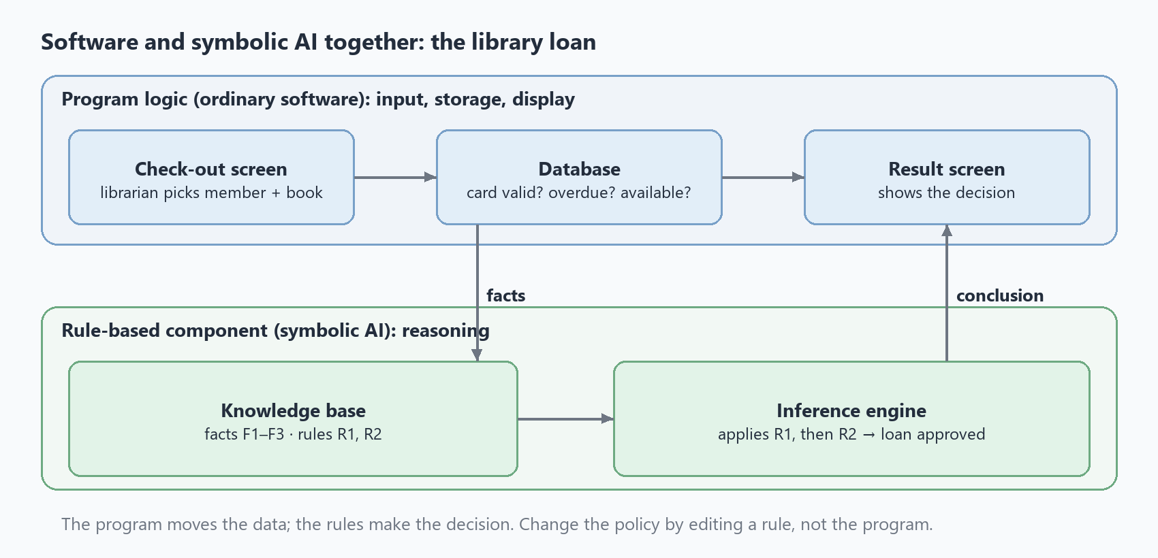
Figure 1. Software and symbolic AI together: the screens and the database (program logic) pass facts to the knowledge base, and the inference engine sends its conclusion back to the screen.
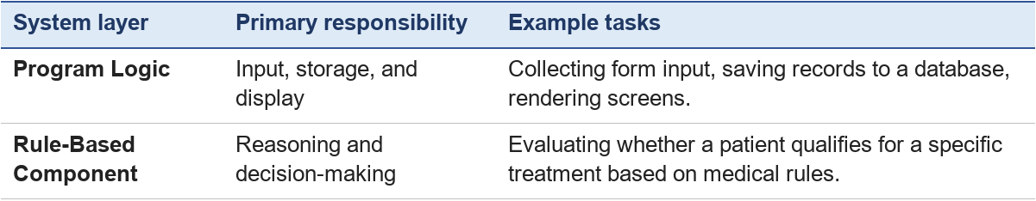

2. Fixed Program Logic vs. Explicit Rules
Traditional software relies on fixed program logic, where algorithms and decision paths are hardcoded by the programmer. Symbolic AI relies on explicit rules stored independently within a knowledge base.
- Fixed Program Logic: Procedural steps are tightly woven into the code. Changing how a decision is made means a programmer must edit the code and re-test it (Chapter 5, Section 8).
- Explicit Rules: Rules are declared as discrete statements (e.g., IF age > 65 AND income < 30000 THEN apply_senior_discount()).

Comparison of inspectability and modifiability
- Easy to inspect: Because explicit rules are written in near-natural, declarative language, domain experts and auditors can read and verify them directly without needing to comb through lines of source code.
- Easy to change: You can add, remove, or modify individual rules in the knowledge base without changing the program code. Each changed rule must still be tested.

3. Worked Example 1: One Decision, Two Ways — the Library Loan
Chapters 5 and 9 wrote the same library decision in two different ways. Put side by side, they show what each approach is good at.
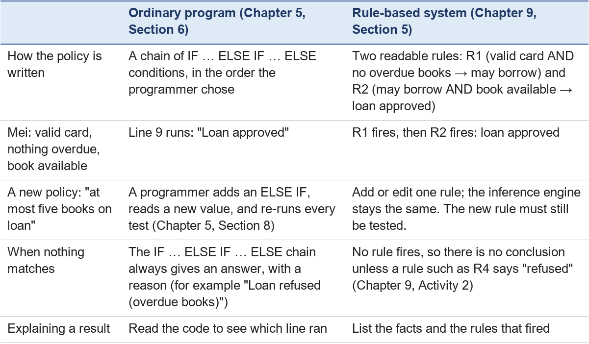
What this shows. Both versions reach the same decision for the same facts. The program is complete and predictable, but its policy is spread through the code. The rules make the policy visible and easy to change, but the system can only conclude what its rules cover. Real systems often combine the two (Figure 1).

4. Worked Example 2: A Medical Eligibility Advisor
Consider a program that helps determine whether a patient qualifies for an expedited health screening.
- Program logic (Python): Collects patient symptoms via an input form, stores them in variables, and displays the final result on screen.
- Rule-based component: Evaluates the explicit rule: IF fever == true AND cough == true THEN qualify_screening = true.

Trace: missing information
Suppose the patient's record lists fever = true, but the cough field is blank (missing).
- The rule requires both conditions to be true.
- Because cough information is missing, the rule fails to fire.
- The system does not know whether the patient has a cough or not; it cannot assume the cough is false just because the field is empty.
Consequently, it cannot provide a definitive recommendation, illustrating how missing information disrupts rule-based reasoning.

5. Learner Activity
Part A — missing or false? Use the rule from Section 4: IF fever == true AND cough == true THEN qualify_screening = true.
1. The record now says fever = true and cough = false. Does the rule fire? Can the system conclude that the patient does not qualify?
2. The record says cough = true, but the fever field is blank. What should the system do?
Part B — change the policy in both versions. The library decides that a member with overdue books may still borrow if they have paid their fine.
3. What must change in the Chapter 5 program?
4. What must change in the Chapter 9 rules?
5. After the change, which version makes the new policy easier for a librarian to read? Why?
Expected answers
1. The rule does not fire, because cough == true is false. The system now knows this rule does not apply, but it still cannot say "does not qualify" unless another rule states that conclusion — a rule-based system only concludes what its rules support.
2. The rule cannot fire, and the system must not assume the fever is false (or true): missing information does not prove the opposite. A good system would ask for the missing value or report that it cannot decide.
3. A programmer edits the condition chain — for example, refuse for overdue books only when the fine is not paid — adds a new input fine_paid, and re-runs all the old test cases plus new ones for the changed branch (Chapter 5, Sections 7–8).
4. Add one rule, for example R5: IF the member has a valid card AND has overdue books AND has paid the fine, THEN the member may borrow. R2 and the inference engine stay the same; the new rule still has to be tested.
5. Usually the rules: the new policy appears as one readable sentence (R5), while in the program it is hidden inside the order of the conditions. Either answer is acceptable if it is explained.

6. Hands-on: a rule-based assistant vs a machine-learning assistant
PPT 2024 ends the Symbolic AI chapter with a hands-on activity (chap4, slide 50): build a tiny "smart assistant" that switches a fan and a lamp on and off, first with fixed rules, then with a machine-learning model, and compare them. It turns the whole module into one experiment.
Test status (4 November 2026): Part A, the script on slide 50, was rebuilt in the live Scratch editor and tested. In Part B, the team trained the model on Machine Learning for Kids and tested it on the website (Figures 4 and 5), then ran its own script in Machine Learning for Kids' version of Scratch and tried three commands (Figures 6 and 7).
Goal. See, with your own hands, what a rule-based program understands and what a trained model understands, and why.
Preparation. A computer with a web browser; Scratch (https://scratch.mit.edu); Machine Learning for Kids (https://machinelearningforkids.co.uk), which lets you train a simple text classifier and use it inside Scratch. About 40 minutes.

Part A — the rule-based assistant (15 minutes)
1. In Scratch, make two sprites, a fan and a lamp, each with an on and an off costume.
2. Build the script in Figure 2, which comes from slide 50. Inside a forever loop, it asks for a command with ask … and wait, then checks the answer with one IF rule for each command:
- IF answer = "Fan on" OR answer = "Fan on please" THEN broadcast turn-fan-on and wait
- IF answer = "Fan off" THEN broadcast turn-fan-off and wait
- IF answer = "Lamp on" THEN broadcast turn-lamp-on and wait
- IF answer = "Lamp off" THEN broadcast turn-lamp-off and wait
3. The slide shows only this main script. Give each sprite a short script of its own that reacts to the messages, for example: when I receive turn-fan-on, switch the fan's costume to on.
4. Click the green flag, test the commands in the table below, and record what happens.
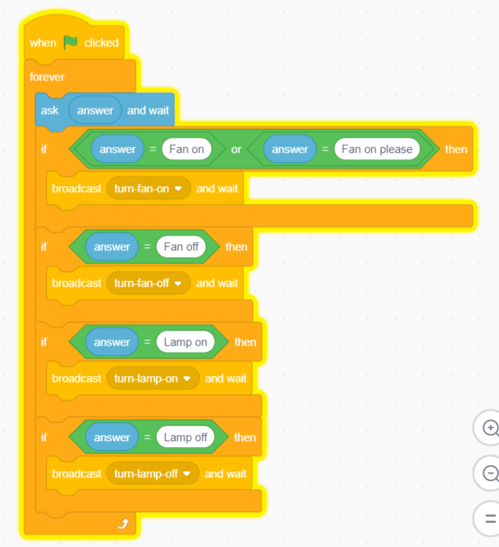
Figure 2. The rule-based assistant. Source: professor's PPT 2024, chap4 slide 50. On the slide, the ask block contains the answer block, so the first question is blank and later questions repeat your last answer; you can type "Enter your command" there instead, as in Figure 3.

Part B — the machine-learning assistant (25 minutes)
1. In Machine Learning for Kids, choose Get started, then Try it now (no account is needed, but the site first asks you to pass a "Verify you are human" check). This mode gives you one project, for a few hours, on one computer. Create a new project that recognises text.
2. Make four labels: fan_on, fan_off, lamp_on, lamp_off.
3. Type at least six different example sentences for each label — for example, for fan_on: "turn on the fan", "I'm hot", "it's so warm in here", "switch the fan on", "fan please", "I need some air".
4. Train the model, then test it in the website with sentences you did not type.
5. Open the project in Scratch from Machine Learning for Kids and build the script in Figure 6. It is the team's working version of the slide's script (Figure 3). It asks "Enter your command", then has one IF for each label, using the model's recognise text … (label) block. For example: IF recognise text (answer) (label) = fan_on THEN broadcast turn-fan-on. It differs from the slide in three ways:
- There is one extra ask before the forever loop.
- The loop ends with wait 5 seconds. Without a wait, the next question replaces the reply straight away.
- Four short scripts on the same sprite show the result, for example: when I receive turn-fan-on, say "Fan on" for 5 seconds.
6. Click the green flag. Because of the extra ask, the question appears twice at the start, and the script does not check your first answer. Press Enter the first time, then type your command the second time.
7. Test the same commands again. Each reply stays for about 5 seconds, until the question comes back.
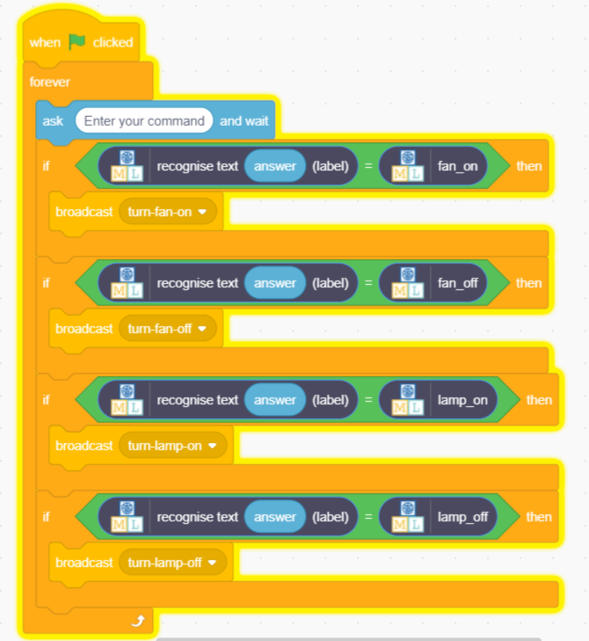
Figure 3. The machine-learning assistant. Source: professor's PPT 2024, chap4 slide 50. The loop and the four messages stay the same. The main change is the test inside each IF: it now asks the trained model instead of comparing exact words.
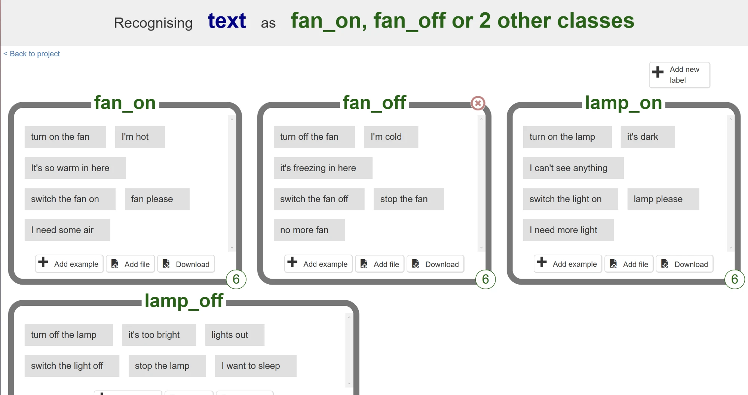
Figure 4. The team's training examples: six for each label. Screenshot from Machine Learning for Kids, 4 November 2026.
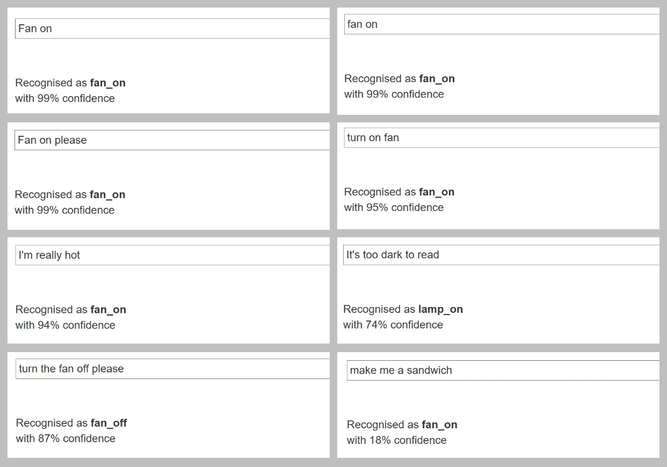
Figure 5. The trained model's answers to the eight test commands. Screenshots from Machine Learning for Kids, 4 November 2026.
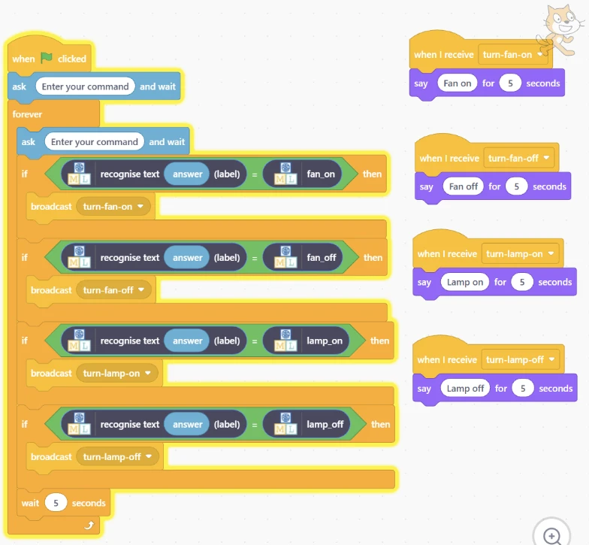
Figure 6. The team's working script, running in Machine Learning for Kids' version of Scratch. The yellow glow shows that it is running. Screenshot, 4 November 2026.
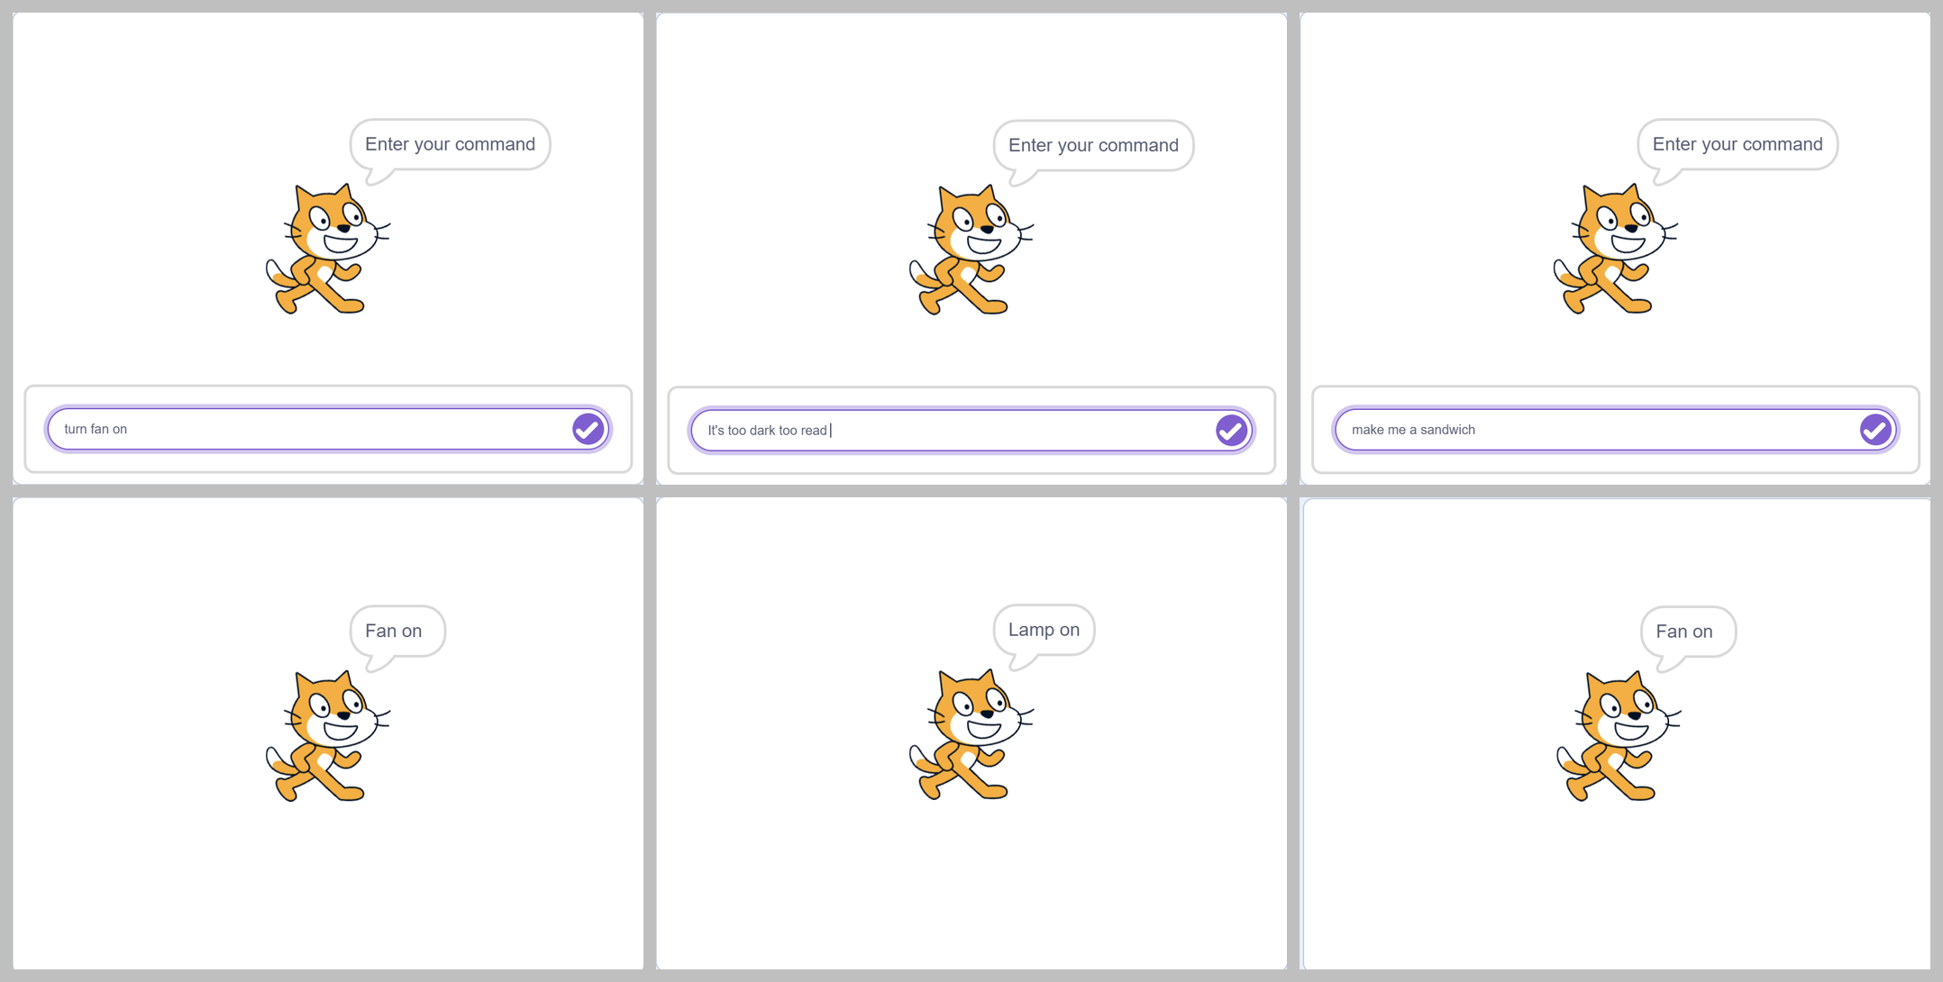
Figure 7. Three commands run through the script in Figure 6: the command typed (top) and the cat's reply (bottom). The team typed "turn fan on" and "It's too dark too read" (a typing slip), so the wording differs a little from the table below, but the cat still gave the replies you would expect. Screenshots, 4 November 2026.

Observation table
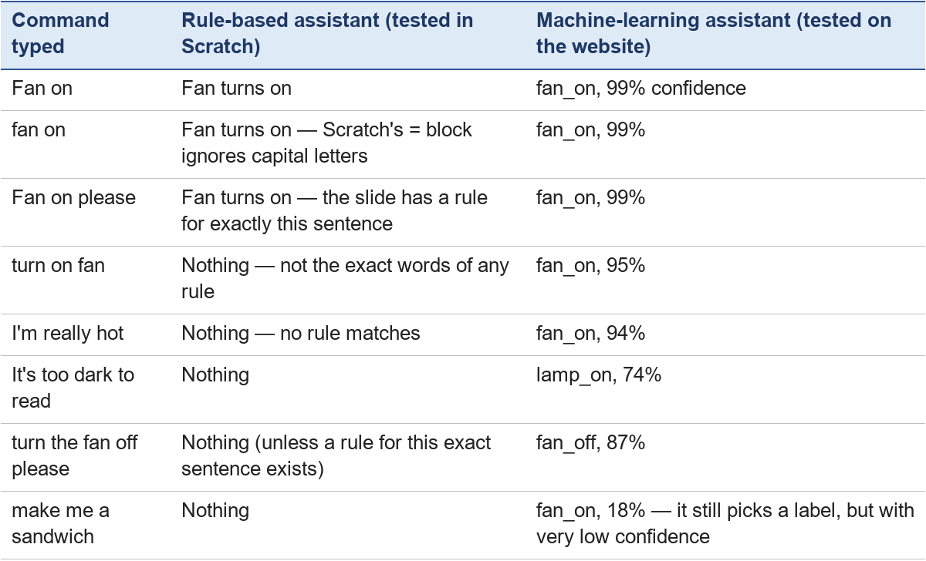
None of these eight commands was a training example, yet the model chose a sensible label for the first seven. The last result matters most: the script in Figure 6 checks only the label, not the confidence, so the cat said "Fan on" when the team typed "make me a sandwich" (Figure 7). A real assistant would have switched the fan on.

Reflection
1. Which assistant understood more ways of saying the same thing? Why?
2. For the rule-based assistant, can you explain exactly why each command worked or failed? Can you for the machine-learning one?
3. Which assistant would you trust to control something important, such as a heater in a baby's room? What would you add to make it safe?
4. How could the two be combined?
Expected answers
1. The machine-learning assistant: it learned patterns from examples, so it matched wording it had never seen, such as "turn on fan" (fan_on, 95%). The rule-based one only matches the exact words its rules were written for (Scratch ignores capital letters, but not different wording). That is why slide 50 needs a second condition just for "Fan on please".
2. Yes for the rules — each result traces back to one rule (or to no rule), as in Chapter 9. For the trained model we can see the label and the confidence, but not a readable reason; this is the interpretability difference of Chapter 6, Section 3.
3. Many people would choose rules for the safety part, because their behaviour is predictable and can be checked, and they do nothing when no rule matches. The sandwich test shows why: the model answered fan_on with only 18% confidence, and the script acted on it anyway (Figure 7). A good design adds a rule such as "IF the confidence is below a threshold THEN ask again" and safety rules (maximum temperature) that the model cannot override.
4. Use the model to understand what the user said (the perception part), then pass its label to explicit rules that decide what to do (the decision part). This is the hybrid architecture of Section 1 and the neuro-symbolic idea of Section 7.

7. Optional extension: neuro-symbolic AI (not examined; moved from the former Chapter 5)

7.1 Combining neural networks and rules
To work around the limits of each approach, many researchers combine both into Neuro-Symbolic AI. By pairing Neural Networks (which excel at perceiving messy, unstructured real-world data like vision, speech, and text) with Symbolic Logic Engines (which excel at reasoning, math, and safety guardrails), hybrid systems aim to be both adaptable and reliable (Liang et al., 2025; Bougzime et al., 2025):
- Self-driving vehicles: Neural vision models detect pedestrians from camera images, while explicit rules can express safety requirements such as IF pedestrian_detected THEN stop.
- Healthcare & LLM Verifiers: A clinical assistant can be designed so that a neural language model reads free-text patient notes, while symbolic engines check facts against clinical knowledge bases and medical rules to prevent dangerous drug contraindications.
Scope note from the project plan: neuro-symbolic AI is out of scope for this module and is mentioned here only for the point about brittleness; it is not examined.

7.2 Comparison table
To synthesize everything we have learned in this chapter, here is a master comparison table evaluating Pure Connectionist AI, Pure Classical Symbolic AI, and Modern Hybrid Neuro-Symbolic AI.
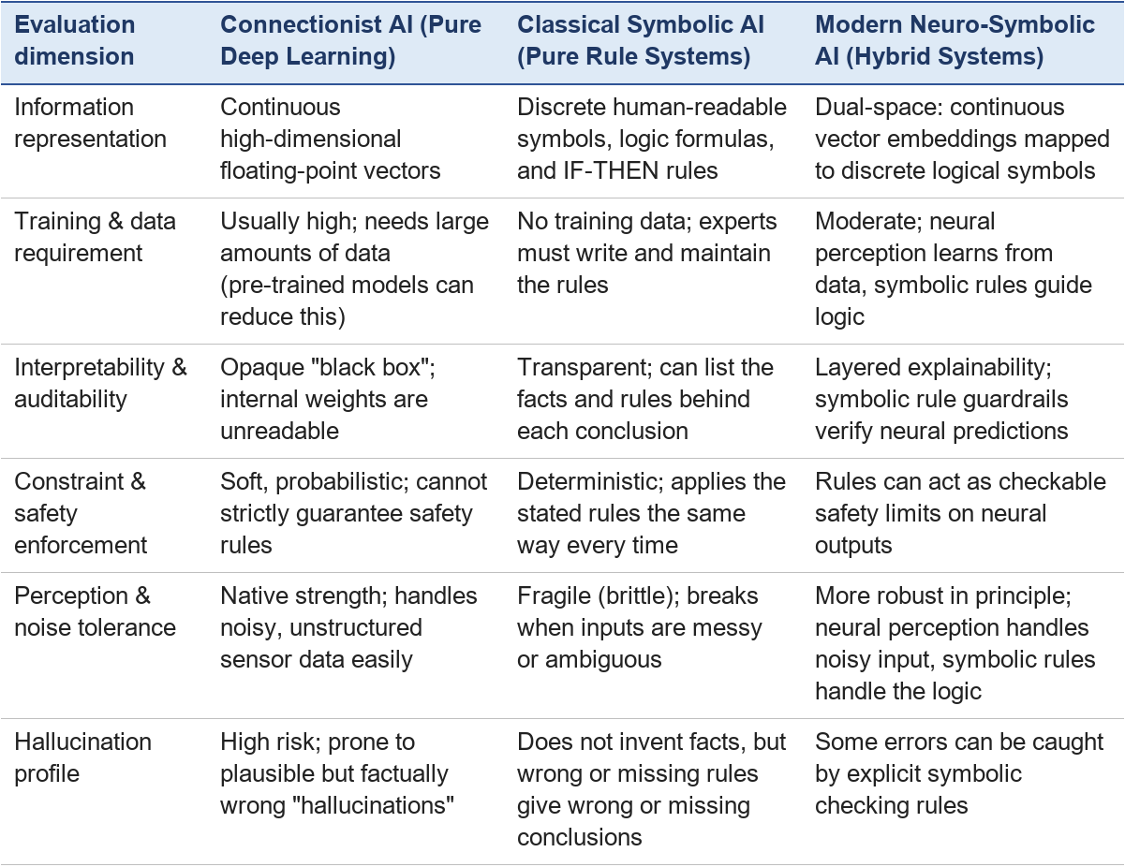

Key points
- Hybrid architectures separate concerns: program logic handles input, storage, and display, while a rule-based component handles reasoning.
- Explicit rules are separate from procedural code, making them easy for humans to inspect and modify.
- Explicit rules are reliable under strict conditions but become unreliable when information is missing, conflicting, or outdated.
- Missing information does not prove the opposite; assuming a fact is false simply because data is absent can cause logical errors in rule-based systems.
- The same decision can be written as a program or as rules: the program always gives an answer, while the rules make the policy easier to read and change but conclude only what they cover.

